For immediate release: Wed 14 May 2025

Outdoor Cinema 2025
Film nights under the stars
Wed 20 Aug – Sun 31 Aug
Barbican Sculpture Court
Outdoor Cinema 2025 is supported by Associate partner Mastercard and Destination Partner Culture Mile BID.
Barbican Cinema’s Outdoor Cinema returns this summer with a specially curated programme of films to watch under the city stars, in the dramatic surroundings of the Barbican Sculpture court, complete with a selection of food stalls and bars.
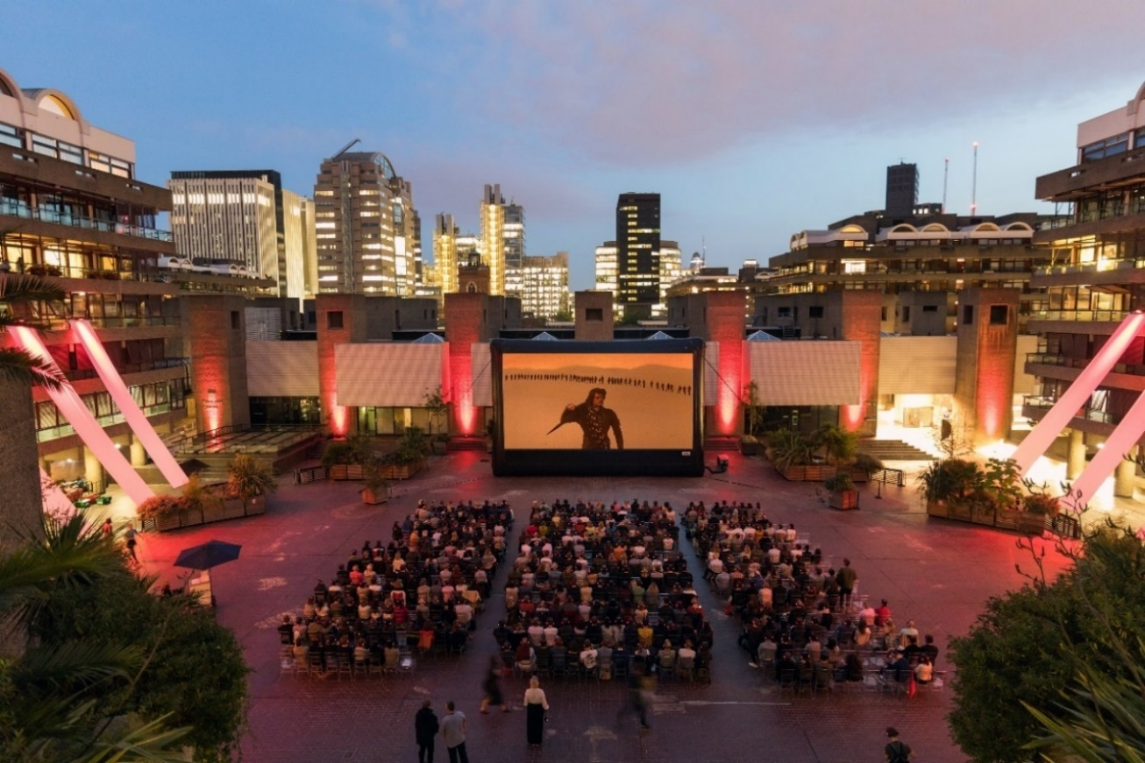
Dune, USA 1984, Dir David Lynch
The Barbican Cinema Curators have put together an original line-up from some of the best visual storytellers of our time, with films from David Lynch, Wes Anderson, Claire Denis, Apichatpong Weerasethakul, Gina Prince-Bythewood, Koji Hashimoto, Julien Henriques, Isao Takahata, and Sara Dosa, that demand to be seen on the big screen.
Outdoor Cinema opens Wed 20 August with Dune, David Lynch’s cult adaptation of Frank Herbert’s novel, which is a thrilling and unique sci-fi extravaganza by one of cinema’s most exciting visionaries.
Running over 11 days, the series closes on Sun 31 August with the beloved cult musical Little Shop of Horrors, about a nerdy florist trying his luck at finding romance with the help of a giant man-eating plant, which is complemented with a catchy soundtrack and cameos from Steve Martin, Jim Belushi and Bill Murray
In between, the programme promises something for all cinematic tastes, including Wes Anderson’s visually ravishing animation Fantastic Mr. Fox; Claire Denis’ shimmering Beau Travail, a haunting tale of desire and despair in the French Foreign Legion; and Apichatpong Weerasethakul’s Palme d’Or-winning Uncle Boonmee Who Can Recall His Past Lives, a magical portrait of an ailing Thai farmer visited by ghosts and spirits that is a journey into another realm.

From the UK comes Babymother, a Caribbean dancehall drama that takes audiences back to 1990s Harlesden and is widely considered to be the first ever Black British musical. Black female representation is also at the heart of Love & Basketball, a romantic sports drama about two young basketball players who fall in love, and the film brought a much-needed female gaze to the sports movie canon.
Thirty years after the original Godzilla, the King of the Monsters was resurrected in the thrilling 1984 reboot The Return of Godzilla, which successfully inaugurated a new era in the franchise’s history. The imaginative special effects and 1980s aesthetics update Godzilla for a new generation, while the thunderous sound effects, make for an intense and exciting cinema experience.
Further highlights include Grave of the Fireflies, Isao Takahata’s anti-war masterpiece, an unflinching look at the desperation and horror of survival in war time; and the mesmerising portrait of two obsessive, doomed volcanologists in Fire Of Love, a documentary that charts the mythical love story of Katia and Maurice Krafft, who shared a passion for only two things: volcanoes, and each other.
Björk’s Cornucopia is billed as her ‘most elaborate staged concert to date’, the multifaceted Icelandic singer-songwriter performs a spellbinding live show based around her 2017 album Utopia. Accompanied at times by a choir, Björk creates a stirring audiovisual experience: intimate, urgent and explosive.
Cary Sawhney, Interim Head of Barbican Cinema says:
“Outdoor Cinema is an opportunity to showcase the sheer joy of watching films alfresco, under the stars on the big screen, as a collective experience in the heart of London. From cult classics, international gems to musicals, there’s something for all ages and tastes and once again we look forward to welcoming audiences into this special setting to enjoy our programme.”
Part of Barbican’s Summer 2025 Highlights Programme, several screenings in this year’s Outdoor Cinema series are part of the Barbican cross-arts season Frequencies: the sounds that shape us​, which offers audiences the chance to go beyond music, exploring the power of sound and the sonic experience to shape how we move, think, feel and to inspire change.
SCREENINGS
Dune (12A)
USA 1984, Dir David Lynch, 131min
Wed 20 Aug, 8.45pm
Barbican Sculpture Court
In the year 10,191 Paul Atreides (Kyle MacLachlan), the son of a Duke, is embroiled in a life-and-death struggle with the merciless Harkonnens for control of the invaluable ‘spice’ in David Lynch’s wildly ambitious imagining of Frank Herbert’s 1965 story.
Decades after its mixed reception, Dune can now be reevaluated as a truly unique and thrilling sci-fi extravaganza by one of cinema’s most exciting visionaries. The production design and visual effects, not least the scenes with the gigantic sandworms, and the extraordinary, Oscar-nominated sound design make for an incredible cinematic spectacle.
This screening is part of the Barbican’s wider Frequencies: the sounds that shape us​ season.
Uncle Boonmee Who Can Recall His Past Lives (12A)
Thailand 2010, Dir Apichatpong Weerasethakul, 109min
Thu 21 Aug, 8.30pm
Barbican Sculpture Court
A mere plot synopsis cannot do justice to Apichatpong Weerasethakul’s hypnotic marvel about a dying man who moves to the countryside for his last days, where the apparition of his dead wife and his estranged son, in the form of a hairy jungle spirit, reunite with him.
Exploring themes of memory, afterlife and reincarnation, this is an intense, dreamlike journey into another world, including a memorable encounter with a forlorn princess and a talking catfish. Haunting and moving, the film boasts otherworldly sound design from Akritchalerm Kalayanamitr, creating a tangible and immersive encounter with the spiritual world. The film deservedly won the Palme d'Or at the Cannes Film Festival.
This screening is part of the Barbican’s wider Frequencies: the sounds that shape us​ season.
Love & Basketball (12A)
USA 2000, Dir Gina Prince-Bythewood, 124min
Fri 22 Aug, 8.30pm
Barbican Sculpture Court
Monica (Saana Lathan) and Quincy (Omar Epps) are two childhood friends who fall in love whilst following their joint passion for basketball. Over 15 years they fall in and out of love, navigating the challenging balance of their ambitions and their desires for each other, all in the pursuit of professional basketball careers.
With supporting roles played by the likes of Gabrielle Union, Regina Hall and Alfre Woodward, this semi-autobiographical drama is a great triumph for Black female representation both on and off-screen, that also brought a much-needed female gaze to the sports movie canon.
The Return of Godzilla (12A*) + recorded intro by kaiju expert Steven Sloss
Japan 1984, Dir Director: Koji Hashimoto, 103min
Sat 23 Aug, 8.30pm
Barbican Sculpture Court
Nine years after the last of the Showa-era Godzilla films, the iconic kaiju made a triumphant movie return in 1984. Ignoring all of the previous films save the 1954 original, Koji Hashimoto’s reboot returned to the dark roots of the first film, updating the film’s sociopolitical commentary for the late Cold War era. Here, the radioactive monster returns to wreak destruction on Japan and subsequently inflames tensions between the United States and the Soviet Union.
The imaginative special effects and 1980s aesthetics update Godzilla for a new era, while the thunderous sound effects, from the monster’s chilling roar to Reijiro Koroku’s stirring score, make for an intense and exciting cinema experience.
This screening is part of the Barbican’s wider Frequencies: the sounds that shape us​ season.
Fantastic Mr. Fox (PG)
USA 2009, Dir Wes Anderson, 87min
Sun 24 Aug, 8.30pm
Barbican Sculpture Court
A heist caper stitched with corduroy and velvet-pawed uprising; Fantastic Mr. Fox is as clever in spirit as it is in style. Joined by an all-star cast, including Meryl Streep, Bill Murray and Jason Schwartzman, George Clooney’s smooth-talking Mr. Fox – a charismatic schemer with a taste for adventure and expertly toasted cider – cannot resist one more heist. What unfolds is a game of strategy and mischief at every turn as the Fox family fights to protect their home from the farmers’ revengeful pursuit.
Whether it’s your first watch or a long-awaited rewatch, this beautifully scruffy tale feels as fresh and sharply crafted as ever. Settle into our own urban burrow — the Barbican’s Outdoor Cinema, where wild tales come to roost beneath the stars.
Babymother (15)
UK 1998, Dir Julien Henriques, 82min
Tue 26 Aug, 8.30pm
Barbican Sculpture Court
Shot on location in Harlesden, North London, Anita (Anjela Lauren Smith) is a young mother who dreams of becoming a dancehall star. Living on a council estate and raising two children alone means that money is tight, but she has all the talent and ambition she needs to make it big – plus the support of her two best friends with whom she forms her vocal group, Sharon (Caroline Chikezie) and Yvette (Jocelyn Esien).
The rhythms of London’s reggae scene are woven through Julien Henriques’ stylish and pioneering film, featuring bold and energetic musical numbers that speak to the legacy of dancehall culture in the capital.
This screening is part of the Barbican’s wider Frequencies: the sounds that shape us​ season.
Grave of the Fireflies (12A)
Japan 1988, Dir : Isao Takahata, 89min
Wed 27 Aug, 8.30pm
Barbican Sculpture Court
One of Studio Ghibli’s earliest works, the themes of Grave of the Fireflies are timeless and prescient, asking us not to look away when presented with the stark reality faced by Japanese civilians in WWII.
Michio Mamiya’s heartbreaking score washes over this exquisite animation, bringing a rich depth of emotion to the story of Seita (Tsutomu Tatsumi) and Setsuko (Ayano Shiraishi), a boy and his younger sister who are left homeless during bombing raids, forced to find ways to survive amidst the devastation.
Fire Of Love (PG)
Canada/ USA 2022, Dir Sara Dosa, 98min
Thu 28 Aug, 8.30pm
Barbican Sculpture Court
Maurice and Katia Kraftt were two volcanologists and explorers who died doing what they loved – unravelling the mysteries of volcanic eruptions.
Their work and discoveries, collected over many years exploring the planet’s volcanic hot spots taught us about the natural world around us, and has been instrumental in the saving of thousands of lives.
Awe-inspiring imagery and deeply immersive soundscapes allow us to experience the incredible explosive power of volcanoes up close, assembled from several hours of previously unseen 16mm film and a collection of thousands of photographs sourced from the Kraftt’s archives.
Beau Travail (15)
France 1998, Dir Claire Denis, 93min
Fri 29 Aug, 8.30pm
Barbican Sculpture Court
Claire Denis reimagines Herman Melville’s Billy Budd in her extraordinary masterpiece, in which passions simmer in the male environment of the French Foreign Legion.
Voted one of the 10 best films of all time in a recent Sight & Sound poll, Beau Travail delves into the tensions within a French Foreign Legion regiment in the former colony of Djibouti, when the arrival of a handsome young soldier provokes a crisis in Galoup, a grizzled sergeant-major (Denis Lavant). Jealous and inexplicably shaken, Galoup resolves to destroy the younger man.
This screening is part of the Barbican’s wider Frequencies: the sounds that shape us​ season.
Björk’s Cornucopia (12A)
Portugal 2025. Dir Ísold Uggadóttir, 98min
Sat 30 Aug, 8.30pm
Barbican Sculpture Court
Björk’s latest concert film is an electrifying experience; one that is underscored by a poignant socio-political message about the need for climate change action. A fantastical, fungi-inspired set design, wild floral and aquatic visuals and stunning costumes designed by Balmain's Olivier Rousteing and Iris van Herpen are the backdrop to her unique voice, as she performs songs including “Mouth’s Cradle”, “Sue Me” and “Isobel”. The set also includes two songs, “Ovule” and “Atopos”, performed live for the first time.
This screening is part of the Barbican’s wider Frequencies: the sounds that shape us​ season.
Little Shop of Horrors (PG)
USA 1986, Dir Frank Oz, 105min
Sun 31 Aug, 8.30pm
Barbican Sculpture Court
Frank Oz’s adaptation of the off-Broadway smash hit musical is a mega-blast of fun from beginning to end. Rick Moranis plays Seymour, a nerdy guy working in a failing florist, who longs for the love of his colleague, Audrey (Ellen Greene). In the shop’s basement, Seymour secretly nurtures a strange plant, which he names Audrey II, which brings in new customers and revitalises the business but, to his alarm, grows into a bloodthirsty monster…
This delightful pastiche is crammed with showstopping hits, including Somewhere That's Green, the Oscar-nominated Mean Green Mother from Outer Space and, of course, Suddenly Seymour. Moranis and Greene are super, and there are terrific comedy cameos from Jim Belushi, John Candy, Bill Murray and Steve Martin as a villainous dentist, with Levi Stubbs of The Four Tops as the voice of Audrey II.
ENDS
Notes to Editors
For further information contact:
Ian Cuthbert, Communications Manager - Cinema
ian.cuthbert@barbican.org.uk
020 3834 1121
Andrea Laing, Communications Assistant: Theatre & Dance, Cinema and Creative Collaboration
andrea.laing@barbican.org.uk
About Priceless.com
Priceless.com is available exclusively to Mastercard cardholders and provides access to unforgettable experiences and valuable everyday offers in the cities where you live and travel. Time is the most precious resource we have, it is Mastercard’s mission to provide you opportunities to have meaningful moments with the people you care about. Fuel your passions. Make memories to last a lifetime. Sign up to priceless.com now to receive regular updates, so you’re the first to hear about these exclusive experiences and many more.
About Culture Mile
The Culture Mile Business Improvement District (BID) is an area brimming with cultural creativity, commercial vibrancy and a strong sense of community, home to iconic institutions like the Barbican and the future Museum of London. Over five years, it will invest up to £11m in public realm improvements, sustainability initiatives, and destination marketing.
Box office: www.barbican.org.uk
Standard: £18
Barbican Members: £14.40
Corporate Members: £13.50
Young Barbican: £10
Under 14: £10
There is £1.50 booking fee for purchases made online
Barbican press room
All Barbican Centre press releases, news announcements and the Communications team’s contact details are listed on our website at www.barbican.org.uk/our-story/press-room
About the Barbican
The Barbican is a catalyst for creativity, sparking possibilities for artists, audiences, and communities. We showcase the most exciting art from around the world, pushing traditional artistic boundaries to entertain and inspire millions of people, create connections, provoke debate, and reflect the world we live in.

We are an international arts and events centre rooted firmly in our own neighbourhood, collaborating with local communities and putting the City of London on the map as a destination for everybody. Central to our purpose is supporting emerging talent and shaping opportunities that will accelerate the next generation of creatives.

As a not-for-profit, we rely on the generosity of individuals and organisations, including our principal funder the City of London Corporation. Every ticket purchased, donation made, and pound earned supports our arts and learning programme and enables the widest possible range of people to experience the joy of the arts.

Opened in 1982, the Barbican is a unique and audacious building, recognised globally as an architectural icon. As well as our theatres, galleries, concert halls and cinemas, we have a large conservatory with over 1,500 species of plants and trees, a library, conference facilities, public and community spaces, restaurants, bars, and a picturesque lakeside oasis.

We’re proud to be the home of the London Symphony Orchestra, and a London base of the Royal Shakespeare Company. We regularly co-commission, produce and showcase the work of our other associates and partners including the Academy of Ancient Music, BBC Symphony Orchestra, Boy Blue, Darbar, Doc'n Roll Film Festival, Drum Works, EFG London Jazz Festival, London Palestine Film Festival, Serious, and Trafalgar Theatre Productions.

For more information, visit our website or connect with us on Instagram | Facebook | YouTube | Spotify | LinkedIn
About Barbican Cinema
We connect audiences with a curated programme of international cinema; from celebrated filmmakers to ground-breaking and under-heard voices from past and present.
Our programmes are presented in Cinemas 1 in the main centre and Cinemas 2&3 on Beech Street. Our programme ranges from thematic seasons that respond to today’s world, to new releases, ScreenTalks, cross-artform collaborations, family events, access screenings and event cinema that presents the performing arts on screen.
We showcase the work of emerging filmmakers, as well as less familiar work of exceptional filmmakers from the UK and around the world. We champion the work of Barbican Young Programmers and give stage to emerging musicians in our ongoing film & live music series which includes our flagship collaboration with the Guildhall School of Music & Drama.
As part of a cross-arts centre, our cinemas are a cultural space for people to share the viewing experience. We strive to be inclusive in everything we do; providing platforms for the widest possible range of filmmakers and ensuring we are an open, welcoming and accessible venue for all our audiences.

