For immediate release: Thur 26 Oct 2023

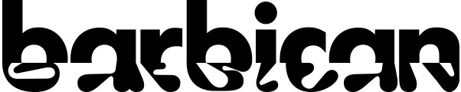

Barbican Cinema
New Release ScreenTalks – Nov 2023

This November, Barbican Cinema presents a packed line-up of ScreenTalk Previews for upcoming new releases, including a discussion with Academy Award-winning actor-turned-writer/director Emerald Fennell following a special screening of Saltburn (Sat 4th Nov 8:25pm). This dark and delicious comedy thriller starring Barry Keoghan as a young Oxford University student who finds himself drawn into the world of a charming aristocrat, played by Jacob Elordi, is a beautifully wicked tale of privilege and desire set in the grandeur of an upper-class estate.

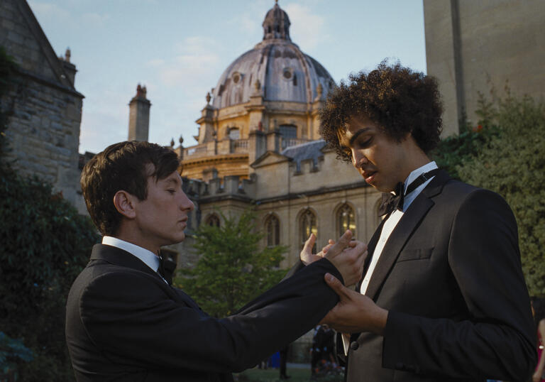
Saltburn UK 2023 dir Emerald Fennell

Also in November, Barbican Cinema presents three ScreenTalks supported by Campari, official drinks sponsor for Barbican ScreenTalks to include a complimentary Campari Spritz or Crodino non-alcoholic aperitivo with every ticket purchased.

Director Justine Triet will be in conversation with journalist Fionualla Halligan following a preview of Anatomy of a Fall (Thu 2 Nov, 7.45pm, Cinema 1), a crime thriller following the trial of a woman (Sandra Hüller) accused of murdering her husband in their remote chalet in the French Alps. Anatomy of a Fall was the winner of the Cannes 2023 Palme d’Or award.

Following a preview screening of The Eternal Daughter (Sun 19 Nov, 5.30pm, Cinema 1), writer/director Joanna Hogg and film critic Ben Nicholson will discuss Hogg’s atmospheric mystery drama, which is nominated for the Golden Lion in Venice 2023 and stars Tilda Swinton in dual roles as both a mother and her daughter.

Finally, the director of Chicken Run: Dawn of the Nugget (Tue 28 Nov, 6:15pm, Cinema 1) Sam Fell will appear in a ScreenTalk hosted by Barbican Cinema Curator Sonia Zadurian after this special preview screening.

ENDS
Notes to Editors

For further information contact:
Sumayyah Sheikh, Communications Assistant, Theatre & Dance and Cinema
sumayyah.sheikh@barbican.org.uk

Ian Cuthbert, Communications Manager, Cinema
ian.cuthbert@barbican.org.uk / 07980 925 352

Sarah Harvey, Barbican Cinema Press Consultant
sarah@sarahharveypublicity.co.uk / 07958 597 426
Box office: www.barbican.org.uk
ScreenTalk prices:
Standard £13.50
Members £9.60
Corporate Members £9
Young Barbican £5
Barbican press room
All Barbican Centre press releases, news announcements and the Communications team’s contact details are listed on our website at www.barbican.org.uk/our-story/press-room

About the Barbican
The Barbican is a catalyst for creativity, sparking possibilities for artists, audiences, and communities.

We showcase the most exciting art from around the world, pushing traditional artistic boundaries to entertain and inspire millions of people, create connections, provoke debate, and reflect the world we live in.

We are an international arts and events centre rooted firmly in our own neighbourhood, collaborating with local communities and putting the City of London on the map as a destination for everybody. Central to our purpose is supporting emerging talent and shaping opportunities that will accelerate the next generation of creatives.

As a not-for-profit, we rely on the generosity of individuals and organisations, including our principal funder the City of London Corporation. Every ticket purchased, donation made, and pound earned supports our arts and learning programme and enables the widest possible range of people to experience the joy of the arts.

Opened in 1982, the Barbican is a unique and audacious building, recognised globally as an architectural icon. As well as our theatres, galleries, concert halls and cinemas, we have a large conservatory with over 1,500 species of plants and trees, a library, conference facilities, public and community spaces, restaurants, bars, and a picturesque lakeside oasis.

We are the home of the London Symphony Orchestra, and a London base of the Royal Shakespeare Company. We regularly co-commission, produce and showcase the work of our other partners and associates: the Academy of Ancient Music, the BBC Symphony Orchestra, Boy Blue, Britten Sinfonia, Cheek by Jowl, Drum Works, the Los Angeles Philharmonic, Serious and We Are Parable.
For more information, visit our website or connect with us on Instagram | Twitter | Facebook | YouTube | Spotify | LinkedIn
About Barbican Cinema
We connect audiences with a curated programme of international cinema; from celebrated filmmakers to ground-breaking and under-heard voices from past and present.
Our programmes are presented in Cinemas 1 in the main centre and Cinemas 2&3 on Beech Street. Our programme ranges from thematic seasons that respond to today’s world, to new releases, ScreenTalks, cross-artform collaborations, family events, access screenings and event cinema that presents the performing arts on screen.
We showcase the work of emerging filmmakers, as well as less familiar work of exceptional filmmakers from the UK and around the world.
We champion the work of Barbican Young Programmers and give stage to emerging musicians in our ongoing film & live music series which includes our flagship collaboration with the Guildhall School of Music & Drama.
As part of a cross-arts centre, our cinemas are a cultural space for people to share the viewing experience. We strive to be inclusive in everything we do; providing platforms for the widest possible range of filmmakers and ensuring we are an open, welcoming and accessible venue for all our audiences.

