FOR IMMEDIATE RELEASE: Wed 20 Sep 2023

Barbican Family Film Week 2023
Barbican’s beloved season returns this autumn half-term with a packed week of children’s films from around the world, special guest introductions, free workshops and events, including special previews of Oink, Chicken Run: Dawn of the Nugget and a relaxed screening event of Spider-man Across the Spider Verse with a Drawing Demo.
Sat 21 Oct – Sat 28 Oct
Barbican Cinema 2 & 3 and Fountain Room
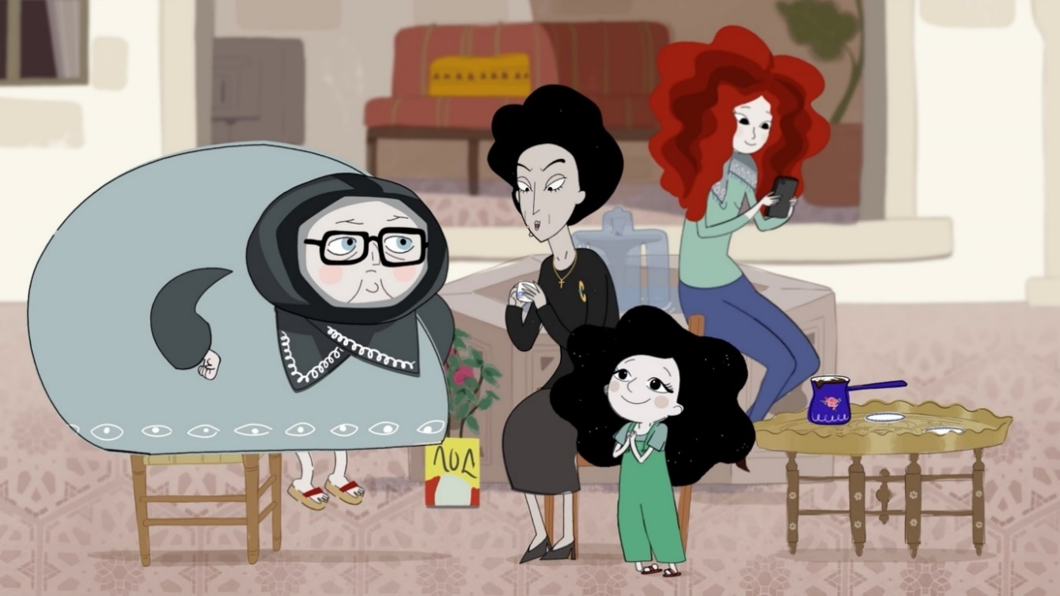
Dounia and the Princess of Aleppo, Dirs André Kadi & Marya Zarif
- Special Preview: Oink + pre-film quiz – Sat 21 Oct
- Nimona + live intro from directors, Troy Quane + Nick Bruno, and writer ND Stevenson – Sun 22 Oct
- Puffin Rock and the New Friends – Mon 23 Oct
- Relaxed screening and Drawing Demo: Spider-man: Across the Spider-verse with children’s author and illustrator Rikin Parekh – Tue 24 Oct
- Sirocco and the Kingdom of the Winds – Wed 25 Oct
- Free animation workshops morning with Chocolate Films – Wed 25 Oct
- Special Preview: Chicken Run: Dawn of the Nugget + recorded intro from director Sam Fell + Aardman workshops – Thu 26 Oct
- Dounia and the Princess of Aleppo presented in partnership with SAFAR Film Festival and free pre-film workshop – Sat 28 Oct
The fun kicks off on Sat 21 Oct with a special preview screening of Oink, a charming stop-motion film from the Netherlands, in which a nine-year old girl gets a pet pig named Oink as a gift from her long-estranged grandfather – who may have ulterior motives - plus an on-stage film quiz, all about animals on film.
Nimona, screening on Sun 22 Oct, is a futuristic medieval-punk mash up animation in which a knight is framed for a crime he didn't commit, and Nimona – a shape-shifting magnet for mayhem - is the only one who can help him prove his innocence. Family Film Week is delighted there will also be a live intro from the film’s directors Troy Quane & Nick Bruno, and the creator of the graphic novel, ND Stevenson.
Family Film Week’s first-ever relaxed screening - designed for an audience with additional needs – will take place on Tue 24 Oct. Themed around Spider-man: Across the Spider-verse, children’s book illustrator Rikin Parekh will do an on-stage demonstration ahead of the screening to show young audience members how to draw Miles Morales as Spider-man, followed by an opportunity to draw-along during the screening.
On Thu 26 Oct children and their families will be treated to the celebrated return of Aardman’s much loved animated birds in Chicken Run: Dawn of the Nugget in two special preview screenings ahead of the film’s release in December, each with a pre-recorded introduction from the director, Sam Fell. Both screenings will be preceded by a bookable workshop run by an Aardman animator, to learn how to make Chicken Run themed character models.
Dounia and the Princess of Aleppo, a beautiful animation that champions hope and understanding, will screen in partnership with SAFAR Film Festival on Sat 28 Oct. With just a few nigella seeds tucked in the palm of her hand, six-year-old Dounia and her family must flee Aleppo when her father is arrested. The film blends conflict with fantasy and music, creating a poetic story that gives young audiences an entry point to discuss Dounia’s refugee experience and the need for respect and understanding. Prior to the film there will be a free drop-in workshop in Cinema 2 & 3 foyer led by artist Leen Kay, who will explore themes from the film and draw upon her experience as a photographer and designer.
Other highlights include Puffin Rock and the New Friends (Mon 23 Oct) , a gentle animation from the wonderful Cartoon Saloon, perfect for the youngest of film fans, follows the adventures of pufflings Oona and Baba as they try to bring the last little egg of the season home before a storm hits; and Sirocco and the Kingdom of the Winds (Wed 25 Oct), a new surreal animation in which two girls discover a secret passage into the universe of their favourite book, which was given its world premiere, opening the Annecy film festival earlier this year.
To complement this year’s film programme there will be a free Animation Workshops morning workshops on Wed 25 Oct, with Chocolate Films in the Fountain Room, Level G, in which filmmakers and artists will show young people how to make their own animations and learn about filmmaking techniques.
Susie Evans, Barbican Cinema Curator says: “With this year’s Family Film Week, we’ve designed a programme of films and events to spark a love of the big screen cinema experience in our youngest of audiences. There are some real crackers that you won’t see anywhere else – including the fantastically surreal, Sirocco and the Kingdom of the Winds, as well as the utterly charming comedy Oink. We’re also super excited to be partnering with SAFAR on a screening of Dounia and the Princess of Aleppo, a beautifully animated story of a child’s eye view of displacement and conflict. And in addition to all those rarely seen gems, we’ve got some famous faces too – including the Netflix smasher Nimona on the big screen as well as a sneaky-peek preview of Aardman’s latest masterpiece, Chicken Run: Dawn of the Nugget. We can’t wait to see you in the cinema!”
Screenings and Events:
Special Preview: Oink (U*) + pre-film quiz
Netherlands 2022, Dir Mascha Halberstad, 72min
Sat 21 Oct, 11am, Cinema 2
Family Film Week is delighted to be hosting a special preview of this charming stop-motion from the Netherlands, not released in the UK until 2024.
Dutch with English subtitles. Subtitles read aloud for children via headsets.
Age recommendation: 5+
Nimona (PG) + Live intro from directors, Troy Quane & Nick Bruno, and creator ND Stevenson
USA 2023, Dir. Tory Quane & Nick Bruno 101min
Sun 22 Oct, 11am, Cinema 2
When a knight in a futuristic medieval world is framed for a crime he didn’t commit, the only one who can help him prove his innocence is Nimona — a mischievous teen who happens to be a shapeshifting creature he's sworn to destroy.
With thanks to Netflix.
Age recommendation: 7+
Puffin Rock and the New Friends (U)
Ireland 2023 Dir Jeremy Purcell 80min
Mon 23 Oct 11.40am, Cinema 2
When the last Little Egg of the season disappears under mysterious circumstances, Oona races to bring it home before a big storm hits Puffin Rock and puts the entire island in danger.
Featuring the dulcet tones of Chris O’Dowd on narration duty and a whole host of new beautifully realised animal friends.
Age recommendation: 3+
Drawing Demo with author-illustrator Rikin Parekh + Relaxed screening: Spider-man: Across the Spider-verse (PG)
US 2023, Dirs. Joaquim Dos Santos, Kemp Powers, Justin K. Thompson, 140min
Tue 24 Oct, 2.15pm, Event runtime approx. 3hours, Cinema 2
Family Film Week is pleased to welcome super Spidey fan and illustrator extraordinaire, Rikin Parekh, to the cinema for an on-stage demonstration where we’ll be learning how to draw Miles Morales as Spider-man.
This is followed by Spider-man: Across the Spider-verse, which screens in a relaxed environment, tailored for an audience with additional needs.
Screening with HoH Captions and Audio Description will be available on request.
Age recommendation: 7+
Free Animation workshops with Chocolate Films
Wed 25 Oct, 10.15am – 1.15pm, Fountain Room
The wonderful Chocolate Films will demonstrate how to create stop-motion animations at the Animation Station. These workshops are sign up on the day and can last up to an hour. Or drop-in to the time-lapse animation drawing zone. Please note that places are assigned on a first come, first served basis and spaces are limited. These workshops are free.
Age recommendation: 4-12
Sirocco and the Kingdom of the Winds (U*)
Belgium 2023, Dir Benoît Chieux, 76min
Wed 25 Oct, 2.15pm, Cinema 2
Agnes, a children’s fantasy author, has written stories of a faraway land featuring a mysterious wizard named Sirocco. But somehow this fictional world has come to life and when Agnes is asleep, Juliette and Carmen – two young girls she is babysitting - are sucked into the pages of these strange tales, complete with cat transformations, alligator air ships, toad-like mayors and bird headed opera divas.
French with English subtitles. Subtitles read aloud for children via headsets. Headsets handed out on arrival to cinema, first come, first served. Do we have an issue with provision? Not sure why we have to note: first come, first served.
Age recommendation: 5+
Special Preview: Chicken Run: Dawn of the Nugget (PG) + Recorded intro from director
Sam Fell
Dir. Sam Fell UK 2023 97min
Thu 26 Oct, 12.15pm Cinema 2 & 1.30pm Cinema 3
Family Film Week is excited to be screening this early preview ahead of the Netflix release on December 15th.
Having pulled off an escape from Tweedy’s farm, Ginger and the flock find a peaceful sanctuary, far from the dangers of the human world. When she and Rocky hatch little Molly, Ginger’s happy ending seems complete, but back on the mainland, the whole of chicken-kind faces a new and terrible threat.
Screening with HoH Captions / Audio description available on request. BSL for in cinema intro.
With thanks to Netflix.
Age recommendation: 6+
Aardman Workshops
Thu 26 Oct, 10.00-11.00am & 12pm – 1pm, Fountain Room
With BSL interpretation available.
An Aardman animator will share thier expertise in workshops where young people get to make their own Chicken Run themed character model. Free Pre-film drop-in workshop
Sat 28 Oct, 10am - 11am Cinema 2&3 Foyer
Join us in the foyer from 10am for a free drop-in workshop led by artist Leen Kay.
Exploring themes from the film and drawing on Leen’s own experiences and her work as an architect, photographer and designer, Leen will work with families using craft-based activities to take a step into the world of Dounia and The Princess of Aleppo.
If you’d like to find out more about Leen’s work, you can take look at some of her previous projects on Instagram: @Berryfield.Studio (https://instagram.com/berryfieldstudio)
Dounia and the Princess of Aleppo (PG*)
Canada 2022, Dirs André Kadi Marya Zarif, 72min
Sat 28 Oct, 11am, Cinema 2
Family Film Week is partnering up with SAFAR Film Festival to present this beautiful animation that champions hope and understanding.
Six-year-old Dounia lives with her father and grandparents in Aleppo but when her father is arrested, her family must flee the city. Forced on a treacherous journey Dounia never loses her determination to find a new home and carries with her a handful of nigella seeds to connect her with the magic of her beloved country.
Arabic with English subtitles. Subtitles read aloud for children via headsets. Headsets handed out on arrival to cinema, first come, first served. See comment above re first come, first served.
Age recommendation: 6+
For more details of SAFAR: www.safarfilmfestival.co.uk
ENDS
Notes to Editors
For further information contact:
Ian Cuthbert, Communications Manager, Cinema
ian.cuthbert@barbican.org.uk / 07980 925 352
Sarah Harvey, Barbican Cinema Press Consultant
sarah@sarahharveypublicity.co.uk / 07958 597 426
Sumayyah Sheikh, Communications Assistant, Theatre & Dance and Cinema:
sumayyah.sheikh@barbican.org.uk
Box office: www.barbican.org.uk
All film tickets: £2.50 under 18s / £3.50 adults
No unaccompanied adults or children
Aardman workshops on Thu 26 Oct are £3 and are only available to bookers of the film screenings of Chicken Run: Dawn of the Nugget on the same day. No unaccompanied adults or children. Everyone needs a ticket.
* Local classification
Age recommendations are suggestions only – responsibility lies with parent/guardian.
Barbican press room
All Barbican Centre press releases, news announcements and the Communications team’s contact details are listed on our website at www.barbican.org.uk/our-story/press-room
About the Barbican
The Barbican is a catalyst for creativity, sparking possibilities for artists, audiences, and communities.

We showcase the most exciting art from around the world, pushing traditional artistic boundaries to entertain and inspire millions of people, create connections, provoke debate, and reflect the world we live in.

We are an international arts and events centre rooted firmly in our own neighbourhood, collaborating with local communities and putting the City of London on the map as a destination for everybody. Central to our purpose is supporting emerging talent and shaping opportunities that will accelerate the next generation of creatives.

As a not-for-profit, we rely on the generosity of individuals and organisations, including our principal funder the City of London Corporation. Every ticket purchased, donation made, and pound earned supports our arts and learning programme and enables the widest possible range of people to experience the joy of the arts.

Opened in 1982, the Barbican is a unique and audacious building, recognised globally as an architectural icon. As well as our theatres, galleries, concert halls and cinemas, we have a large conservatory with over 1,500 species of plants and trees, a library, conference facilities, public and community spaces, restaurants, bars, and a picturesque lakeside oasis.

We are the home of the London Symphony Orchestra, and a London base of the Royal Shakespeare Company. We regularly co-commission, produce and showcase the work of our other partners and associates: the Academy of Ancient Music, the BBC Symphony Orchestra, Boy Blue, Britten Sinfonia, Cheek by Jowl, Drum Works, the Los Angeles Philharmonic, Serious and We Are Parable.
For more information, visit our website or connect with us on Instagram | Twitter | Facebook | YouTube | Spotify | LinkedIn
About Barbican Cinema
We connect audiences with a curated programme of international cinema; from celebrated filmmakers to ground-breaking and under-heard voices from past and present.
Our programmes are presented in Cinemas 1 in the main centre and Cinemas 2&3 on Beech Street. Our programme ranges from thematic seasons that respond to today’s world, to new releases, ScreenTalks, cross-artform collaborations, family events, access screenings and event cinema that presents the performing arts on screen.
We showcase the work of emerging filmmakers, as well as less familiar work of exceptional filmmakers from the UK and around the world.
We champion the work of Barbican Young Programmers and give stage to emerging musicians in our ongoing film & live music series which includes our flagship collaboration with the Guildhall School of Music & Drama.
As part of a cross-arts centre, our cinemas are a cultural space for people to share the viewing experience. We strive to be inclusive in everything we do; providing platforms for the widest possible range of filmmakers and ensuring we are an open, welcoming and accessible venue for all our audiences.

