For immediate release - Wed 17 May 2023
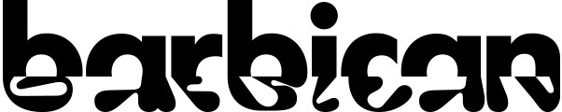

Barbican Summer Outdoor Cinema Screenings
Wed 23 Aug – Sun 3 Sep
www.barbican.org.uk/whats-on/2023/series/outdoor-cinema
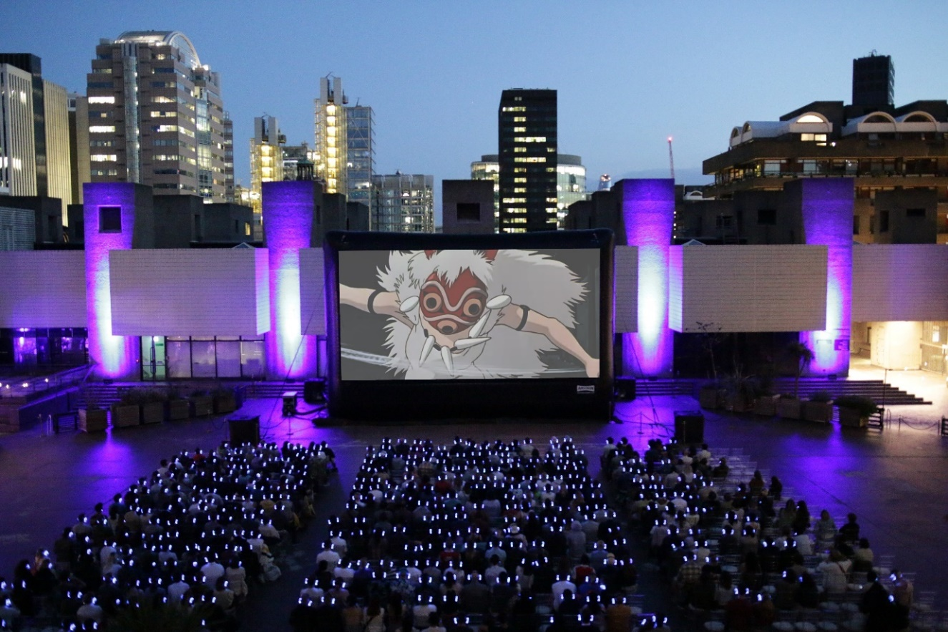
Princess Mononoke, Outdoor Cinema 2022, photograph by Suzanne Zhang
Barbican Cinema is delighted to present another late summer programme of open-air evening screenings, in the spectacular setting of the Sculpture Court.

Building on the success of the last two editions, this year’s Outdoor Cinema series has a new official drinks’ sponsor Campari, and the Barbican is inviting audiences to enjoy a complimentary Campari Spritz, or a Crodino non-alcoholic aperitivo, with every ticket purchased.
The programme, developed in collaboration with producers and programmers across artforms at the Barbican, has something for all cinematic tastes.
Gali Gold, Head of Cinema, comments:
“From Hollywood classics, music concerts and Afro-Futurism, to trailblazing queer milestones, animé and musical crowd pleasers, this year’s Outdoor Cinema programme celebrates the rich spectacle that cinema can offer in its full diversity.
We’re delighted to screen these handpicked favourites, side by side, in our unique summer venue in the heart of the city. This is a true celebration of cinema and the collective experience of being immersed in films together.”
Outdoor Cinema begins on Wed 23 Aug with Andrei Tarkovsky’s autobiographical film Mirror (Soviet Union, 1975), a unique and visually striking cinematic poem in which the director reflects upon his rural childhood in the Soviet Union before the Second World War, and the destiny of the Russian people. The film features unforgettable imagery from the start, music by Bach and poetry by the director’s father Arseny Tarkovsky..
Hero (China, 2002) is an Academy-Award nominated martial arts epic, set in ancient China, from director Yimou Zhang (House of Flying Daggers). With stunning visuals from celebrated cinematographer Christopher Doyle and a glittering cast including Tony Leung, Jet Li, Ziyi Zhang and Maggie Cheung, this is a beautiful tale of love, loss and a belief in something greater than oneself.
Legendary director Martin Scorsese’s concert film The Last Waltz (US, 1978) depicts the equally legendary The Band’s farewell concert appearance. The film is a celebration and tribute to the group who came to prominence in the late 1960s. It captures a defining era, with performances and contributions from Bob Dylan, Neil Diamond, Joni Mitchell, Van Morrison and Neil Young.
Nausicaä of the Valley of the Wind (1984) is a Japanese post-apocalyptic animé fantasy film written and directed by Hayao Miyazaki. This haunting sci-fi garnered widespread critical acclaim and is filled with landscapes and elaborate designs that will contrast well with the brutalist Barbican surroundings. With a wise and strong female lead at the centre, it will surprise and delight the whole family.
One of Alfred Hitchcock’s finest thrillers Rear Window (USA, 1954), stars James Stewart as a man who suspects one of his neighbours may have committed a murder. This is one of cinema’s great studies of voyeurism and remains a captivating thriller nearly 70 years on. Where better to see the film than in the Barbican Sculpture Court, surrounded by apartments, with our residents looking down from above.
Aretha Franklin's celebrated 1972 performance at the New Temple Missionary Baptist Church in Los Angeles is documented in Sydney Pollack’s Amazing Grace (US, 2018). The film is regarded as one of the great concert films and captures Franklin at the height of her powers.
Jennie Livingston’s Paris Is Burning (US 1990) is a chronicle of New York's drag scene in the 1980s, focusing on balls, voguing and the ambitions and dreams of those who gave the era its warmth and vitality. Its importance continues to grow as the years pass; it was a rare film that focused on the lives of queer people of colour, whose charisma shines through in their witty interviews and their fierce routines and performances.
In Ryan Coogler’s Academy-Award winning, big budget, thrill-ride Black Panther (US, 2018) audiences are invited to witness the glorious majesty of Wakanda, the electric cityscapes of Busan, and the magical pinks and blues of the ancestral planes, under the Barbican’s summer night sky. Emotions and adrenaline run high in this beautifully imagined sci-fi epic.
The alfresco fun closes on Sun 3 Sep with the classic Singin’ in the Rain (US, 1951). One of the most beloved of all Hollywood musicals, with career-best performances from Gene Kelly and Debbie Reynolds, it is packed with showstoppers (Make ‘Em Laugh, Good Morning and the title number) guaranteed to get audiences going, alongside superb performances and a witty script.
LISTINGS
All screenings take place on the Barbican Sculpture Court
Mirror (U)
Soviet Union 1975, Dir Andrei Tarkovsky, 106 min
Wed 23 Aug, 8.30pm

Hero (12)
China 2002, Dir Zhang Yimou, 99 min
Thu 24 Aug, 8.30pm

The Last Waltz (U)
US 1978, Dir Martin Scorsese, 117 minutes
Fri 25 Aug, 8.30pm
Nausicaa and the Valley of the Wind (PG)
Japan 1984, Dir Hayao Miyazaki, 117 min
Sat 26 Aug, 8.30pm,
Rear Window (PG)
USA 1954, Dir Alfred Hitchcock, 114 min
Sun 27 Aug, 8.30pm

Amazing Grace (U)
USA 2018, Dir Sydney Pollack, Alan Elliot, 120 min
Wed 30 Aug, 8.30pm

Paris is Burning (15)
USA 1990, Dir Jennie Livingston, 78 min
Thu 31 Aug, 8.30pm

Black Panther (12A)
USA 2018, Dir Ryan Coogler, 134 min
Fri 1 Sep, 8.15pm
Singin' in the Rain (U)
USA 1951, Dir Stanley Donen & Gene Kelly, 103 min
Sun 3 Sep, 8.15pm
ENDS
For further information contact:
Ian Cuthbert, Communications Manager, Cinema
ian.cuthbert@barbican.org.uk / 07980 925 352
Sarah Harvey, Barbican Cinema Press Consultant
sarah@sarahharveypublicity.co.uk / 07958 597 426
Sumayyah Sheikh, Communications Assistant, Theatre & Dance and Cinema:
sumayyah.sheikh@barbican.org.uk
Box office: www.barbican.org.uk
Ticket prices:
Standard £18; Members £14.40; Corporate Members £13.50; Under 14 £10;
Young Barbican £10 (Limited availability).
Barbican press room
All Barbican Centre press releases, news announcements and the Communications team’s contact details are listed on our website at www.barbican.org.uk/our-story/press-room
About Barbican Cinema
We connect audiences with a curated programme of international cinema; from celebrated filmmakers to ground-breaking and under-heard voices from past and present.
Our programmes are presented in Cinemas 1 in the main centre and Cinemas 2&3 on Beech Street.
Our programme ranges from thematic seasons that respond to today’s world, to new releases, ScreenTalks, cross-artform collaborations, family events, access screenings and event cinema that presents the performing arts on screen.
We showcase the work of emerging filmmakers, as well as less familiar work of exceptional filmmakers from the UK and around the world.
We champion the work of Barbican Young Programmers and give stage to emerging musicians in our ongoing film & live music series which includes our flagship collaboration with the Guildhall School of Music & Drama.
As part of a cross-arts centre, our cinemas are a cultural space for people to share the viewing experience. We strive to be inclusive in everything we do; providing platforms for the widest possible range of filmmakers and ensuring we are an open, welcoming and accessible venue for all our audiences.
About the Barbican
A world-class arts and learning organisation, the Barbican pushes the boundaries of all major art forms including dance, film, music, theatre and visual arts. Its creative learning programme further underpins everything it does. Over a million people attend events annually, hundreds of artists and performers are featured, and more than 700 staff work onsite. The architecturally renowned centre opened in 1982 and comprises the Barbican Hall, the Barbican Theatre, The Pit, Cinemas 1, 2 and 3, Barbican Art Gallery, a second gallery The Curve, public spaces, a library, the Lakeside Terrace, a glasshouse conservatory, conference facilities and three restaurants. The City of London Corporation is the founder and principal funder of the Barbican Centre.

The Barbican is home to Resident Orchestra, London Symphony Orchestra; Associate Orchestra, BBC Symphony Orchestra; Associate Ensembles the Academy of Ancient Music and Britten Sinfonia, Associate Producer Serious, and Artistic Partner Create. Our Artistic Associates include Boy Blue, Cheek by Jowl, Deborah Warner, Drum Works and Michael Clark. The Los Angeles Philharmonic are the Barbican’s International Orchestral Partner, and Jazz at Lincoln Center Orchestra are International Associate Ensemble.

Find us on Facebook | Twitter | Instagram | YouTube | Spotify

