Presented by
Howard Panter for Trafalgar Theatre Productions, the National Theatre, Barbara Whitman, Wessex Grove, Frank Marshall, Creative Partners Productions, New Frame Productions, Tilted, María Inés Olmedo Projects,
Alan Cumming, Ilana Glazer, Jennifer Hudson, Mindy Kaling & Billy Porter,
in association with the Barbican

REHEARSAL IMAGES RELEASED AS FINAL CASTING ANNOUNCED FOR A STRANGE LOOP
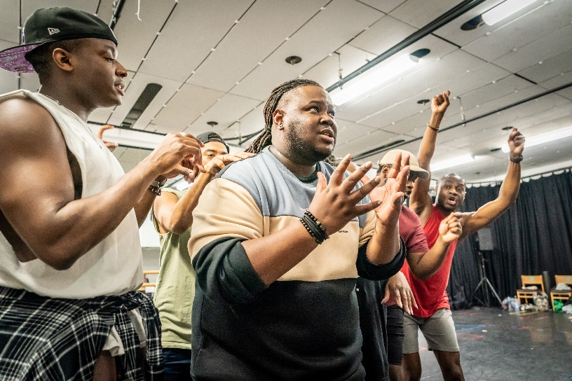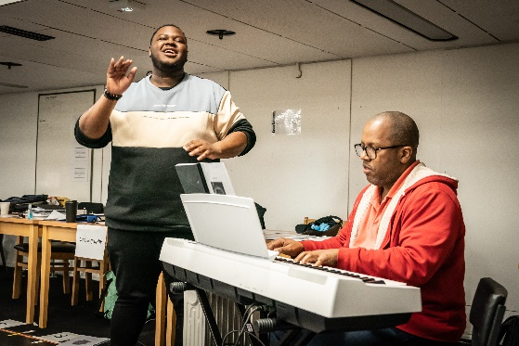

WINNER OF EVERY BEST MUSICAL AWARD ON BROADWAY
INCLUDING THE TONY AWARD AND THE PULITZER PRIZE
BARBICAN THEATRE
17 JUNE – 9 SEPTEMBER 2023

“A dazzling ride. No measure of praise could be too much”
New York Times
“A One-Of-A-Kind Masterpiece”
Vogue

TICKETS ON SALE FROM STRANGELOOPMUSICAL.COM

Final casting and the full creative team is today announced for the London season of the smash-hit musical A Strange Loop, as first-look rehearsal images are released. A Strange Loop is transferring from Broadway to London’s Barbican Theatre for a one-time-only 12-week limited season from 17 June, with a producing team including the National Theatre, Jennifer Hudson and Alan Cumming among others.

The full cast is led by Kyle Ramar Freeman, making his West End debut reprising the role of Usher - which he played on Broadway - who grapples with desires, identity and instincts he both loves and loathes, all brought to life on stage by a hilarious, straight-talking ensemble of ‘Thoughts’.

Thought 1 is Sharlene Hector best known for being a lead vocalist for British band Basement Jaxx, Nathan Armarkwei-Laryea (Women Beware The Devil, Spring Awakening, Hamlet) plays Thought 2, Yeukayi Ushe (The Lion King, Kinky Boots, The Book of Mormon) is Thought 3, Tendai Humphrey Sitima (The Play That Goes Wrong) plays Thought 4, with Danny Bailey (Jesus Christ Superstar, Girl From the North Country) as Thought 5 and Eddie Elliott (Blues for an Alabama Sky, The Lion King and Motown The Musical) playing Thought 6.

Written by Michael R. Jackson and directed by Stephen Brackett, A Strange Loop is choreographed by Raja Feather Kelly, with set designs by Arnulfo Maldonado, lighting by Jen Schriever, sound by Drew Levy, costumes by Jen Schriever and Rona Siddiqui is Music Supervisor.

Michael R. Jackson’s blisteringly funny masterwork exposes the heart and soul of Usher - a young, gay, Black writer who hates his day job, so writes a musical about a young, gay, Black writer who’s writing a musical about a young, gay, Black writer…a strange loop.

Jackson’s critically acclaimed Pulitzer Prize-winning A Strange Loop, was nominated for 11 Tony Awards and winner of every Best Musical award in New York. Only the 10th musical to win the Pulitzer Prize for Drama - with the previous winner being Hamilton - the committee cited the show as a “metafictional musical that tracks the creative process of an artist transforming issues of identity, race, and sexuality that once pushed him to the margins of the cultural mainstream into a meditation on universal human fears and insecurities”.

The New York critics heaped plaudits on this sensational production: The New York Times said the show was a “dazzling ride” and “no measure of praise could be too much”. The Wall Street Journal described the show as “hilarious, intimate and personal” adding that “A Strange Loop is extraordinary in just about every way. It represents theater at its most daring and unexpected”. And Variety summed it up, hailing A Strange Loop as “the most furiously entertaining show on Broadway”.

Michael R. Jackson is a playwright, composer, and lyricist who is a rising star in the world of contemporary writing and quickly gaining recognition as one of the most innovative voices in American theatre. Born and raised in Detroit, Michigan, Jackson moved to New York to attend NYU (New York University), where he began his career as a writer and performer. His writing is already drawing comparisons to other literary greats, and he is quickly becoming recognised as an inspiring and transformative writer in his own right. His next musical, White Girl in Danger, a co-production between the Vineyard and Second Stage, recently opened at New York’s Tony Kiser Theater.

LISTINGS INFORMATION
BARBICAN THEATRE
Previews: From 17 June
Press Night: 29 June at 7.00pm
Tickets: from £20
Performances: Monday - Saturday at 8pm, matinees on Thursday and Saturday at 2.30pm
Age guidance: 16+ (Contains explicit language, references to racism, sexual assault, homophobia and scenes of an adult nature)
For access performances: please visit Strangeloopmusical.com
Running time: 1 hour 40 minutes with no interval

Website: Strangeloopmusical.com
Trailer: A STRANGE LOOP is coming to London! - YouTube
Twitter: @StrangeLoopLDN
Instagram: @StrangeLoopLDN
Facebook: /StrangeLoopLDN
Rehearsal Images: https://www.dropbox.com/scl/fo/pn6ufrf02gjpesd8q2g1f/h?dl=0&rlkey=stvegkpk7zz9of4bbpiypadxv

For further information, please contact:
Esther Beaumont / Neil Reading
Neil Reading PR
020 7839 2277
Esther@neilreadingpr.com

Trafalgar Theatre Productions
Trafalgar Theatre Productions, produces new shows and classic musicals in London, UK nationally and internationally, including the Tony and Olivier award-winning smash hit musical Jersey Boys, now playing at London’s newly renovated Trafalgar Theatre alongside a UK & Ireland Tour, Broadway’s multi award-winning musical, Alanis Morrisette’s Jagged Little Pill, which opened at Trafalgar’s Theatre Royal Sydney in December 2021 and the first major international production of it to open in Australia straight from Broadway without a West End season, a major revival of the award winning classic musical Anything Goes at London’s Barbican Theatre in the summers of 2021 and 2022, starring Sutton Foster, Robert Lindsay, Felicity Kendal and Gary Wilmot, the tenth anniversary UK & Ireland tour of the acclaimed National Theatre production of The Curious Incident of the Dog in the Night-Time, the current 50th Anniversary World Tours of The Rocky Horror Show with numerous engagements in Australia and the UK, the Lincoln Center’s award-winning production of The King and I at the London Palladium and worldwide, and a co-production of War Horse with The National Theatre in Australia and Asia-Pacific.

In the West End, productions have also included On Blueberry Hill, The National Theatre’s A Taste of Honey starring Jodie Prenger, Peter Nichols’ A Day in the Death of Joe Egg starring Toby Stephens, Claire Skinner and Patricia Hodge, Equus by Peter Shaffer, the hit comedy Education, Education, Education, the acclaimed award-winning play Admissions starring Alex Kingston, new British musical Tom Morris’ The Grinning Man, Apologia starring Stockard Channing and Killer Joe starring Orlando Bloom. Other co-productions have included the two sell-out ground-breaking productions: the Bush Theatre’s Misty and National Theatre’s Nine Night.

Co-productions include Good starring David Tennant, Death of a Salesman, The Best Exotic Marigold Hotel, The Starry Messenger starring Matthew Broderick and Elizabeth McGovern at Wyndham’s Theatre, Mary Stuart starring Juliet Stevenson and Lia Williams at the Duke of York’s, and London season of The Messiah starring Hugh Dennis and The Height of The Storm at Wyndham’s Theatre starring Jonathan Pryce and Dame Eileen Atkins.

National Theatre
At the National Theatre we make world-class theatre, and we make it for everyone. We stage over 20 productions at our South Bank home in London each year. Our programme is broad and inclusive, appealing to the widest possible audiences with new plays, musicals, reimagined classics and work or young audiences. Our work is also seen in London’s West End, on tour across the UK and internationally, through National Theatre Live broadcasts and screenings to cinemas around the world, the National Theatre Collection, which makes recordings of shows available to UK schools and the global education sector, and now our streaming platform, National Theatre at Home. Whether you have seen our work many times or are joining us for the first time, we hope you will be entertained, challenged and inspired.

National Theatre Productions
National Theatre Productions (NTP) aims to extend the life of National Theatre productions, without subsidy, in London’s West End, on tour throughout the UK, on Broadway, internationally, and in collaboration with co-producing partners around the world. Since 2009, NTP has transferred 19 productions to the West End, taken six productions to Broadway, toured the UK and Ireland extensively with a broad repertoire of productions originating at the National Theatre on the South Bank, and taken the Olivier and Tony®-Award winning productions of War Horse and The Curious Incident of the Dog in the Night-Time on tour around the globe. National Theatre productions have now been seen across five continents by over 15 million people worldwide.
www.nationaltheatre.org.uk

Barbara Whitman
Barbara Whitman made her Broadway debut producing A Raisin in the Sun, starring Sean Combs, Phylicia Rashad, Audra McDonald, and Sanaa Lathan. Other Broadway credits include Good Night, Oscar starring Sean Hayes, A Strange Loop (Tony and Drama Desk Awards, Best Musical; Pulitzer Prize) Diana – The Musical, Burn This starring Adam Driver and Keri Russell, Angels in America (Tony and Drama Desk Award, Best Play Revival), 1984, The Glass Menagerie starring Sally Fields, War Paint starring Patti LuPone and Christine Ebersole, The Humans (Tony Award, Best Play), Oh, Hello starring Nick Kroll and John Mulaney, Fully Committed starring Jesse Tyler Ferguson, Fun Home (Tony Award, Best Musical), Hedwig and the Angry Inch (Tony and Drama Desk Awards, Best Musical Revival), Of Mice and Men starring James Franco, If/Then starring Idina Menzel, Hands on a Hardbody, Red (Tony and Drama Desk Awards, Best Play), Next to Normal (Pulitzer Prize), Hamlet starring Jude Law, 33 Variations starring Jane Fonda, Mary Stuart, Legally Blonde - The Musical, The 25th Annual Putnam County Spelling Bee, and Dirty Rotten Scoundrels. National tours include Fun Home, Hedwig and the Angry Inch, If/Then, Murder for Two, Next to Normal, Legally Blonde – The Musical, …Spelling Bee, Dirty Rotten Scoundrels and Frost/Nixon. A native New Yorker, Barbara attended NYU's Gallatin School and received an MFA in Theatre Management and Producing from Columbia University. She’s a member of the Board of Governors and the Executive Committee of the Broadway League. She’s also on the Columbia University School of the Arts Dean’s Council.

The Barbican
A world-class arts and learning organisation, the Barbican pushes the boundaries of all major art forms including dance, film, music, theatre and visual arts. Its creative learning programme further underpins everything it does. Over a million people attend events annually, hundreds of artists and performers are featured, and more than 700 staff work onsite. The architecturally renowned centre opened in 1982 and comprises the Barbican Hall, the Barbican Theatre, The Pit, Cinemas 1, 2 and 3, Barbican Art Gallery, a second gallery The Curve, public spaces, a library, the Lakeside Terrace, a glasshouse conservatory, conference facilities and three restaurants. The City of London Corporation is the founder and principal funder of the Barbican Centre.

Find us on Facebook | Twitter | Instagram | YouTube | Spotify

