Thu 23 Mar ’23

Snapshots: Caribbean Cinema Up Close
17–31 May
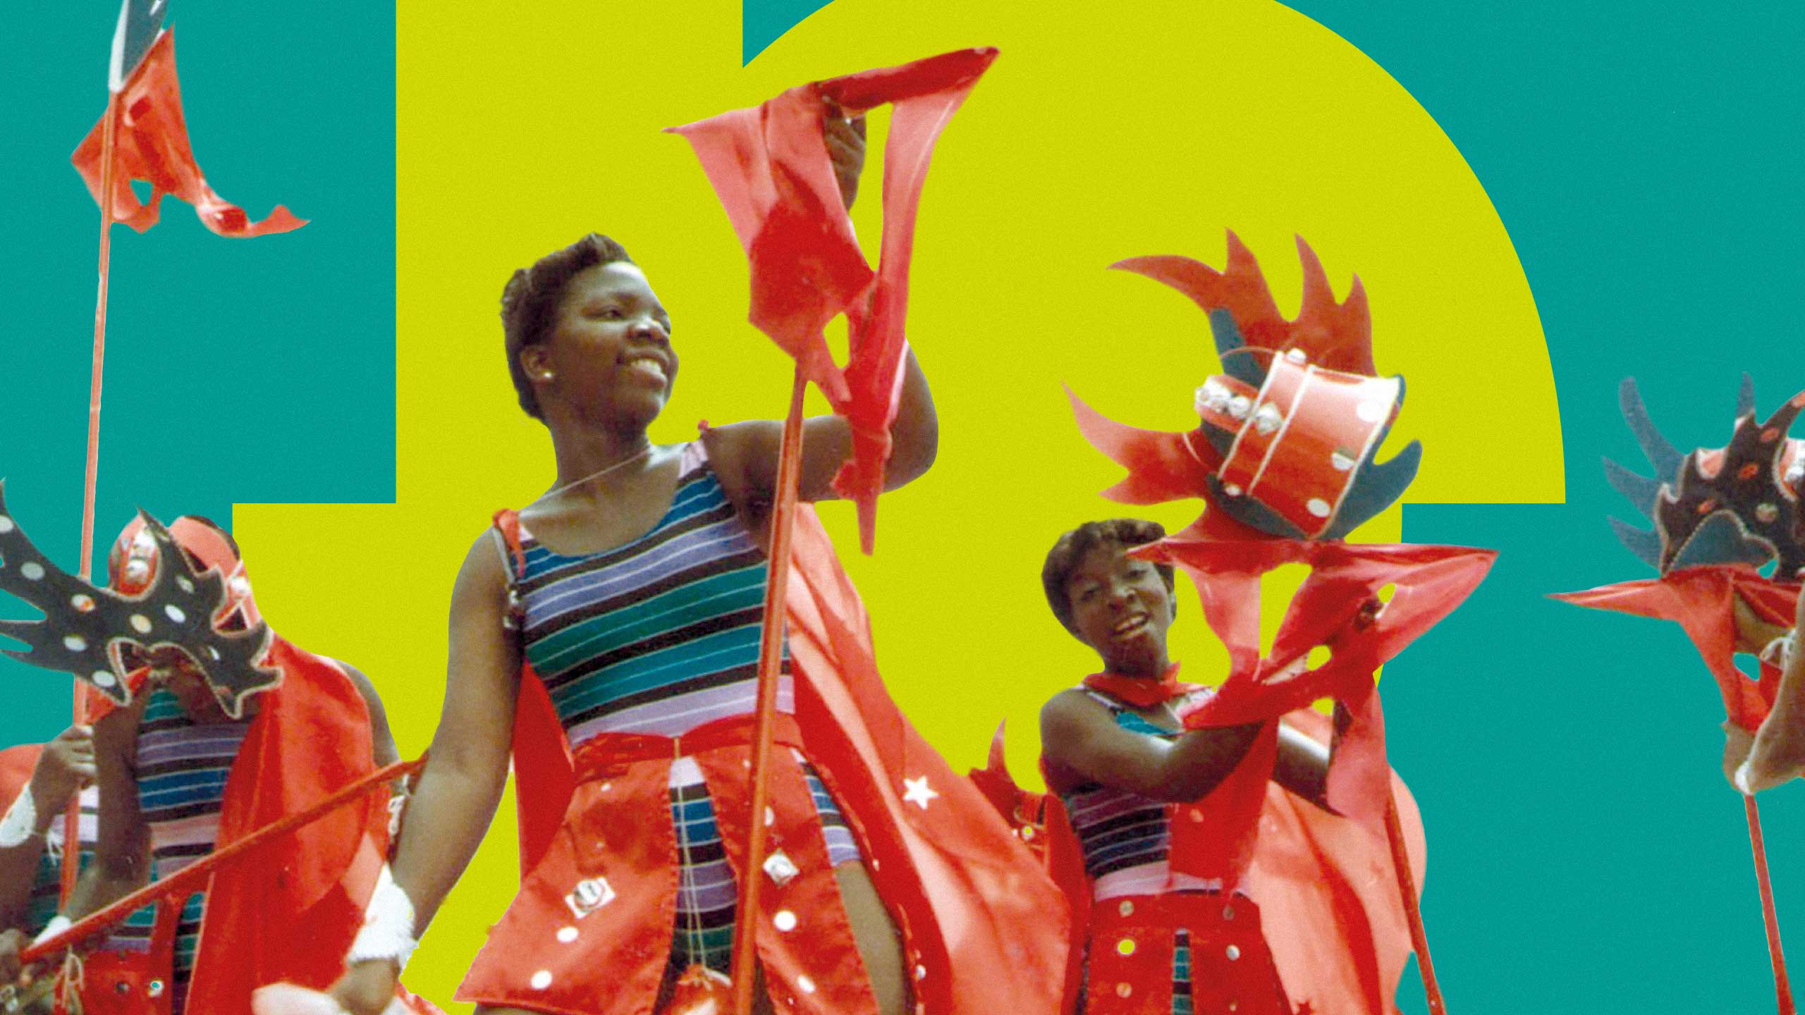
The Barbican is delighted to present a collection of films that offer a rare insight into the flourishing Caribbean film culture. Exploring individual and shared cultural identities, Snapshots: Caribbean Cinema Up Close runs from 17-31 May, and kicks off with a Special Preview of the new restoration of Kavery Kaul’s One Hand Don’t Clap, her upbeat archive documentary which explores the importance of Calypso music and the community around it, and will be followed by a ScreenTalk (via Zoom) with the director.

In the run up to the crowning of Trinidad's 1986 Calypso Monarch, the film follows iconic Calypsonians such as Calypso Rose and Lord Kitchener as they discuss their early careers, and gain access to this beloved genre of music, focusing on the history and the intergenerational aspects of Calypsonian culture. One Hand Don’t Clap screens in a new 4K digital restoration by the Academy Film Archive and the Women’s Film Preservation Fund of New York Women in Film & Television with the support from the Leon Levy Foundation.
The season continues with Currents, a programme of seven shorts by Caribbean filmmakers which explore universal themes of (familial and self) acceptance, overcoming adversity, justice and pride from a uniquely Caribbean perspective.
Snapshots: Caribbean Cinema Up Close closes with writer/director José María Cabral’s Parsley, based on the real story of the Parsley Massacre, a mass killing of Haitians living in the Dominican Republic's north western frontier October 1937. Parsley tells the story of a heavily pregnant Haitian woman left alone in the wilderness near the Dominican border, trying to escape the attack.
Snapshots: Caribbean Cinema Up Close is programmed by Patrice Robinson, who says:
“I am excited, both personally and professionally, to be presenting these films which explore and reflect on the joyous and difficult aspects of life in the Caribbean to audiences. I believe it is important to think about the past when considering the present, and to acknowledge that those who came to the UK have done great things, but that their connection to the Caribbean of today is still present, relevant and impactful. These films have taught me much about this region which is of great importance to me, and I cannot wait to share this with audiences at the Barbican, especially in the lead up to the 75th National Windrush Day on 22 June.”
Patrice Robinson is a graduate of the Independent Cinema Office’s FEDS Scheme; Snapshots: Caribbean Cinema Up Close is her debut curatorial season. With interest in communities, community access to film and the intimacies of the human experience, Patrice is a film programmer and writer working in the intersection of audiences and cinema.
Screenings
One Hand Don’t Clap (*12A) + Zoom ScreenTalk with Director Kavery Kaul
US 1988, Dir Kavery Kaul, 92 mins
Wed 17 May, 6.15pm, Cinema 2
Watch legendary Calypso artists such as the ‘Grandmaster of Calypso’ Lord Kitchener and Calypso Rose championing the next generation of Calypsonians in the run up to the 1986 crowning of Trinidad’s Calypso Monarch.
Currents (*15)
Dir various, 89 min
Wed 24 May, 6.30pm, Cinema 2
A collection of shorts from seven Caribbean filmmakers. Currents explores universal themes of (familial and self) acceptance, overcoming adversity, justice, and pride from a uniquely Caribbean perspective.

The Wound is a Portal
Trinidad and Tobago 2022, Dir Gesiye, 11 min
Filmmaker and artist Gesiye invites 8 Trinidadians to get a tattoo which connects them all, whilst exploring their wider and more personal connection to the island.
Home Movie Tape
Dominica 2022, Dir Michael Lees, 5 min
Collage footage taken during the Covid-19 pandemic in the style of a home movie examines the complexities of life through the eyes and experiences of the filmmaker’s nearest and dearest.
Strictly Two Wheel
Jamaica 2022, Dir Ania Freer, 10 min
Bobo speaks of his two great loves – his children and his bikes. As a highly skilled and respected member of his local community, Strictly Two Wheel portrays a father providing his children with a rich cultural inheritance by passing on his ability to build and mend bicycles.
My Maxi
Trinidad and Tobago 2021, Dir Andrei Pierre, 4 min
Marcus attempts to be open with his parents about his sexuality and identity. A breakthrough conversation alters the dynamic of the relationship held with them in ways he was not expecting.
The Inner View
Trinidad and Tobago 2022, Dir Eric Barry, 9 min
Joshua attends a job interview which leaves him with a decision to make – be honest and stay true to his moral grounding or lie to secure the job. Sugarcake (12 mins) – A chance meeting between two strangers leads to a lifesaving conversation that forces both parties to confront their pre-conceived notions about what makes a good parent. 2021 Jamaica Dir Joshua Paul 12 min
Twa Fèy
Haiti 2020, Dir Eléonore Coyette / Sephora Monteau, 27 min
Initially following Esther, a 6-year-old who faces abuse at the hands of her father, Twa Fèy (three leaves) intertwines the stories of three women, highlighting the power of sisterhood.

Senior Community Screening (60+) One Hand Don’t Clap (*TBC)
US 1988, Dir Kavery Kaul, 92 mins
Mon 29 May, 11am, Cinema 2

Barbican Cinema welcomes its senior audience to a screening of One Hand Don’t Clap – with free tea, coffee and cake post screening.
Parsley (*18)
Dominican Republic 2022, Dir José María Cabral, 83 min
Mon 31 May, 6.30pm, Cinema 2
José María Cabral tells the story of the 1937 Parsley massacre - whereby Haitians living in the Dominican Republic were killed by order of dictator Rafael Trujillo.
Snapshots: Caribbean Cinema Up Close has been developed in association with trinidad+tobago film festival
*local classification certificate
ENDS
Notes to Editors
For further information contact:
Ian Cuthbert, Communications Manager, Cinema
ian.cuthbert@barbican.org.uk / 07980 925 352
Sarah Harvey, Barbican Cinema Press Consultant
sarah@sarahharveypublicity.co.uk / 07958 597 426
Sumayyah Sheikh, Communications Assistant, Theatre & Dance and Cinema:
sumayyah.sheikh@barbican.org.uk
Box office: www.barbican.org.uk
Standard ticket price: £13/ Members: £10.40/ Concessions: £11
Under 18s: £6, Young Barbican: £5
Barbican press room
All Barbican Centre press releases, news announcements and the Communications team’s contact details are listed on our website at www.barbican.org.uk/our-story/press-room

About the Barbican
A world-class arts and learning organisation, the Barbican pushes the boundaries of all major art forms including dance, film, music, theatre and visual arts. Its creative learning programme further underpins everything it does. Over a million people attend events annually, hundreds of artists and performers are featured, and more than 700 staff work onsite. The architecturally renowned centre opened in 1982 and comprises the Barbican Hall, the Barbican Theatre, The Pit, Cinemas 1, 2 and 3, Barbican Art Gallery, a second gallery The Curve, public spaces, a library, the Lakeside Terrace, a glasshouse conservatory, conference facilities and three restaurants. The City of London Corporation is the founder and principal funder of the Barbican Centre.

The Barbican is home to Resident Orchestra, London Symphony Orchestra; Associate Orchestra, BBC Symphony Orchestra; Associate Ensembles the Academy of Ancient Music and Britten Sinfonia, Associate Producer Serious, and Artistic Partner Create. Our Artistic Associates include Boy Blue, Cheek by Jowl, Deborah Warner, Drum Works and Michael Clark. The Los Angeles Philharmonic are the Barbican’s International Orchestral Partner, the Australian Chamber Orchestra are International Associate Ensemble at Milton Court, and Jazz at Lincoln Center Orchestra are International Associate Ensemble.

Find us on Facebook | Twitter | Instagram | YouTube | Spotify
About Barbican Cinema
We connect audiences with a curated programme of international cinema; from celebrated filmmakers to ground-breaking and under-heard voices from past and present.
Our programmes are presented in Cinemas 1 in the main centre and Cinemas 2&3 on Beech Street. We also present selected programmes and new release titles on our online platform Barbican Cinema On Demand which is available to stream across the UK.
Our programme ranges from thematic seasons that respond to today’s world, to new releases, Screentalks, cross-artform collaborations, family events, access screenings and event cinema that presents the performing arts on screen.
We showcase the work of emerging filmmakers, as well as less familiar work of exceptional filmmakers from the UK and around the world.
We champion the work of Barbican young programmers and give stage to emerging musicians in our ongoing film & live music series which includes our flagship collaboration with the Guildhall School of Music & Drama.
As part of a cross-arts centre, our cinemas are a cultural space for people to share the viewing experience. We strive to be inclusive in everything we do; providing platforms for the widest possible range of filmmakers and ensuring we are an open, welcoming and accessible venue for all our audiences. We programme free offsite events in east London, offer reduced price tickets to 14-25 year olds through the Young Barbican membership scheme and special student ticket prices.

