Thu 9 Mar 2023

Chronic Youth Film Festival 2023
22 & 23 Apr, Cinema 2
www.barbican.org.uk/whats-on/series/chronic-youth-film-festival
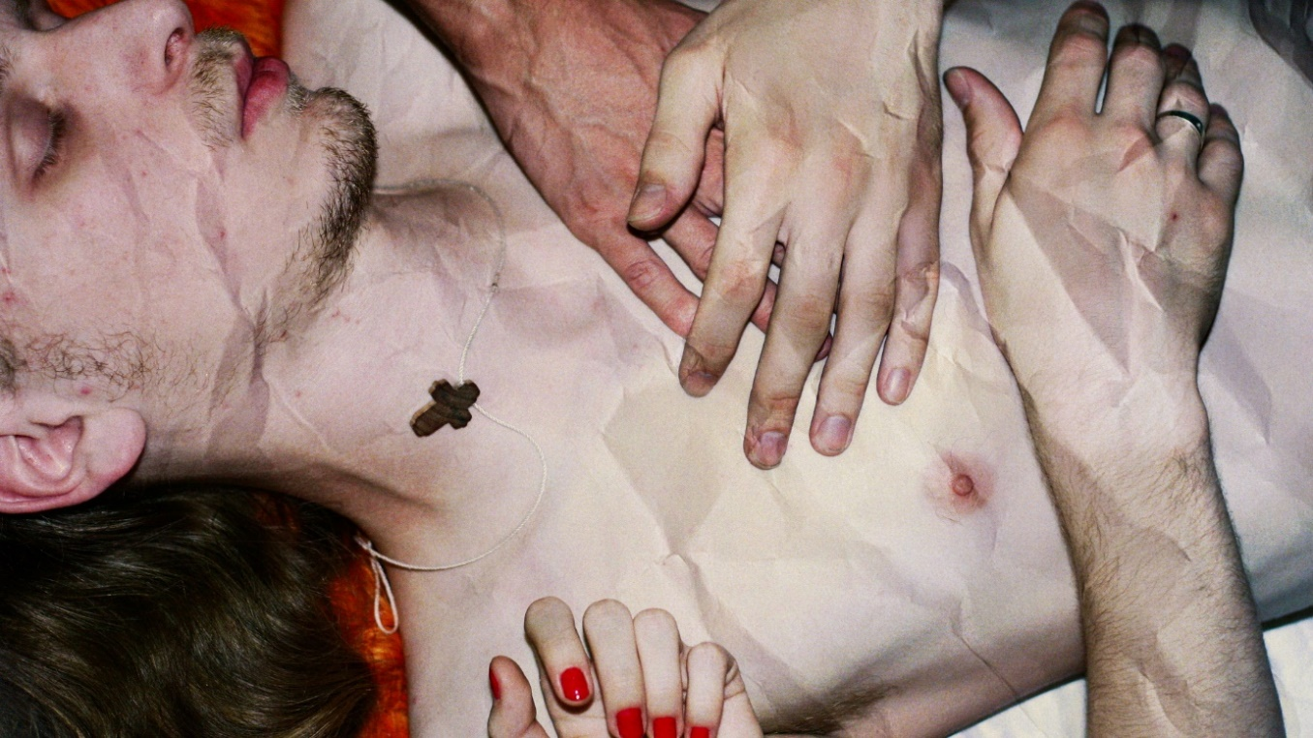
How To Save A Dead Friend (Sweden/ Norway/ France 2022), Dir Marusya Syroechkovskaya

Chronic Youth Film Festival, now in its eighth year, returns to the Barbican with a bold programme that explores the theme A Time and a Place. This is the result of a seven-month collaborative exploration by Barbican Young Programmers aged 16 to 25, who curate and deliver the festival.
The line-up includes new films, ScreenTalks, a British archive film, documentaries and an open-submission shorts programme. The films cover a myriad of issues facing young people today and explore questions around identity, belonging, memory, community and found family.

The Young Programmers comment:
“Tackling the big and the small, the personal and the political, this year’s festival’s array of films couldn't be more different. But they each capture a moment, blips in space and time, that have resonated with each of us, a collective of very different perspectives that have been thrown together. A mix of documentary, fiction and something in between, this year we jump from each scattered pinpoint, and celebrate the different snapshots.”
The festival opens on Sat 22 Apr with A Room of My Own, a tender exploration of female friendship and sexual awakening set in contemporary Georgia, co-written and directed by Ioseb “Soso” Bliadze.
A hit on the international festival circuit, and described by Variety as a “sublimely understated snapshot of a Georgian generation in gentle crisis,” A Room of My Own is Bliadze’ second feature, after his debut Otar’s Death.
The documentary Delphine’s Prayers, directed by Rosine Mbakam, is a portrait of Delphine, a 30-year-old Cameroonian woman now living in Brussels. Like many before her, she belongs to a generation of young African women crushed by patriarchal societies and abandoned to Western sexual colonization as her only means of survival. Through her strength and bravery, she exposes these patterns of domination that continue to lock up African women.
The festival continues with the London Premiere of How To Save A Dead Friend. Filmed over 12 years and pieced together across 8 different formats, it chronicles filmmaker Marusya Syroechkovskaya’s adolescence in Russia’s silenced generation.
Screenings on Sun 23 Apr kick off with Collapse in Time and Place, a collection of shorts from emerging filmmakers, in a range of styles, exploring the ever-changing relationship between place and aspects of identity and community. This will be followed by a ScreenTalk with participating filmmakers.
Sunday afternoon includes the 1986 British archive film The Passion of Remembrance, directed by filmmakers Maureen Blackwood and Isaac Julien who create a visual mosaic to signify the complexity of the black British experience and the often-overlooked intersections between race, class, gender and sexuality.
Chronic Youth Film Festival closes on Sun 23 Apr with Turner Bill Ross’ experiment in docu-fiction Bloody Nose Empty Pockets. In the shadows of the bright lights of Las Vegas, it’s the last call for a beloved dive bar known as the Roaring 20s, which has to close. This is a bittersweet document of real people, facing an uncertain future in a difficult time: America at the end of 2016.

The festival is supported by the Barbican’s Creative Colloboration, Cinema and Marketing teams.

Screenings:
A Room of My Own (15*)
Georgia, 2022, Dir loseb "Soso" Bliadze, 107 minutes
Sat 22 Apr, 1.30 pm, Cinema 2

Tina, sheltered and timid, moves into a hastily organised flat-share with the party-loving Megi, unravelling a story of sexual freedom explored and independence gained in modern-day Tbilisi.

Initially uncomfortable sharing space with her eccentric flatmate, and still fixated on past wounds, Tina lets go of her reservations to learn how to stand on her own two feet. In this story of autonomy, queerness, and the transformative power of desire, the pandemic fades into the background. Ioseb “Soso” Bliadze’s feature is a tender and sensual exploration of love in Georgia.
Delphine’s Prayers (18*)
Belgium/Cameroon, 2021, Dir Rosine Mbakam, 91 minutes
Sat 22 Apr, 3.45 pm, Cinema 2
Rosine Mbakam continues her exploration of diasporic Cameroonian identity in this devastating documentary of a young woman now based in Brussels.
Delphine’s Prayers is a chilling insight into how certain dynamics of power — first, between men and women, then, between coloniser and colony—persist in destroying the lives of many West African women. We hear of this destruction first-hand in an altogether unfiltered monologue from Delphine—thirty, despondent, though not yet embittered; and still with tales to tell.
London Premiere: How To Save A Dead Friend (18*)
Sweden/Norway/France/Germany, 2022, Dir Marusya Syroechkovskaya, 103 mins
Sat 22 Apr, 6.15 pm, Cinema 2
Filmed over 12 years and pieced together across 8 formats, How to Save A Dead Friend chronicles director Marusya Syroechkovskaya’s adolescence in Russia’s silenced generation.

As the ‘Depression Federation’s’ global ambitions take hold, voices are silenced and young people fall through the cracks of a broken society. It is against this backdrop that love blossoms, saving the young filmmaker from joining the country’s daunting suicide statistics. In turn, we learn the lengths she will go to return the favour.
Shorts: Collapse in Time and Place
Dirs various, running time approx.: 64 mins
Sun 23 Apr, 1.45 pm, Cinema 2
A collage of shorts from emerging filmmakers bringing together films exploring the ever-changing relationship between place and aspects of identity.

Through a range of personal and collective journeys, filmmakers seek to navigate the complexities of subjective memories, untold histories and how these shape their communities. Experimenting with forms including archival footage, home movies and animation, the films act as a collapse in temporalities, visually connecting the past with present day issues on an individual and societal scale.

The Passion of Remembrance (15)
UK, 1986, Dirs Isaac Julien & Maureen Blackwood, 96 mins
Sunday 23 Apr, 3.50 pm, Cinema 2

The Sankofa collective’s first feature takes a deep dive into 1980s Black Britain, eloquently distilling tensions of race, gender, and sexuality.

“We haven’t got the space to get it wrong… that’s the problem”. Working through multiple distinct narratives, and combining archival footage, fictional drama, and monologues set within the subconscious, The Passion of Remembrance presents a richly experimental visual mosaic exploring the layers of Black experience.

Bloody Nose Empty Pockets (15)
US 2020, Dirs Turner Ross & Bill Ross IV, 98 mins
Sun 23 Apr, 6.15 pm, Cinema 2

A mesmerising experiment in docu-fiction, Bloody Nose, Empty Pockets is a portrait of the last night of an American dive bar and its patrons, steeped in bittersweet drunken melancholy.

“You don’t have to go home but you can’t stay here” Las Vegas, 2016, and it’s last call for a beloved dive bar in Vegas. Bloody Nose, Empty Pockets is a document of real people in an unreal situation, a triumphant blurring of lines between documentary and fiction, and a heart-wrenching look at what it means to lose a place you love.
ENDS
Notes to Editors
For further information contact:
Ian Cuthbert, Communications Manager, Cinema
ian.cuthbert@barbican.org.uk / 07980 925 352
Sarah Harvey, Barbican Cinema Press Consultant
sarah@sarahharveypublicity.co.uk / 07958 597 426
Sumayyah Sheikh, Communications Assistant, Theatre & Dance and Cinema:
sumayyah.sheikh@barbican.org.uk
Box office: www.barbican.org.uk
Standard ticket price: £13/ Members: £10.40/ Concessions: £11
Under 18s: £6, Young Barbican: £5
Barbican press room
All Barbican Centre press releases, news announcements and the Communications team’s contact details are listed on our website at www.barbican.org.uk/our-story/press-room

About the Barbican
A world-class arts and learning organisation, the Barbican pushes the boundaries of all major art forms including dance, film, music, theatre and visual arts. Its creative learning programme further underpins everything it does. Over a million people attend events annually, hundreds of artists and performers are featured, and more than 700 staff work onsite. The architecturally renowned centre opened in 1982 and comprises the Barbican Hall, the Barbican Theatre, The Pit, Cinemas 1, 2 and 3, Barbican Art Gallery, a second gallery The Curve, public spaces, a library, the Lakeside Terrace, a glasshouse conservatory, conference facilities and three restaurants. The City of London Corporation is the founder and principal funder of the Barbican Centre.

The Barbican is home to Resident Orchestra, London Symphony Orchestra; Associate Orchestra, BBC Symphony Orchestra; Associate Ensembles the Academy of Ancient Music and Britten Sinfonia, Associate Producer Serious, and Artistic Partner Create. Our Artistic Associates include Boy Blue, Cheek by Jowl, Deborah Warner, Drum Works and Michael Clark. The Los Angeles Philharmonic are the Barbican’s International Orchestral Partner, the Australian Chamber Orchestra are International Associate Ensemble at Milton Court, and Jazz at Lincoln Center Orchestra are International Associate Ensemble.

Find us on Facebook | Twitter | Instagram | YouTube | Spotify
About Barbican Cinema
We connect audiences with a curated programme of international cinema; from celebrated filmmakers to ground-breaking and under-heard voices from past and present.
Our programmes are presented in Cinemas 1 in the main centre and Cinemas 2&3 on Beech Street. We also present selected programmes and new release titles on our online platform Barbican Cinema On Demand which is available to stream across the UK.

Our programme ranges from thematic seasons that respond to today’s world, to new releases, Screentalks, cross-artform collaborations, family events, access screenings and event cinema that presents the performing arts on screen.
We showcase the work of emerging filmmakers, as well as less familiar work of exceptional filmmakers from the UK and around the world.
We champion the work of Barbican young programmers and give stage to emerging musicians in our ongoing film & live music series which includes our flagship collaboration with the Guildhall School of Music & Drama.
As part of a cross-arts centre, our cinemas are a cultural space for people to share the viewing experience. We strive to be inclusive in everything we do; providing platforms for the widest possible range of filmmakers and ensuring we are an open, welcoming and accessible venue for all our audiences. We programme free offsite events in east London, offer reduced price tickets to 14-25 year olds through the Young Barbican membership scheme and special student ticket prices.

