Barbican images – Our Time on Earth, Barbican 5 May-29 Aug 2022
Press image request form

To request high res images or for any other questions, please contact Anna Dabrowski anna.dabrowski@barbican.org.uk 07921219144

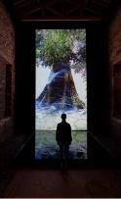  01. Marshmallow Laser Feast and Andres Roberts collaborate on new work in Our Time on Earth, Barbican, London,  Image: 'Previous work by Marshmallow Laser Feast; Observations On Being, Coventry City of Culture 2021. Installation image of We Live in an Ocean of Air Video Edition  Photo by David Levene | 02. Brigitte Baptiste, Colombian Biologist, working with IoDF (Institute of Digital Fashion) on new commission Queer Ecology in Our Time on Earth, Barbican, London. Credit: Max Morales | 03. Etta Madete , design architect working with BuildX Studio on new commission in Our Time on Earth, Barbican, London. Credit: Natasha Sweeney | 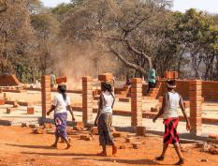  04. BuildX Studio, curated by Carolina Larrazabal & Etta Madete on new commission in Our Time on Earth, Barbican, London.  Image: Building Sachibondu Hospital, Zambia. Credit: BuildX Studio
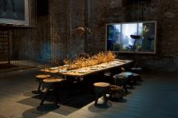  05. Superflux Refuge for Resurgence on display at Our Time on Earth, Barbican, London.  Image: installation at Arsenale Corderi, Venice Biennale in 2021. Credit: Giorgio Lazzaro. | 06. Eyes as Big as Plates by Finnish-Norwegian artist duo Riitta Ikonen and Karoline Hjorth, will be on display as part of Our Time on Earth, Barbican, London,  Credit: Eyes as Big as Plates # Sinikka (Norway 2019) © Karoline Hjorth & Riitta Ikonen | 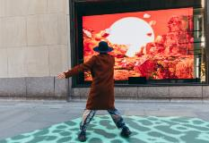07. Tin & Ed’s Life Forces will be on display at in Our Time on Earth, Barbican, London.  Image: Life Forces, Rockefeller Center, New York, 2021. Credit: Rockefeller Center | 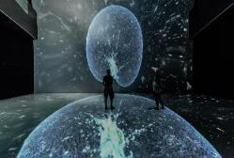  08. Noise Aquarium will be on display at in Our Time on Earth, Barbican, London  Image: NOISE AQUARIUM, Victoria Vesna / Angewandte Scientific Visualization Lab, 8K Deep Space, Ars Electronica. Linz, Austria 2018. photo: Glenneroo
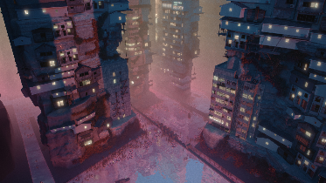09. Liam Young ‘s Planet City on display at Our Time on Earth, Barbican, London.  Credit: Liam Young | 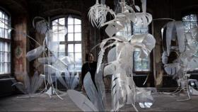  10. Wither by Thijs Biersteker on display at Our Time on Earth, Barbican, London.  'Wither' (2021) by Thijs Biersteker. Staatliche Kunstsammlung Dresden, Germany 2021. Credit: Thijs Biersteker. | 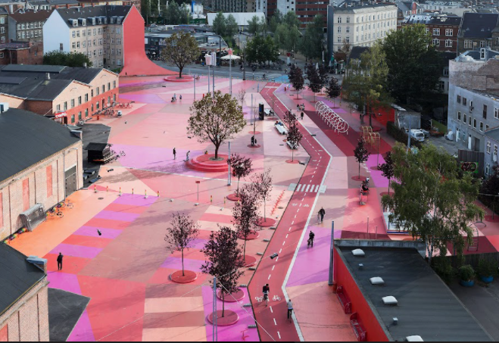  11. A new commission The Ideal City from SPACE10 in partnership with Modem will be on display at Our Time on Earth, Barbican, London.  Image: Iwan Baan© | 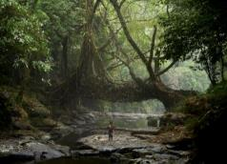  12. Representatives from the Khasis community in the North-eastern Indian state of Meghalaya collaborate with Julia Watson and Maria Smith for a new commission for Our Time on Earth, Barbican, London.  Image: A young fisherman walks under a  living root bridge at Mawlynnong village,  India. The Khasi people have used the trainable roots of rubber trees to grow Jingkieng  Dieng Jri living root bridges over rivers for  centuries. Credit: © Amos Chapple
13. George Mombiot
George Monbiot working with Holition on Soil, a new commission for Our Time on Earth, Barbican, London.
Image: Dave Stelfox©

