FAQs

What art forms does Open Lab support?
Open Lab is for artists from all performing arts disciplines and those who are working on interdisciplinary performances. You will be supported by the Theatre and Dance team whose main expertise is in theatre, dance, live art and circus. Information about our previous Open Lab cohorts can be found on the website https://www.barbican.org.uk/take-part/emerging-practising-artists/open-lab/theatre-and-dance

What kinds of performance are you interested in?
Any! Your proposal does not have to be for a traditional ‘end-on’ performance. We are open to proposals using any form, whether that be radio, podcast, audio trail, gaming, one on one performance, installation or something we have never even come across before! Do consider though that the lab week in the Pit is a key part of our offering so you will want to give some thought to how this resource can best benefit the development of your idea.

What kinds of proposals are unlikely to be successful?
We are unlikely to support your proposal if:
- The proposal doesn’t engage with the four aims of Open Lab (new voices, new audiences, new ideas, new challenges)
- You are a playwright looking for support in the development or staging of a new script
- You are in full time education
- You are living outside the UK
- You are making a show for the first time
- You are already a well established artist, for example:
  - You have already had more than one main stage show at a leading large scale venue (800 seats or more)
  - You are or have previously been an Arts Council National Portfolio Organisation
- Your proposed production has already had a full public performance and you aren’t able to demonstrate how further development would be of real benefit.

I have applied in previous years can I apply again?
Every year we receive many strong applications so please do not be disheartened if you have not been shortlisted in the past, we encourage you to reapply.

Can I apply with more than one proposal?
If you have more than one idea that fits the criteria then you may submit applications for both.

I have already undertaken an R&D/work-in progress-sharing/rehearsed reading of this project, is it still eligible?
Yes, all of these are fine. However, proposals that have already had a full, public performance are unlikely to be successful unless you are able to demonstrate how further development would be of real benefit.

Can I get feedback on an unsuccessful application?
Due to the volume of applications, we receive we regret that we are not able to offer feedback for expressions of interest. However, anyone who progresses to the second stage will be given feedback if they would like it.

Can I discuss my application with you before I apply?
Yes, if you have specific questions please email theatre@barbican.org.uk. We are also happy to receive invitations to see performances by artists or companies who are thinking of applying, although it will not always be possible for us to attend.

Is there a timeline for when the project should be completed?
Open Lab is a research and development opportunity and there is no expectation of a final show or completed work at the end of the programme. We find that this takes the pressure off the development of the idea and allows you to focus on experimenting further.

Is there an opportunity to perform / share my work?
At the end of the programme, there will be an opportunity to share your work or findings. We invite successful applicants to consider methods of sharing which would be beneficial to their project and are open to suggestions. This is not a requirement, but many artists find it useful.

Can I apply for additional funds to support the performance?
We encourage successful Open Lab artists to seek additional support from Art Council or beyond to supplement the resources we are offering. We can provide a full list of in-kind support for inclusions in applications as well as a supporting statement and advice.

The Pit

The Pit is a studio theatre space, which is usually configured as single sided raked seating with 150 seats but can accommodate other configurations. The dimensions of the space without seats are 15m x 13.5m. The height is only 4.5 metres at its highest so the possibilities for aerial work are limited.

Working Hours
Usual working hours for a lab week would be Monday to Friday between the hours of 10am and 6pm, with an hour lunch break 1-2pm.

Barbican staff
In your Lab week we can provide world-class technical support, working with a Lighting, Stage and Sound & AV technician. Prior to your Lab week we will endeavour to conduct a production meeting in which we will discuss any technical requirements and any technical hires there might be as well as going through the Technical Specification document for the space.

Equipment
We have a large stock of lighting and sound equipment as well as a modest budget to hire more specific equipment if needed. If you would like to see a floor plan, full equipment list or discuss your technical specifications in advance of making an application please email theatre@barbican.org.uk.

Photos

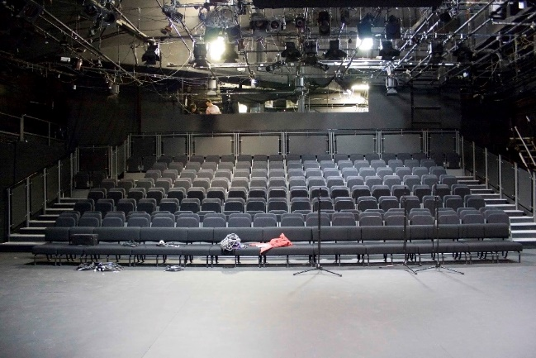
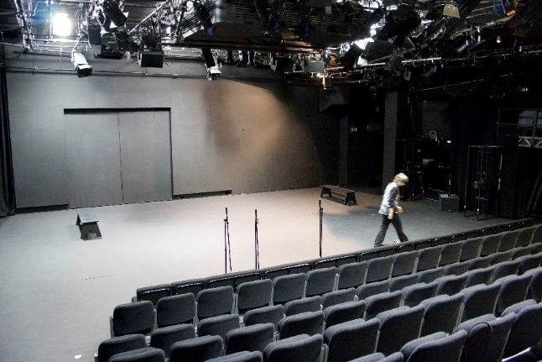

Access Guide

This guide should provide you with information you need to make your time with us at Barbican Theatre as smooth as possible.
If you want to let us know of any specific access requirements, or have any questions relating to access, please get in touch: theatre@barbican.org.uk.

Contents:
- Getting to the Barbican
- Accessible Parking
- Building and Lift Access
- Backstage Barbican
- Accessible Performance Guide
- Harassment & Abuse of Power
- J9 Venue

- Getting to the Barbican
The address for heading to the Barbican is below:
Theatre Stage Door
Barbican Theatre
Silk Street
London
EC2Y 8DS

The nearest underground stations to the Barbican Centre are the Barbican (5 mins walk), or Moorgate (5 mins walk). Please refer to the map on the last page for the location of these and other stations.

- Accessible Parking
The Barbican Centre is signposted on all main roads into the City. The car parks are off Silk Street and off Beech Street (westbound access only). There is a headroom restriction of 1.85m. All car parks stay open until midnight. The easiest access into the Barbican is from Car Park 3 or Car Park 5, both of which have blue badge parking bays.
If you require a parking space for the duration of your visit, please let us know and we can arrange one for you.

- Building Access
Upon arrival at the Barbican, we ask that you head to our Theatre Stage Door.
There is a wheelchair platform lift at Stage Door. Upon entry, you will be greeted by one of our Stage Door Keepers at the reception desk. They will ask you to sign in and they will call your main contact at the Theatre to let them know you’ve arrived. They will issue you with a pass, we ask that you show your pass and sign in and out every time you enter or exit the building on the lists provided for fire safety reasons.
You can contact Stage Door on +44 (0)20 7628 3351. The Stage Door is usually open from 8.30am-11pm Monday to Saturday. Stage Door will of course be open on Sunday if there is a show.

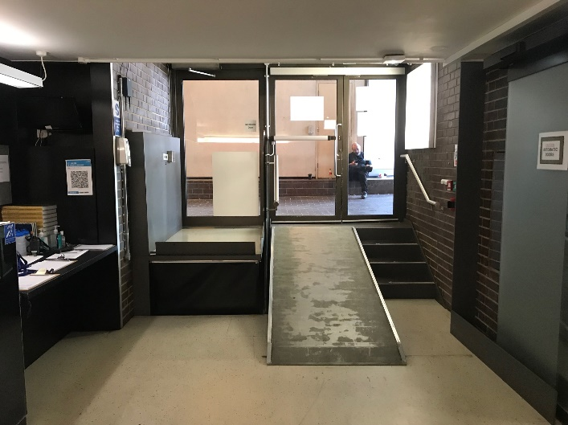
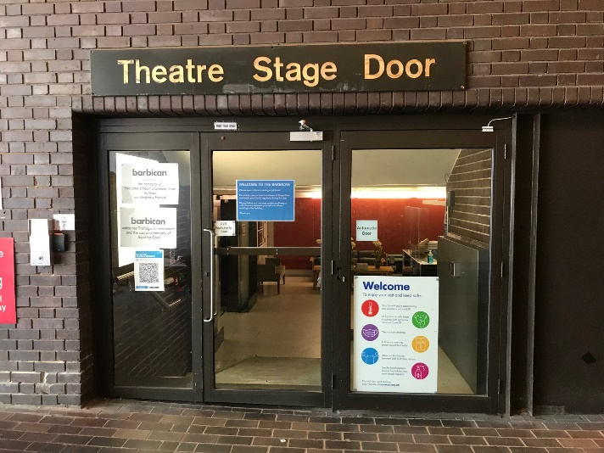

Lifts
Barbican’s backstage has 2 accessible lifts.

- Backstage Barbican
Toilets
Our accessible toilet / wet room facility includes a right hand transfer toilet and shower with fold up seat. A mobile hoist is also available. The door is locked by pushing a button inside.
This toilet / wet room is situated on Level A in the Theatre building and can be reached via the lift from Stage Door.
We have gender-neutral toilets available on Level A.

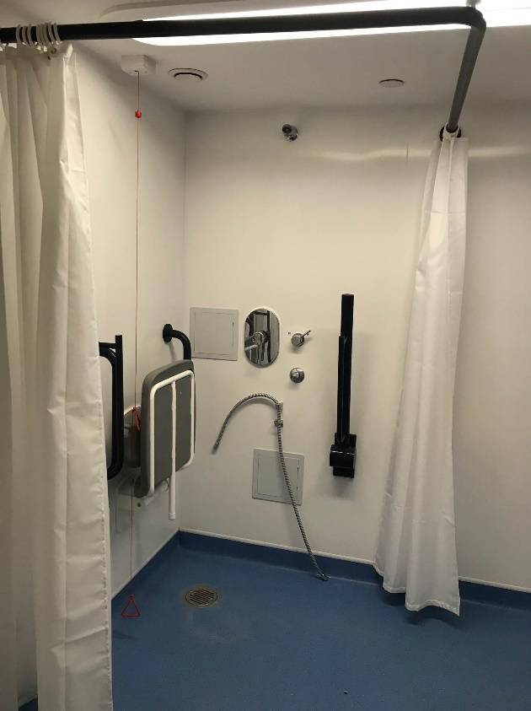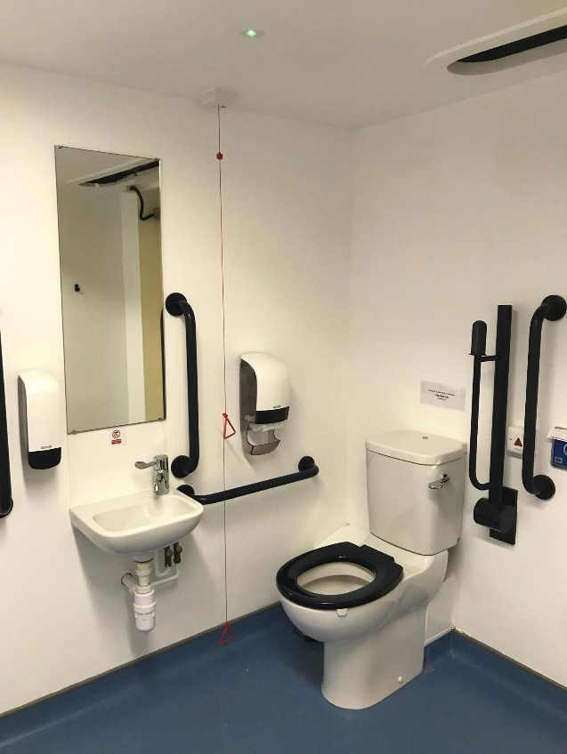

Accessible Dressing Room
Our accessible dressing room facility includes a mobile hoist, low dressing table (62cm to bottom edge, 75cm to top edge) and grab rails and a bench. The door is locked by pushing a button inside.
This dressing room is situated on Level A in the Theatre building and can be reached via the lift from Stage Door.

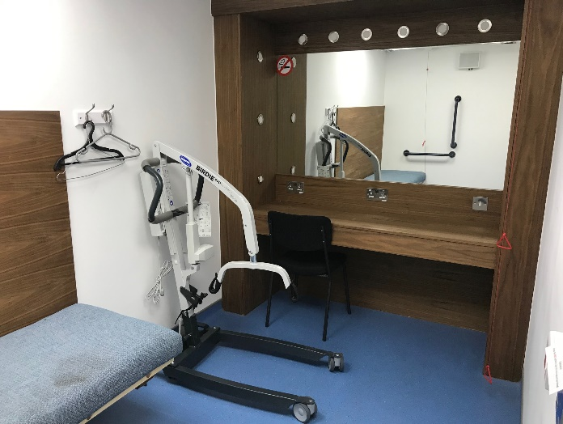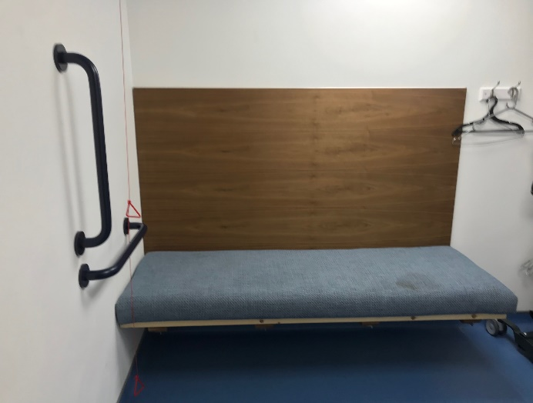

Chill-Out Space
Our recently renovated chill-out space is designed to accompany our relaxed performances at Barbican and be a space where audience members can go to should they need. However, we are also happy for visiting companies to use it should you need to have a space to rest.
It includes a sofa, soft furnishings, neutral lighting and bean bags.
We ask that no food or drink is consumed in the chill-out space and that it is left in the condition it was found in as this is a space open to our audiences.

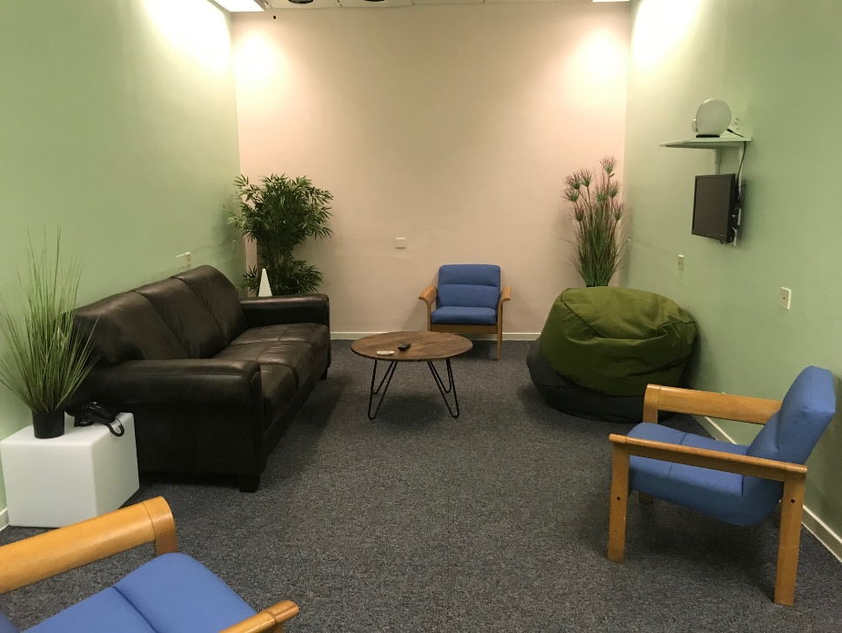

Changing Places facility
We have a Changing Places facility located within the Beech Street Cinema complex for the use of people who require additional space and equipment for support with personal care. The facility includes a height adjustable bench, tracking hoist system, a centrally placed toilet, a height adjustable basin and a shower.

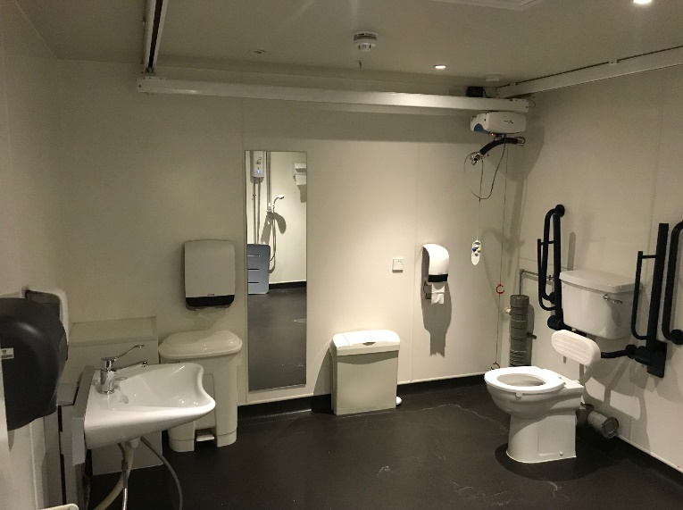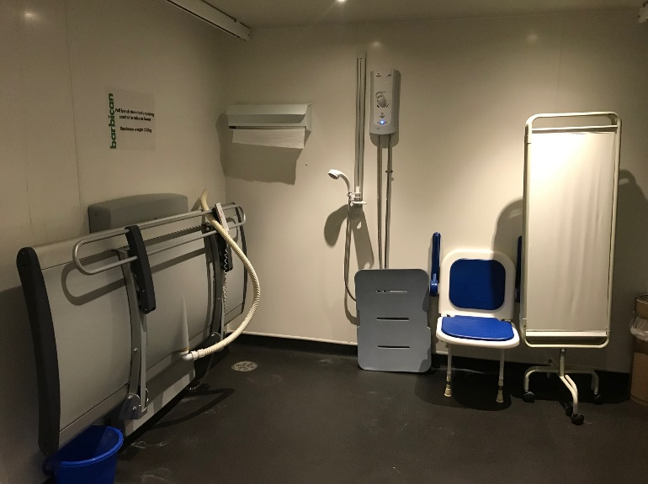

- Harassment and Abuse of Power
The Barbican is committed to providing a safe place for all staff and artists to work where everyone is respected and listened to. As part of this commitment, we are clear that there is no place for any kind of harassment, bullying, victimisation or abuse of power in the workplace and have introduced contract clauses for visiting companies and artists to ensure everyone working at the Barbican is treated with dignity and respect.
If you experience or witness any kind of unacceptable behaviour while working at the Barbican, please inform a Barbican Producer or Stage Manager. All reports will be treated seriously and confidentially.

- J9 Venue
The Barbican is a registered J9 venue. This national initiative aims to provide safe and secure opportunities for people to disclose domestic abuse and access a full support system. Dedicated Barbican staff at each J9 contact point around the Centre are trained to signpost, advise, and spot the signs of domestic abuse. Professional counselling is not available on the premises but we do provide a safe place where people can access information and use a phone to call for further help. J9 contact points at the Barbican are designated by the Pink Heart sign.

