FOR IMMEDIATE RELEASE
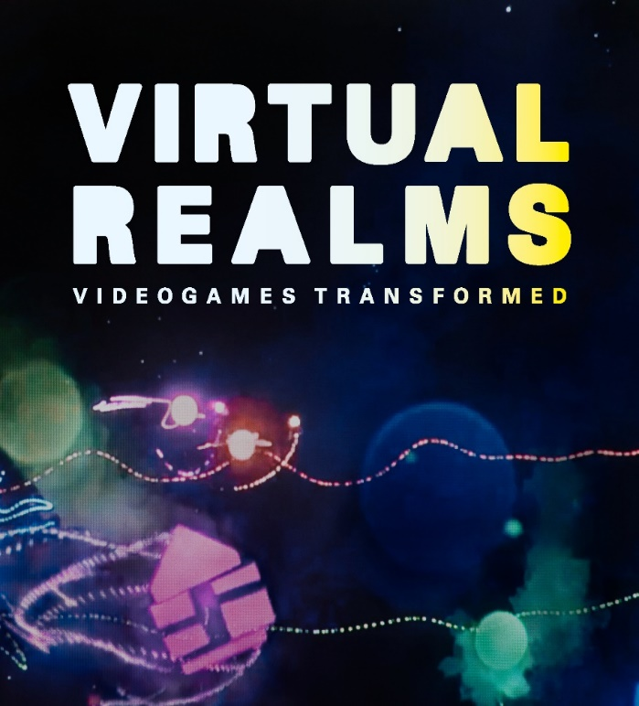

A new exhibition, produced by the Barbican will premiere at ArtScience Museum at Marina Bay Sands in Singapore on 12 June 2021. Virtual Realms: Videogames Transformed organised and curated by Barbican International Enterprises in a co-production with ArtScience Museum and Melbourne Museum, radically reimagines videogames as immersive audiovisual experiences for a gallery space.

Nearly two decades on from the Barbican’s celebrated Game On exhibition, a showcase on the history of videogames, Virtual Realms redefines videogame creativity and explores how we can play collaboratively across virtual and physical realms. With celebrated game designer Tetsuya Mizuguchi as the guest curator, the exhibition invites audiences to experience six new interactive experiences that have been conceived by leading videogame developers, working in partnership with media designers.

Barbican International Enterprises (BIE) is a world leading creator of internationally touring exhibitions and experiences that aim to reframe visitors understanding of familiar subjects and explore some of the most challenging and inspirational topics in the world today. ​​

With a focus on contemporary culture, emerging technology and digital creativity, BIE create holistic environments in which contemporary art, immersive experiences, historical artefacts, design, videogaming, and music provide the platform for a creative exploration of essential narratives. Previous shows by the team include AI: More than Human (2019), Into the Unknown: A Journey through Science Fiction (2017), and Digital Revolution (2014).

Please see further details on the exhibition in ArtScience Museum’s press release.

Virtual press conference information

Date: 9 June, Wednesday
Time: 10am – 11am (UK time) / 5pm – 6pm (Singapore time)
Spokespersons: Patrick Moran, Co-curator and Acting Co-Head, Acting Head of Barbican International Enterprises
Tetsuya Mizuguchi, Co-curator and Founder and CEO of Enhance
Honor Harger, Executive Director, ArtScience Museum

To register your interest or for more details please contact:
Anna Dabrowski (Barbican) anna.dabrowski@barbican.org.uk
Dawn Wang (ArtScience Museum) dawn.wang@marinabaysands.com
Gladys Sim (ArtScience Museum) gladys.sim@marinabaysands.com

ArtScience Museum presents the global premiere of Virtual Realms: Videogames Transformed

Co-curated by celebrated videogame designer
Tetsuya Mizuguchi, this multi-sensorial exhibition
re-imagines videogames as a 21st century artform

SINGAPORE (12 May 2021) – Videogames take centre stage at ArtScience Museum, in a new major exhibition, Virtual Realms: Videogames Transformed. Making its global premiere in Singapore on 12 June, Virtual Realms is curated and organised by the Barbican in co-production with ArtScience Museum and Melbourne Museum.

Co-curated by celebrated Japanese videogame designer, Tetsuya Mizuguchi, Virtual Realms is a multi-sensorial exhibition that re-imagines videogames as a 21st century artform. The exhibition brings together interactive works by six of the world’s leading videogame developers, who have collaborated with top media design studios to create a series of large-scale, immersive installations.

The game developers at the centre of the exhibition are KOJIMA PRODUCTIONS (makers of the hit game DEATH STRANDING), Enhance (Tetsuya Mizuguchi and team behind Rez Infinite and Tetris Effect), thatgamecompany (authors of the meditative games Sky: Children of the Light and Journey), Tequila Works (the studio that made Deadlight and RiME), Media Molecule (creators of LittleBigPlanet and Dreams) and David OReilly (artist and creator of the games Everything and Mountain). They have partnered with media artists and design studios, Rhizomatiks, FIELD.IO, The Mill, Marshmallow Laser Feast, onedotzero and The Workers to make six new commissions that transport videogames from the screen into the galleries.

“We are delighted to be working with the Barbican in London on the world premiere of this extraordinary new exhibition at ArtScience Museum. Perfectly aligned with ArtScience Museum’s mission to explore the intersection of art, science, culture and technology, Virtual Realms brings cutting-edge videogames into a museum setting. It enables visitors to step inside worlds created by renowned videogame developers. The six newly commissioned artworks at the heart of the exhibition take the form of stunning participative installations. By extending the story worlds, aesthetics and interactivity of well-known videogames into spatial environments, the exhibition offers a different kind of museum experience. It invites visitors to venture on a journey of light, music, contemplation and play, experiencing how contemporary videogames have become a truly 21st century cultural phenomena,” said Honor Harger, Executive Director of ArtScience Museum.

“By creating these exciting new collaborations, Virtual Realms offers game developers a unique opportunity to break free from the constraints of consoles and formal game playing and really push the boundaries of how videogames can be experienced together. This exhibition paves the way for a future where the world of games spills out beyond the screen.”, said Tetsuya Mizuguchi, Co-Curator of Virtual Realms and Founder of Enhance

” Over 20 years since the Barbican launched Game On, it is hugely exciting to be returning to the subject of videogames in such an ambitious fashion. In Virtual Realms, Tetsuya Mizuguchi and the design teams have established new, playful and experimental approaches to contemporary videogames as a medium. Six of the world’s leading game developers have collaborated with cutting edge media designers to create these immersive interactive experiences, celebrating collaboration and creativity across the artforms. My thanks to our co-producing partners, ArtScience Museum and Melbourne Museum and the incredibly talented artists designers for sharing and supporting our vision for Virtual Realms.”, said Patrick Moran, Co-curator and Acting Co-Head, Acting Head of Barbican International Enterprises.

Inside the Virtual Realms

Each of the six new commissions is a kaleidoscopic realm driven by a unique theme. The thematic focus of the six virtual realms is: SYNESTHESIA, UNITY, CONNECTION, PLAY, NARRATIVE, EVERYTHING.

SYNESTHESIA

Rezonance, 2021
By Enhance (game developer) and Rhizomatiks (media designer)

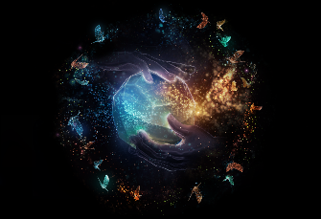
Photo credit: Rezonance, Enhance and Rhizomatiks, 2021

The first realm of the exhibition looks at synesthesia – the neurological phenomenon in which one’s senses will be transported to new dimensions where sound can be ‘seen’ and visuals can be ‘heard’ and ‘felt’.

Tetsuya Mizuguchi has explored the potential of synesthesia since his 2001 game, Rez. Unique among videogame designers, this interest has led to some of the most critically acclaimed titles in the medium, Rez Infinite (2016) and Tetris Effect (2018). Acclaimed Japanese artistic research collective, Rhizomatiks created the Tokyo segment of Olympics’ closing ceremony in Rio De Janeiro in 2016. They also made the world’s first live streamed 360º virtual reality performance for singer, Björk.

Mizuguchi’s experiments with synesthesia have been expanded into a large-scale format, resulting in the new installation, Rezonance (2021). Upon entering the SYNESTHESIA realm, visitors will be part of the pulsing rhythmic beat and become a ‘traveller’ on the Rezonance journey. It allows visitors to encounter this sensorial state as a shared experience. Using light, sound and technology developed specifically for this exhibition, Enhance and Rhizomatiks have created an unexpected synesthetic encounter, which will transport visitors to other worlds and dimensions.

UNITY

Together: the distance between (us), 2021
By thatgamecompany (game developer) and FIELD.IO (media designer)

Photo credit: Together: the distance between (us), thatgamecompany and FIELD.IO, 2021

In the UNITY realm, the dreamlike world of thatgamecompany’s Sky: Children of the Light (2019) has been transformed into an immersive spatial environment. As one moves beneath the circular light-sculpture, music and audio fragments from the game, Sky, are triggered and a choreography of light sequences unfold.
Working with creative studio FIELD.IO, thatgamecompany presents Together: the distance between (us) (2021), an immersive experience where visitors become players in an all-encompassing generative instrument. Visitors will explore the relationship between movement, light and sound as their presence and participation will influence the composition of the space.

CONNECTION

WALL, 2021
By KOJIMA PRODUCTIONS (game developer) and The Mill (media designer)

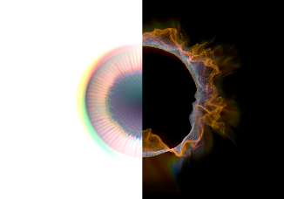
Photo credit: WALL, KOJIMA PRODUCTIONS and The Mill, 2021

Tokyo-based videogame developer KOJIMA PRODUCTIONS, has partnered with the global production studio, The Mill to create, WALL (2021). The Mill is best known for their stunning digital effects and immersive, interactive experiences across the advertising, marketing and film industries.

The key theme of human connection in KOJIMA PRODUCTIONS’ latest game, DEATH STRANDING (2019), has been reimagined for the WALL experience. With a soundscape inspired by DEATH STRANDING, visitors will be transported into an unfamiliar environment where a wall is the only channel of connection to two opposing worlds – one alive with biological cells and the other flowing with galactic energy particles.

As visitors approach the wall, the cells and cosmic particles will respond to their presence, dividing and clustering with one’s movement. The mesmerising patterns that form will offer hints of communication between different spaces and time. Whilst technology can isolate us, WALL demonstrates its potential to create connections in ways that were never previously possible.

PLAY

Dream Shaping, 2021
By Media Molecule (game developer) and Marshmallow Laser Feast (media designer)

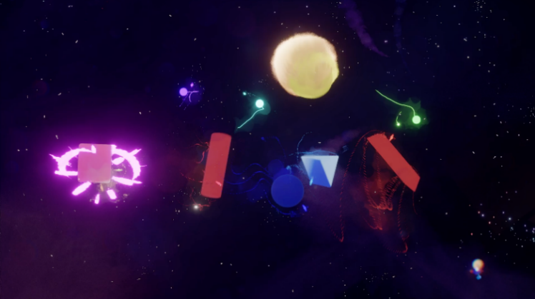
Photo credit: Dream Shaping, Media Molecule and Marshmallow Laser Feast, 2021

The realm of PLAY celebrates the joyful and performative sensibilities that videogames inspire in us, their players. It takes the form of a giant play-space where visitors experiment in both the physical and virtual worlds. Equipped with tracking helmets and a selection of oversized soft geometric forms, participants become part of an improvised performance while other curious visitors look on.

Media Molecule’s vast digital toolset, Dreams (2020) empowers makers to build and share their creations whether games, music, art or animation. Based on Dreams, the installation Dream Shaping (2021), invites visitors to work together to create and manipulate their custom experience. Marshmallow Laser Feast’s acclaimed artistic work, which experiments with making the digital ‘tactile’, has further enhanced the installation, resulting in a uniquely playful experience.

NARRATIVE

Book of Sand, 2021
By Tequila Works (game developer) and The Workers (media designer)

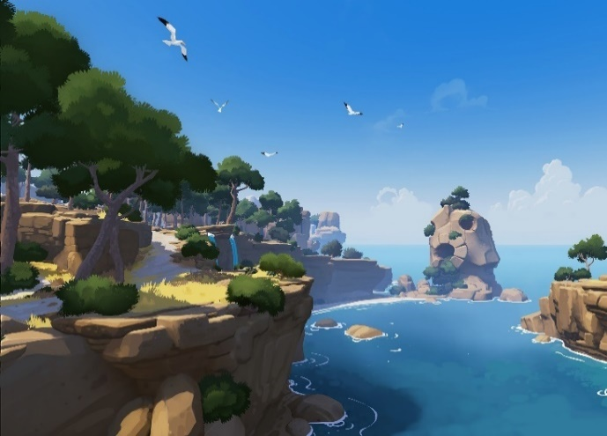
Photo credit: RiME © 2017 Tequila Works. All rights reserved.

The NARRATIVE realm showcases the power of videogames to tell stories and create new forms of fiction. The commission, Book of Sand (2021) invites visitors to step into the mysterious Mediterranean world from RiME (2017).
Inspired by the novella, Book of Sand (1975) by Jorge Luis Borges, the installation explores the notion of an infinite story that has neither a beginning nor an end. Visitors are to follow the lead of the spotlights by stepping into the light to trigger changes on the screen, such as the crumbling of statues or shifting night into day. Depending on the choices made and the collaborations between players, each rendition of the narrative will differ.

EVERYTHING

Eye, 2021
By David OReilly (game developer) and onedotzero (media designer)

Photo credit: Eye, David OReilly and onedotzero, 2021

This realm is inspired by Irish artist David OReilly’s game, Everything (2017), that celebrates the capacity of videogames to generate expansive universes and gives shape to the infinite potential of our imagination. Everything is a meditative and reflective world conveying the Buddhist concept of inter-connectedness.

Working with onedotzero, OReilly has created Eye (2021), a unique interactive environment controlled by visitors, where forms of life self-organise into kaleidoscopic patterns. Eye takes visitors on a visual journey through time, from the Big Bang through to the end of the universe. Visitors can direct elements of the video using giant interactive controllers, or lounge on soft spongy seating, listening to the synchronised soundtrack from the London Symphony Orchestra and bathing in the psychedelic wonder of the space.

Exhibition Design

The exhibition design for Virtual Realms has been created by Chiara Stephenson. Chiara Stephenson is a scenographer with a background in stage design for theatre, ballet and live music events. For this exhibition, Chiara has collaborated with graphic design studio Stinsensqueeze to create the environmental design that ties the commission spaces together and invites audiences to learn more about the commissions through video and wall text. She also collaborated with theatre and music lighting designer Matt Daw to create the surreal colour palettes that infuse the exhibition space. Their design is complete with geometric structures that stand as portals into the commission realms and encourage a spirit of discovery and play throughout the exhibition.

The musician and composer Erland Cooper has created a binaural, ambient score for the entrance of the exhibition, weaving sounds together from each of the realms to create a fabric that offers a glimpse into its multiple landscapes and gradients that follow. A catalogue for the exhibition, designed by Stinsensqueeze and featuring behind-the-scenes images of the commission in progress as well as stills from the celebrated videogames and installation shots of the final works will be released in July 2021.

Supporters
We are very thankful to our Supporters, who believed and invested in the Virtual Realms exhibition:

SYNESTHESIA and CONNECTION have been kindly supported by HP Inc.
PLAY was made in Dreams and has been kindly supported by Vicon.
NARRATIVE was made possible thanks to the support of Epic MegaGrants.
EVERYTHING has been kindly supported by Hewlett Packard and the London Symphony Orchestra.

Dates and Tickets
Virtual Realms: Videogames Transformed will run from 12 June 2021 to 9 January 2022 in Singapore before embarking on its global tour.

Tickets are available for purchase from 31 May at all Marina Bay Sands Box Offices and website. Terms and Conditions apply.

Ticket prices as follows:

 | STANDARD TICKET (SGD) | SINGAPORE RESIDENT (SGD)
Adult | 19 | 16
Concession | 14 | 12
Family package  (2 kids & 2 adults) | 54 | 45

For more information, please visit www.marinabaysands.com/museum/exhibitions/virtual-realms.html

About Marina Bay Sands Pte Ltd
Marina Bay Sands is the leading business, leisure and entertainment destination in Asia. It features large and flexible convention and exhibition facilities, more than 2,500 hotel rooms and suites, the rooftop Sands SkyPark, the best shopping mall in Asia, world-class celebrity chef restaurants, a theatre and an outdoor event plaza. Completing the line-up of attractions is ArtScience Museum at Marina Bay Sands which plays host to permanent and marquee exhibitions. For more information, please visit www.marinabaysands.com.

About ArtScience Museum
ArtScience Museum is a major cultural institution in Singapore that explores the intersection between art, science, technology and culture. It is the cultural component of Marina Bay Sands. Since its opening in February 2011, ArtScience Museum has staged large-scale exhibitions by some of the world’s major artists, including Leonardo da Vinci, M.C. Escher, Salvador Dalí, Andy Warhol and Vincent Van Gogh, as well as exhibitions that explore aspects of science and technology – including particle physics, big data, robotics, palaeontology, marine biology and space science. For more information, please visit www.marinabaysands.com/museum.html

About the Barbican
A world-class arts and learning organisation, the Barbican, London pushes the boundaries of all major art forms including dance, film, music, theatre and visual arts. Its creative learning programme further underpins everything it does. Over 1.1 million people attend events annually, hundreds of artists and performers are featured, and more than 300 staff work onsite. The architecturally renowned centre opened in 1982 and comprises the Barbican Hall, the Barbican Theatre, The Pit, Cinemas One, Two and Three, Barbican Art Gallery, a second gallery The Curve, foyers and public spaces, a library, Lakeside Terrace, a glasshouse conservatory, conference facilities and three restaurants. The City of London Corporation is the founder and principal funder of the Barbican Centre.

The Barbican is home to Resident Orchestra, London Symphony Orchestra; Associate Orchestra, BBC Symphony Orchestra; Associate Ensembles the Academy of Ancient Music and Britten Sinfonia, Associate Producer Serious, and Artistic Partner Create. Our Artistic Associates include Boy Blue, Cheek by Jowl, Deborah Warner, Drum Works and Michael Clark Company. The Los Angeles Philharmonic are the Barbican’s International Orchestral Partner, the Australian Chamber Orchestra are International Associate Ensemble at Milton Court and Jazz at Lincoln Center Orchestra are International Associate Ensemble.

Find us on Facebook | Twitter | Instagram | YouTube | Spotify

About Barbican International Enterprises
Barbican International Enterprises (BIE) is a world leading creator of internationally touring exhibitions and experiences that aim to reframe visitors understanding of familiar subjects and explore some of the most challenging and inspirational topics in the world today.

With a focus on contemporary culture, emerging technology and digital creativity, BIE create holistic environments in which contemporary art, immersive experiences, historical artefacts, design, videogaming, and music provide the platform for a creative exploration of essential narratives. Previous shows by the team include AI: More than Human (2019), Into the Unknown: A Journey through Science Fiction (2017), and Digital Revolution (2014).

About Melbourne Museum
Melbourne Museum is the largest museum in the Southern Hemisphere, offering unparalleled insight into Victoria’s histories, cultures and natural environment from a range of perspectives. Behold globally-recognised exhibitions such as First Peoples, Te Vainui O Pasifika, Bugs Alive!, 600 Million Years, The Mind, Dinosaur Walk, and Forest Secrets, along with brilliant temporary and touring exhibitions from near and far.

Located in the iconic Carlton Gardens and designed by Denton Corker Marshall, this iconic structure houses spaces such as Bunjilaka Aboriginal Cultural Centre, Te Pasifika Gallery, the Forest Gallery, the Science and Life Gallery, the Melbourne Gallery and the Pauline Gandel Children’s Gallery.

Museums Victoria is the umbrella organisation for Melbourne Museum, Scienceworks, Immigration Museum and IMAX Melbourne, as well as Museums Victoria’s largest collection item, the iconic UNESCO World Heritage-listed Royal Exhibition Building. Attracting in excess of 2 million visitors across all its venues, Museums Victoria is one of the most popular tourism attractions in Victoria.

Find us on: Facebook | Twitter | Instagram | Youtube | Spotify

Media Enquiries

Anna Dabrowski (Barbican) anna.dabrowski@barbican.org.uk
Dawn Wang (ArtScience Museum) +65 6688 0042/ dawn.wang@marinabaysands.com
Gladys Sim (ArtScience Museum) +65 6688 1048/ gladys.sim@marinabaysands.com

For hi-res images, please click here. (Credit as indicated in the document enclosed)

