Audio Trail in Barbican Conservatory
Artist Brief for two posts:
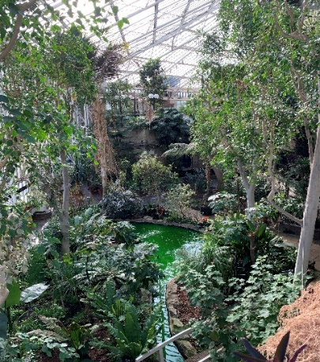
Creative Writer
Sound Artist

Timescale:
May– October 2021 (detailed timeline below)
Deadline:
6pm, 13 May 2021
Fee:
Creative Writer: £2,400
Sound Artist: £1,650

About the project:
Barbican Creative Learning (CL) is excited to be delivering an Audio Trail
which will connect new audiences with our treasured green space, the
Conservatory, by bringing it to life through storytelling. Our key aim is to support
the positive wellbeing of participants by encouraging their
connection to nature following a period where many have been confined to their homes with little to no access to green space during lockdown. We are delivering
the Trail during the summer 2021, giving families a free and accessible activity
to take part in over the holiday break. The Trail will be offered as an
intergenerational activity, for adults and their children to enjoy together.
This project is supported by Wellcome.

How will it work?
We would like to explore working with you to co-create the artistic vision and content of this Audio Trail and are looking to engage two posts: a Creative Writer and
a Sound Artist. Please note, we are particularly looking to work with artists who are underrepresented in the arts.

This is a pilot project where we wish to commission a Creative Writer to produce up to five short stories, each positioned in a different part of the Conservatory, that will explicitly draw on the Conservatory’s flora and fauna, connecting them to their native lands so that participants can be transported to different corners of the world. For example, we may include a story about the koi carp of Japan or the banana trees of the tropics. We also wish to engage a Sound Artist to bring these stories to life more vividly by producing soundscapes that will be dispersed throughout the storytelling.

In our ‘Timeline’ below, we have outlined the time scale for the project.

Timeline

 | Session details & Fee | Artist’s Role
Pre project planning | May, date tbc - online  3 x half days of planning at £150 p/meeting – Creative Writer  2 x half days of planning at £150 p/meeting – Sound Artist | - Attend meetings with CL Producer, Assistant Producer to plan content
 | May, date tbc - online  3 x full day of writing at £300 p/day – Creative Writer  2 x full days of composing at £300 p/day – Sound Artist | - Artist allocation for producing creative content
Recording & Installation | May - June, date tbc – venue tbc  Recording of stories (this could be a recording of the Creative Writer, if appropriate, or we can engage a Storyteller. In this instance, we would expect the Creative Writer to be present during recording if not doing the recording themselves)  2 x full days for recording at £300 p/day – Creative Writer  1 x full day for recording at £300 p/day – Sound Artist | - Artist allocation for recording creative content
 | June/July installation, date tbc – Barbican Centre  1 x full day for installation at £300 p/day – Creative Writer  1 x full day for installation at £300 p/day – Sound Artist | - Artist allocation for support with installing creative content, for example ensuring placement and sound are as expected. This may include a test run with a community group.
Evaluation | October, date tbc - online  Wash up  1 x half day of planning at £150 p/meeting – Creative Writer  1 x half day of planning at £150 p/meeting – Sound Artist | - Attend meetings with CL Producer, Assistant Producer for evaluation session

Total fee for Creative Writer: £2,400

Total fee for Sound Artist: £1,650

Project outcomes for participants:
- They familiarise with the Barbican, for some this may be their first visit, and in particular the Conservatory, which they can continue to revisit in the future
- They have an increased sense of positive mental wellbeing through exposure to green spaces and storytelling
- The Barbican is successful in amplifying and celebrating voices of and stories by people who are underrepresented in the arts through the Artists we engage and the stories they create

We are looking for artists who:
- Have a minimum of 3 years’ experience in creative writing or sound design and production (depending on the role you are applying for)
- Are strong collaborators
- Understand the positive impact that experiencing nature has on wellbeing
- Have experience in producing creative content for a range of age groups
- Are able to work to tight deadlines

Creative Learning will:
- Recruit a Creative Writer to produce the stories for the trail
- Recruit a Sound Artist to produce a complimentary Soundscape for the storytelling
- Collaborate with the Artists to conceive the artistic vision for the trail
- Engage new audiences to the trail
- Facilitate meetings and be first point of contact for comms between Artists
- Provide materials, technical set up and hospitality for all events – as per the requests of the Artists
- Supply recording equipment to record the audio and provide Tech support

How to apply:
If you would like to be considered for the role of either Sound Artist or Creative Writer on the Audio Trail please send your CV and a cover letter (each no more than 2 pages long) outlining how your skills meet the Brief.

Please also include:

- For the Sound Artist post – an example of your work in Sound along with a description

- For the Creative Writer – an example of your work in Creative Writing (and Storytelling if applicable)

Send to: creative.learning@barbican.org.uk with the subject heading ‘Sound Artist/Creative Writer Application [delete as appropriate] – Audio Trail’

Closing date for applications: 6pm, 13 May 2021

Access
If you have any questions about applying for this role please email creative.learning@barbican.org.uk

If you would prefer to send a video of your responses, please send the link to the email address above, along with a C.V. document / video detailing examples of your work to date and experience with working with the arts and children/young people.

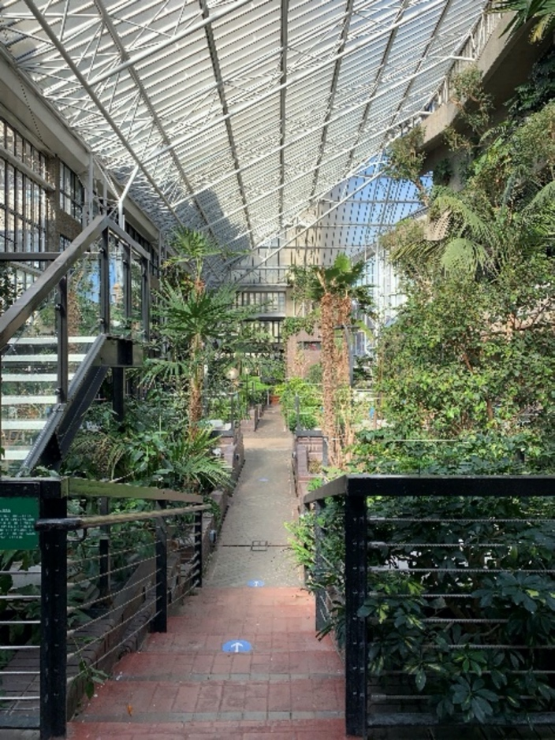

Underrepresentation categorised through Disability, Ethnicity, Sexual Orientation and Socio-Economic Background. Source: https://www.artscouncil.org.uk/sites/default/files/download-file/ACE_DiversityReport_Final_03032020_0.pdf

