Barbican Cinema
Chronic Youth Film Festival 2020
Sat 28–29 Mar
www.barbican.org.uk/whats-on/series/chronic-youth-film-festival-2020
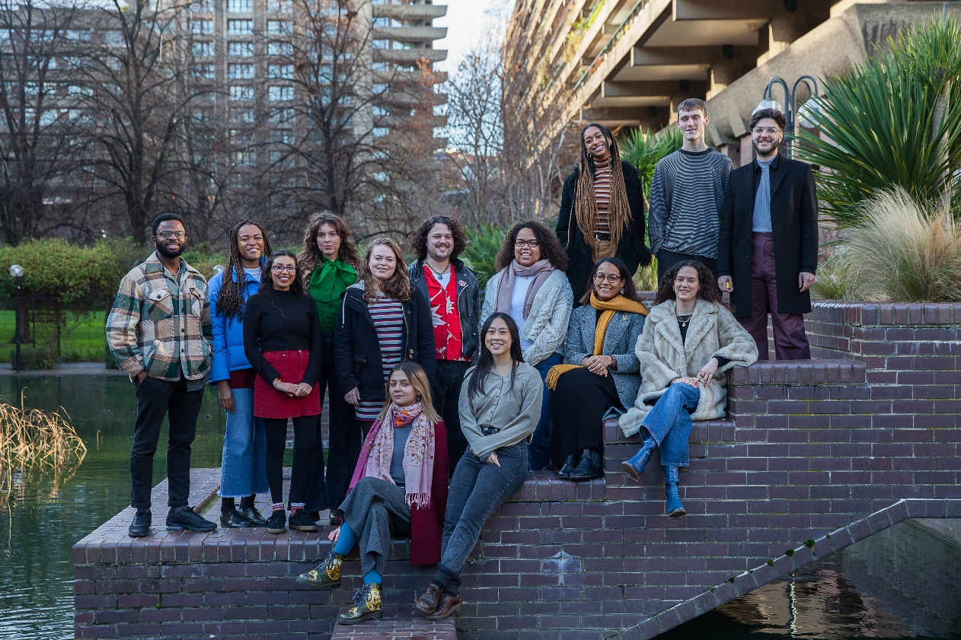
Young Barbican programmers 2020, photo by Betty Zapata
The Barbican Young Programmers have curated an international roster of films for Chronic Youth Film Festival 2020 – which takes place 28-29 Mar – to challenge perspectives and share universal experiences.
Celebrating Chronic Youth’s fifth year, the Festival programmers - aged between 15 and 25 – explored how young people carve out spaces for themselves within communities in hostile or indifferent social and political landscapes.

Chronic Youth opens with the UK premiere of Q’s barbershop (Denmark 2019, Dir Emil Langballe), a light hearted and captivating insight into black masculinity from a Danish barber shop; and follows with Twilight City, a 1989 film by the Black Audio Film Collective, which is a poetic rumination on the overlooked history of othered identities in London.
Other Festival highlights include a special preview of the British film Rocks (UK 2019), a heart-warming story about a group of teenage girl friends coping with the vagaries of modern London life (followed by a ScreenTalk with the director Sarah Gavron and VJ’ing by the Young Programmers); and A First Farewell (China 2018, Dir Lina Wang), a timely and touching account of two children navigating the effects of state enforced cultural homogenization in north-eastern China.
The Festival closes with Una banda des chicas (Argentina 2019, Dir Marilina Giménez), a sonically charged exploration of all-women bands in Argentina challenging the country’s patriarchal music industry.
The Young Programmers have been meeting weekly at the Barbican since September 2019 and working with their mentor, Suzy Gillett. They have been watching, discussing and carefully selecting films for the Chronic Youth Festival. They have also been learning about and contributing to the marketing of the festival and have met special guest speakers who give insights into the film industry.

The Young Programmers 2020 collectively comment:
“We are united by our collective emotional response and desire to share these films with the world!

In these trying times we selected these titles based on their depiction of people coming together and looking for joy in the most unlikely circumstances.

We are championing cinema that portrays the power of change on a personal and local level.”
Chronic Youth Screenings
UK Premiere: Q's Barbershop (15)* + Q&A
2019 Denmark Dir Emil Langballe 60 min
Sat 28 Mar 2020, 14:00, Barbican Cinema 2
Situated in the housing estate of Vollsmose, Denmark, Emil Langballe lends his camera to barbershop owner Qasim, a hardworking entrepreneur and community anchor. This intimate and warm hearted documentary paints the breadth of black masculinity with rich and vibrant colours.
It showcases the importance of community endeavors to survival and joy as the barbershop becomes a second home to local east African men of all ages.
Twilight City (15*) + Dear Babylon (15*) + Panel Discussion
Sat 28 Mar 2020, 16:00, Barbican Cinema 2
Twilight City
1989 UK Black Audio Film Collective 52 min
This 1989 film by the Black Audio Film Collective is a poetic rumination on the overlooked history of othered identities in London. A young black woman, Octavia, writes a letter to her mother Eugenia, who wants to return to London after years in Dominica.
This piece challenges the visual language of documentary by deconstructing London’s architectural landscape. The city becomes a stage on which Britain's relationship with the postcolonial world is made visible, highlighting that migrant history is inextricable from the city's identity.
+Dear Babylon
2019 UK Ayo Akingbade 23 min
After the implementation of a bill that promises to erase social housing, a group of friends who live on an estate decide to make a documentary. Exploring the space between documentary and fiction, exciting young filmmaker Ayo Akingbade comments on the precarity of social housing.
Preview: Rocks (15) + Screentalk
2019 UK Dir Sarah Gavron 93 min
Sat 28 Mar 2020, 18:30, Barbican Cinema 2
Sarah Gavron’s quietly dynamic feature follows Rocks, a teenager who, in her mother’s absence, becomes primary caregiver to her brother Emmanuelle all whilst trying to complete her GCSEs and navigate adolescent friendships.
Propelled by a strong and captivating cast of teenage girls, Rocks immerses you in the day-to-day of contemporary girlhood in London while simultaneously asking questions about the maturity thrust upon young Black girls, going beyond the typical coming-of-age narrative. Selected for the special presentation strand of the 2019 London Film Festival.
Followed by a Screentalk with the Young Programmers.
Followed by VJing by the Young Programmers
Sat 29 Mar 8.15 pm Cinema 2/3 Foyer
A hypnotic audio-visual live performance by the Young Barbican Programmers to close out Saturday evening. Featuring archive dance clips centered around the 20th century and weaved with a selection of curated songs. The Young Programmers will explore live-cinema through bringing footage out of the traditional cinema context and onto the dance floor.
Land of Ashes (15*)
2019 Costa Rica Dir Sofia Quiros Ubeda 82 min
Sun 29 Mar 2020, 14:00, Barbican Cinema 2
Sofia Quiros Ubeda follows her acclaimed short film Selva (2017) with this poetic debut feature. In the wake of her mother’s death, young Selva must navigate the enigmatic world around her.
Caught between the gap of childhood and adolescence, Selva searches for a strong female role model for guidance.
With only her elderly dependent Grandfather and his flirty girlfriend around she seeks mystical means of comfort. This philosophical interpretation of the coming-of-age genre is interwoven with dream-like meditations on grief, loss and hope.
Selected for Cannes Critics Week 2019, this is the UK premiere.
UK Premiere: A First Farewell + Panel Discussion (15*)
2018 China Dir Lina Wang 86 min
Sun 29 Mar 2020, 16:00, Barbican Cinema 2
This is a stunning directorial debut from Xinjiang born filmmaker Lina Wang. Isa and Kalbinur – two young Uighur children from North-eastern China – experience their childhood in a minority community on the backdrop of state-enforced Mandarin-based teaching at school.
Coupled with the uncomfortable path to adolescence and trouble at home, these children come into unwelcome independence as they learn about loss within a lush rural landscape. Wang is able to capture with respect, the joys and sorrows embedded in these children’s lives.
UK Premiere: Una Banda de Chicas (15*)
2019 Argentina Dir Marilina Giménez 83 min
Sun 29 Mar 2020, 18:30, Barbican Cinema 2
Marilinia Giménez’s debut documentary takes us on a sonically charged exploration of all-women bands in Argentina’s male dominated music industry.
Personal interviews are interspersed with diverse live performances as we travel through sub-cultures which are reshaping the scene.
From dingy basements thumping with reggaeton and punk rock to bustling protests about reproductive rights, radical politics take centre-stage in this inspiring portrait of female bands rebelling against the patriarchy.
Short Films Programme
Sun 29 Mar 12-2pm, Barbican Cinema 2
To celebrate emerging talent, the Barbican Young Programmers have curated a selection of short films in response to the theme of ‘Inside Out’, an exploration of the relationship between our inner lives and creativity.
Notes to Editors
For further information contact:
Ian Cuthbert, Communications Manager, Cinema
ian.cuthbert@barbican.org.uk/ 07980 925 352
Sarah Harvey, Barbican Cinema Press Consultant
sarah@sarahharveypublicity.co.uk/ 07958 597426
Ticket prices:
Box office: 020 7638 8891 www.barbican.org.uk
Standard ticket price: £12/ Members: £9.60/ Concessions: £11/ Young Barbican: £5
About Barbican Cinema
We connect audiences with a curated programme of international cinema; from celebrated filmmakers to ground-breaking and under-heard voices from past and present. Our programme ranges from thematic seasons that respond to today’s world, to new releases, Screentalks, cross-artform collaborations, family events, access screenings, cross-artform collaborations and event cinema that presents the performing arts on screen.
We showcase the work of emerging filmmakers, as well as less familiar work of exceptional filmmakers from the UK and around the world. We champion the work of Barbican young programmers and give stage to emerging musicians in our ongoing film & live music series which includes our flagship collaboration with the Guildhall School of Music & Drama.
As part of a cross-arts centre, our cinemas are a cultural space for people to share the viewing experience. We strive to be inclusive in everything we do; providing platforms for the widest possible range of filmmakers and ensuring we are an open, welcoming and accessible venue for all our audiences. We programme free offsite events in east London, offer reduced price tickets to 14-25 year olds through the Young Barbican membership scheme and special student ticket prices.
About the Barbican
A world-class arts and learning organisation, the Barbican pushes the boundaries of all major art forms including dance, film, music, theatre and visual arts. Its creative learning programme further underpins everything it does.
Over a million people attend events annually, hundreds of artists and performers are featured, and more than 300 staff work onsite.
The architecturally renowned centre opened in 1982 and comprises the Barbican Hall, the Barbican Theatre, The Pit, Cinemas 1, 2 and 3, Barbican Art Gallery, a second gallery The Curve, public spaces, a library, the Lakeside Terrace, a glasshouse conservatory, conference facilities and three restaurants. The City of London Corporation is the founder and principal funder of the Barbican Centre.
The Barbican is home to Resident Orchestra, London Symphony Orchestra; Associate Orchestra, BBC Symphony Orchestra; Associate Ensembles the Academy of Ancient Music and Britten Sinfonia, Associate Producer Serious, and Artistic Partner Create. Our Artistic Associates include Boy Blue, Cheek by Jowl, Deborah Warner, Drum Works and Michael Clark Company.
The Los Angeles Philharmonic are the Barbican’s International Orchestral Partner, the Australian Chamber Orchestra are International Associate Ensemble at Milton Court, and Jazz at Lincoln Center Orchestra are International Associate Ensemble.
Find us on Facebook | Twitter | Instagram | YouTube | Spotify
About Inside Out
Inside Out is a Barbican cross arts year-long season that explores the relationship between our inner lives and creativity.
Throughout 2020, Inside Out will showcase the work of artists who have found pioneering ways to articulate their innermost thoughts, feelings and desires, and how this can help us to better understand ourselves and empathise with each other’s experience of the world.
The programme will interrogate themes such as identity, self-expression and how we shape our private selves in a world in which we are more socially connected than ever. It will highlight courageous artists and individuals who have challenged society’s definition of them, including those that have found ways to express themselves during times of censorship.

