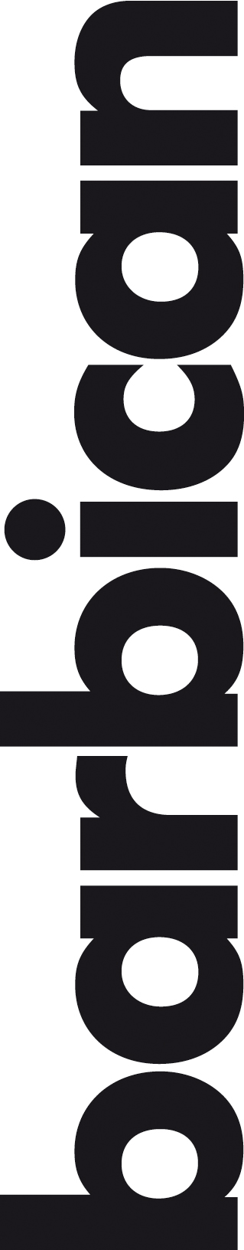
Barbican Cinemas 2 & 3 and Cafe awarded the National Autistic Society’s Autism Friendly Award
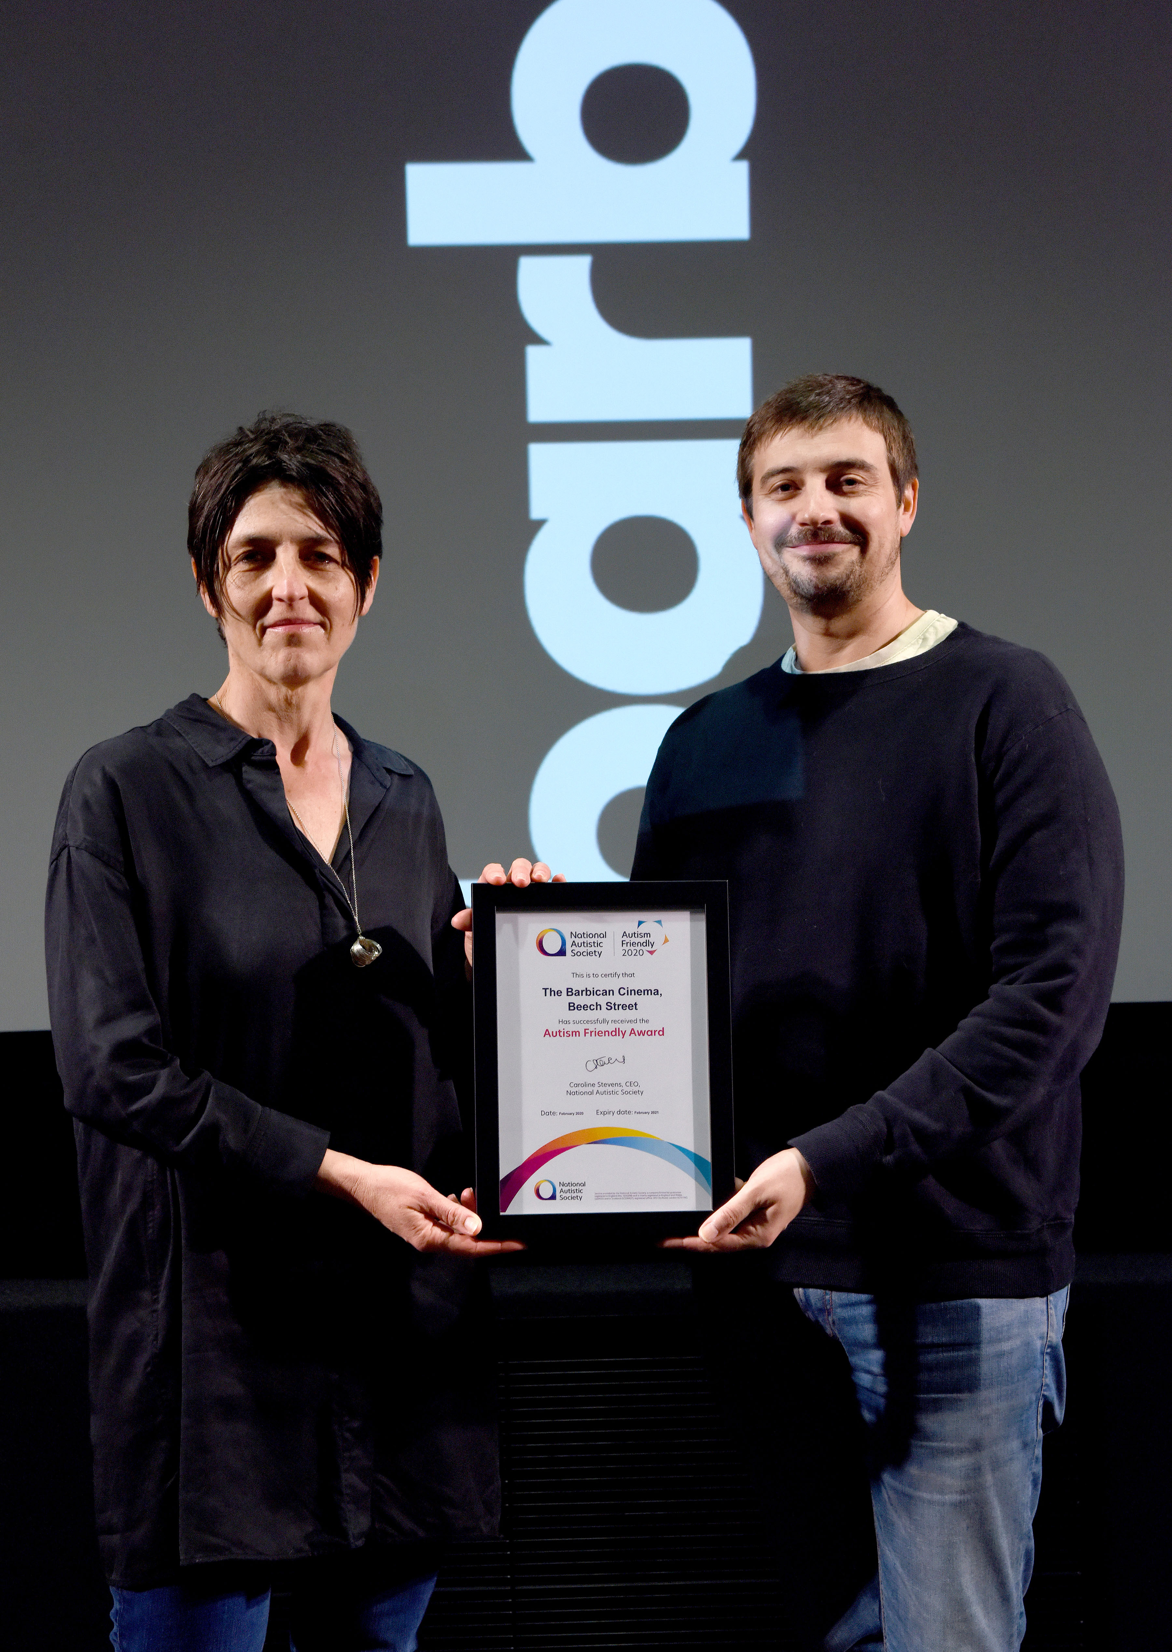
The Barbican is delighted to announce it has been awarded the National Autistic Society’s Autism Friendly Award, which was presented to Gali Gold, Head of Cinema, Barbican, by Daniel Cadey, Autism Friendly Development Manager at the National Autistic Society, at a special presentation in Cinema 3, Beech Street ahead of a Relaxed Screening of Parasite on Friday 14 February.
Daniel Cadey said: “The National Autistic Society is delighted to award our Autism Friendly Award to Barbican Cinemas 2 & 3 and Cafe in recognition of the venue’s adjustments to the overall experience, including lower lighting in the box office area, visual guides on the website, and training for cinema staff.”
Gali Gold said: “We are thrilled to receive this Autism Friendly Award from the National Autistic Society. The Barbican is committed to providing the best service and experience for people with access requirements and we are particularly proud of our regular Relaxed Screenings programme. I am sure this award will further enhance our audience engagement and reach and we look forward to continuing to welcome neurodiverse audiences to a wealth of cinema here at the Barbican.”
The Barbican cinema presents regular Relaxed Screenings including two regular new release screenings every month, as well as a monthly event cinema Relaxed Screening.
In April the season Autism and Cinema, An Exploration of Neurodiversity will present a selection of five screenings and discussions, and will ask how the language of cinema can be challenged and changed by the perspectives of autistic people. Autism and Cinema is presented in collaboration with the Centre for Film and Ethics at Queen Mary University of London as part of a research project supported by Wellcome. All the screenings in this programme will be Relaxed.
Autism and Cinema, An Exploration of Neurodiversity will tour to select cinemas nationwide, supported by Wellcome.

The Barbican Cinema also works with external festival partners to present Relaxed Screenings. In March, the Human Rights Watch Film Festival will present Relaxed Screenings of two festival titles.
Daniel Cadey, continues: “There are around 700,000 autistic children and adults in the UK. They and their families want to go to the cinema like everyone else. But many autistic people can find unfamiliar and noisy public places distressing and disorientating.
“We are delighted that Barbican Cinemas 2 & 3 and Cafe have put so much effort into improving this situation, and has achieved our prestigious Autism Friendly Award. We’re impressed by the care they take to incorporate the feedback of autistic people and their families, to help improve the experience they offer to them and other customers with hidden disabilities.
We hope that many more cinemas and arts venues will follow Barbican Cinema 2 & 3’s inspiring example, so we can move closer to creating a society that works for autistic people”.
Other access facilities and events offered by Barbican Cinemas 2 & 3 and Cafe include: wheelchair accommodation in each screen; captioned screenings and British Sign Language (BSL) interpreted Introductions and ScreenTalks, audio description where provided; heightened sound for guests who are hard of hearing; an Induction Loop for those with hearing aids with the T-setting, both within the cinema and at the ticket desk; and Changing Places facilities for the exclusive use of severely disabled people who need personal assistance, including a height adjustable bench, tracking system, a centrally placed toilet, a height adjustable basin and a shower.
Relaxed, BSL, captioned and audio described events also take place across other Barbican art forms including theatre and dance, visual arts and music. All Barbican venues, restaurants and bars are wheelchair accessible. Full information about facilities and programme here: https://www.barbican.org.uk/your-visit/accessibility
ENDS
Notes to Editors
For Barbican contact:
Sarah Harvey, Barbican Cinema Press Consultant
sarah@sarahharveypublicity.co.uk / 07958 57426
Tom Vine, Communications Officer, Barbican
tom.vine@barbican.org.uk / 020 7382 7321
For National Autistic Society
Louisa Mullan, Media Relations Manager, Culture and Features
Louisa.Mullan@nas.org.uk / 0207 903 3588 X5603
About Barbican Cinema
We connect audiences with a curated programme of international cinema; from celebrated filmmakers to ground-breaking and under-heard voices from past and present. Our programme ranges from thematic seasons that respond to today’s world, to new releases, Screentalks, cross-artform collaborations, family events, access screenings and event cinema that presents the performing arts on screen.
About the Barbican
A world-class arts and learning organisation, that pushes the boundaries of all major art forms including dance, film, music, theatre and visual arts. Its creative learning programme further underpins everything it does.
Over a million people attend events annually, hundreds of artists and performers are featured, and more than 300 staff work onsite.
The architecturally renowned centre opened in 1982 and comprises the Barbican Hall, the Barbican Theatre, The Pit, Cinemas 1, 2 and 3, Barbican Art Gallery, a second gallery The Curve, public spaces, a library, the Lakeside Terrace, a glasshouse conservatory, conference facilities and three restaurants.
The City of London Corporation is the founder and principal funder of the Barbican Centre. The Barbican is home to Resident Orchestra, London Symphony Orchestra; Associate Orchestra, BBC Symphony Orchestra; Associate Ensembles the Academy of Ancient Music and Britten Sinfonia, Associate Producer Serious, and Artistic Partner Create. Our Artistic Associates include Boy Blue, Cheek by Jowl, Deborah Warner, Drum Works and Michael Clark Company.
The Los Angeles Philharmonic are the Barbican’s International Orchestral Partner, the Australian Chamber Orchestra are International Associate Ensemble at Milton Court, and Jazz at Lincoln Center Orchestra are International Associate Ensemble.

About National Autistic Society
Notes to editors

The National Autistic Society
- The National Autistic Society is the UK’s leading charity for autistic people.
- We are here to transform lives, change attitudes and create a society that works for autistic people.
- Since 1962, we have been campaigning for autistic people’s rights and providing support and advice to autistic people and their families.
- To find out more about autism or the charity, visit www.autism.org.uk.
- Follow the National Autistic Society on Twitter @Autism or Facebook.

What is autism?
- Autism is a lifelong disability which affects how people communicate and interact with the world.
- There are approximately 700,000 autistic adults and children in the UK.
- All autistic people have difficulties with communication and social interaction.
- Autism is a spectrum condition. This means autistic people have their own strengths and varying and complex needs, from 24-hour care to simply needing clearer communication and a little longer to do things at work and school.
- Although everyone is different, people on the autism spectrum may:
  - be under or oversensitive to sounds, touch, tastes, smells, light or colours, which can make everyday life extremely difficult
  - be unable to or find it harder to speak, need longer to process information or find it hard to hold conversations
  - experience intense anxiety around unexpected change and in social situations
  - become so overwhelmed that they experience debilitating physical and emotional ‘meltdowns’ or ‘shutdowns’.
- Without the right support or understanding, autistic people can miss out on an education, struggle to find work and become extremely isolated.

