Barbican Cinema
Alternate Realities
A week of storytelling through documentary film and
a free AR & interactive digital art exhibition
Mon 13 – Sun 19 Jan 2020
www.barbican.org.uk/whats-on/2020/series/alternate-realities
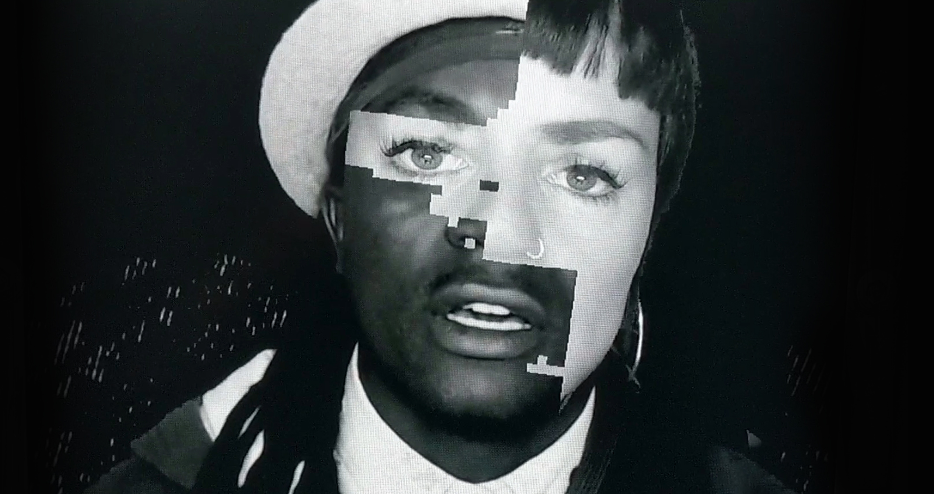
Echo by Georgie Pinn, image courtesy of Sheffield Doc/Fest
Barbican Cinema is delighted to showcase highlights from Sheffield Doc/Fest’s pioneering digital art strand, with two works from the festival’s Alternate Realities exhibition of interactive and immersive non-fiction.
Exhibiting as part of Inside Out, a year-long Barbican cross arts season exploring the relationship between our inner lives and creativity, Alternate Realities is presented by Sheffield Doc/Fest and the Barbican Centre, with support from Arts Council England.
In the interactive installation Echo, by Georgie Pinn, audiences step into the shoes of another through a virtual mirror, select a shared story and discover layers of themselves echoed back. Winner of the ‘Best Digital Experience Award’ at this year’s Doc/Fest, Pinn's artwork is a deeply personal exploration of human identity and empathy, offering an intense and visually unique experience. The Barbican presentation of Echo features new, intimate stories never shown before.
Alongside Pinn's work, Rob Eagle’s augmented reality installation Through the Wardrobe playfully invites visitors into a wardrobe where the possibilities of gender are endless. The viewer is invited to explore the belongings of others and play with their own ideas of gender.
This is a documentary mixed-reality installation that looks at the daily considerations non-binary people must make in expressing their gender identity through clothing.
These installations are accompanied by two screenings: Agostino Ferrente’s Selfie (Italy 2019, dir Agostino Ferrente) and Enrico Masi’s Shelter - Farewell to Eden (Italy/France 2019, dir Enrico Masi), two powerful films that examine identity and depict intensely personal experiences in new and innovative ways.
Gali Gold, Head of Cinema says:
‘Exploring identities and our most inner, authentic selves in a sincere and captivating way is simply vital in the pursuit of openness, of hearts and minds, as individuals and communities in our society. We’re therefore delighted to give artists, filmmakers and audiences the space to connect through unique and excitingly creative stories of the self, in new forms of engagement. We love the opportunity to link the Barbican level G programme and our cinemas, allowing visitors to take active part in journeys inward, guided by the moving image and innovative cinematic modes of storytelling.’
Melanie Iredale, Deputy Director, Sheffield Doc/Fest says:
“We are so looking forward to returning to Barbican with two of our audiences favourites from this year’s Alternate Realities exhibition at Doc/ Fest. Echo and Through the Wardrobe both offer immersive experiences, inviting the viewer to step in to the shoes of another as we listen to personal and intimate stories. A huge thank you to Barbican for once again collaborating on our UK tour, to Arts Council England for the support, and to artists Georgie Pinn and Rob Eagle for sharing their work with us.”
Full programme
Echo
Alternate Realities
Mon 13 - Sun 19 Jan 2020, Mon – Sat 1 pm – 9.00 pm, Sun 12pm – 8pm
Barbican Cinema 2 & 3 Foyers
The installation allows participants to step into someone else’s shoes through a virtual mirror, select a shared story and discover layers of themselves echoed back in this personal exploration of human identity.
Winner of the ‘Best Digital Experience Award’ at this year’s Doc/Fest, the key intention of the ECHO experience is to generate empathy and connect people, offering an intense and visually unique experience. How do we feel when someone blinks with our eyes, smiles with our lips or speaks with our tongue?
Through the Wardrobe
Alternate Realities
Mon 13 — Sun 19 Jan 2020, Mon – Sat 1 pm – 9.00 pm, Sun 12pm – 8 pm
Barbican Cinema 2&3 foyers
Discover a wardrobe where the possibilities of gender are endless. The user is invited to explore the belongings of others and play with gender expression.
Through the Wardrobe is a documentary mixed-reality installation that explores the daily considerations non-binary people must make in expressing their gender identity through clothing.
The experience mixes audio interviews with colourful hand-drawn interactive animations in an augmented reality headset, taking place within a physical set that requires the audience to dress up, touch the furniture, and use their body as a controller to decide on the pace and flow of the experience.
Films screening
Selfie (15*)
Italy 2019, Dir Agostino Ferrente, 78 min
Tue 14 Jan 2020, 19:00, Barbican Cinema 3
Two 16-year-old boys record the aftermath of the killing of one of their friends in this intensely personal documentary, filmed in Naples.
Alessandro and Pietro, both 16, live in Traiano, a poor district in Naples where their friend, Davide, was shot dead by police, who mistook him for a fugitive.
Encouraged by director Agostino Ferrente, the boys film themselves and their neighbourhood in the weeks following the tragedy, as they grieve and consider their own futures.
Despite the context, there is plenty of humour in the iPhone videos the boys create. Using their phones as a mirror to reflect their complex emotions, Alessandro and Pietro are hugely likeable guides, and Selfie is a poignant exploration of loyalty and friendship.
Shelter – Farewell to Eden (15*)
Italy/France 2019, Dir Enrico Masi, 80 min
Sat 18 Jan 2020, 15:30, Barbican Cinema 3
Trans migrant Pepsi, born in the Philippines, shares her fascinating life experiences as she journeys to seek asylum in Italy.
Pepsi recounts her astonishing life, from growing up in the minority Muslim (Moro) community in the Philippines, joining the Islamic Liberation Front and moving temporarily to Libya to work as a nurse. Enrico Masi’s stunningly beautiful film follows Pepsi’s experiences between France and Italy, where she hopes to be granted asylum.
Masi’s sensitive direction and Pepsi’s compelling philosophical narration simultaneously reveals the complexities of her personal experiences and considers gender inequality, transphobia and racism, in a film that has been described as a ‘post-colonial parable’.
Notes to Editors
For further information contact:
Ian Cuthbert, Communications Manager, Cinema
ian.cuthbert@barbican.org.uk/ 07980 925 352
Sarah Harvey, Barbican Cinema Press Consultant
sarah@sarahharveypublicity.co.uk/ 020 7732 7790
Public information:
Box office: 020 7638 8891 www.barbican.org.uk
#AlternateRealities
Both exhibitions Echo & Through the Wardrobe are free of charge and can be booked in person at the Barbican between 12 and 7.15 pm.
The film screenings are:
Standard: £12/ Members: £9.60/ Concs £11, Young Barbican £5.
* Local Classification
About Barbican Cinema
A fully curated programme of international cinema including thematic seasons, new releases, and special events presented in Cinemas 1, 2 and 3.
Our offer includes partnerships with film festivals, art & culture organisations, plus regular family screenings for young audiences and parent & baby screenings.
The Event cinema programme presents the best of the performing arts on screen.
About the Barbican
A world-class arts and learning organisation, that pushes the boundaries of all major art forms including dance, film, music, theatre and visual arts. Its creative learning programme further underpins everything it does. Over a million people attend events annually, hundreds of artists and performers are featured, and more than 300 staff work onsite. The architecturally renowned centre opened in 1982 and comprises the Barbican Hall, the Barbican Theatre, The Pit, Cinemas 1, 2 and 3, Barbican Art Gallery, a second gallery The Curve, public spaces, a library, the Lakeside Terrace, a glasshouse conservatory, conference facilities and three restaurants. The City of London Corporation is the founder and principal funder of the Barbican Centre.
The Barbican is home to Resident Orchestra, London Symphony Orchestra; Associate Orchestra, BBC Symphony Orchestra; Associate Ensembles the Academy of Ancient Music and Britten Sinfonia, Associate Producer Serious, and Artistic Partner Create. Our Artistic Associates include Boy Blue, Cheek by Jowl,
Find us on Facebook | Twitter | Instagram | YouTube | Spotify
About Inside Out
Inside Out is a Barbican cross arts year-long season that explores the relationship between our inner lives and creativity.
Throughout 2020, Inside Out will showcase the work of artists who have found pioneering ways to articulate their innermost thoughts, feelings and desires, and how this can help us to better understand ourselves and empathise with each other’s experience of the world.
The programme will interrogate themes such as identity, self-expression and how we shape our private selves in a world in which we are more socially connected than ever.
It will highlight courageous artists and individuals who have challenged society’s definition of them, including those that have found ways to express themselves during times of censorship.
About Sheffield Doc/Fest
Sheffield Doc/Fest is a film festival and marketplace, celebrating, sharing and debating non–fiction arts as a collective form of engagement. It is a space for freedom and for exploration of the ways in which filmmakers, artists and public may reinvent meaning and new possible worlds.
Doc/Fest is a creative space for discovery, collaboration and inspiration. The festival champions and pushes forward talent, ideas and interaction for the future of film and the arts. It’s an open, inclusive festival, bringing together veteran creatives, new voices and our city to shape and question the world we live in, creating a sense of community and the potential for change.
The 27th edition of Doc/Fest will take place 4-9 June 2020.
Click here to find out more.

