Barbican Cinema
INSIDE OUT
A Year Exploring the Relationship Between Our Inner Lives and Creativity
Jan-Dec 2020

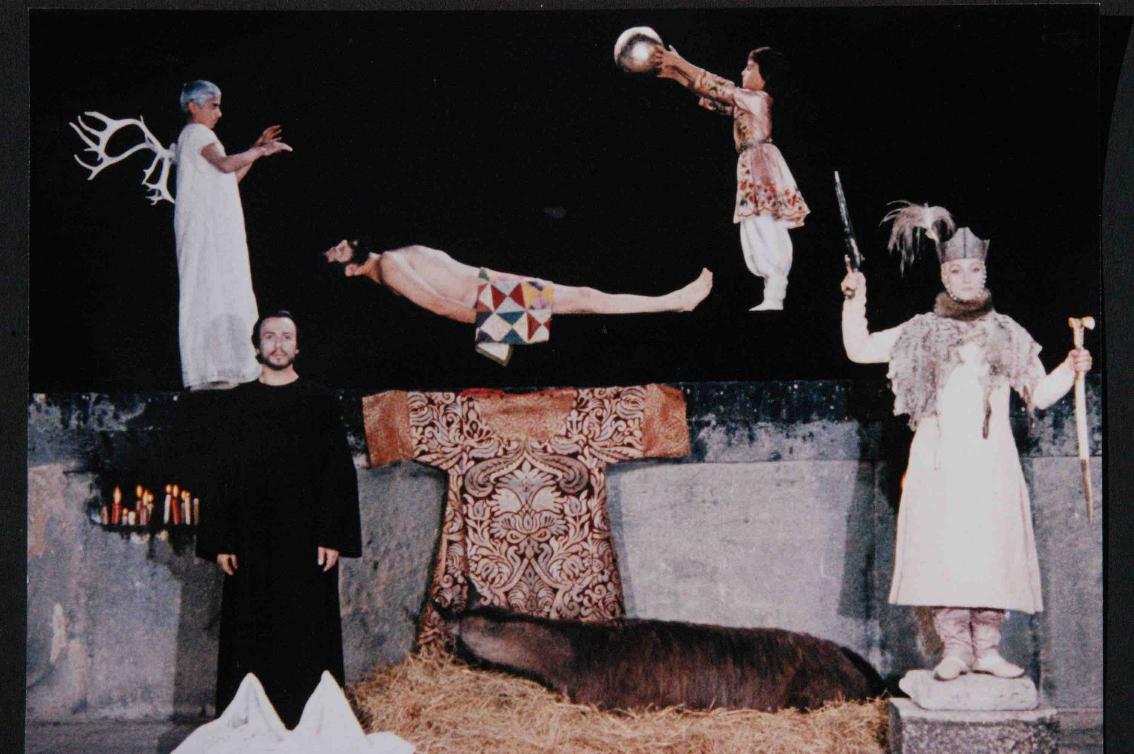
The Color of Pomegranates (Sergei Parajonov, 1969)
The Barbican announces Inside Out, a year exploring the relationship between our inner lives and creativity, taking place throughout 2020 in the Barbican cinemas and across all art forms including arts and learning events, exhibitions, screenings, live performances and concerts, in all of the Barbican’s venues and public spaces.

Throughout 2020, Inside Out will showcase the work of filmmakers and artists who have found pioneering ways to articulate their innermost thoughts, feelings and desires, and how this can help us to better understand ourselves and empathise with each other’s experience of the world.
The programme will interrogate themes such as identity, self-expression and how we shape our private selves in a world in which we are more socially connected than ever. It will highlight courageous filmmakers, artists and individuals who have challenged society’s definition of them, including those that have found ways to express themselves during times of censorship.
Sir Nicholas Kenyon, Managing Director, Barbican said: ‘Throughout the year, Inside Out will draw on ideas from the arts, learning, philosophy, politics and culture to present a thought-provoking programme that invites our audiences to delve deep into the minds of extraordinary artists who found revolutionary ways to share their individual experience of the world’.
Louise Jeffreys, Artistic Director, Barbican said: ‘In an increasingly frenetic world, when we’re under pressure to both reveal more and more of ourselves and to conform to societal expectations, Inside Out will create a space for us all to take a step back to consider who we really are and how we share this with others’.
Gali Gold, Head of Cinema, Barbican said: ‘The observational nature of film -- its demand for a point of view, its unique formation of space and time, together with its ability to see through and visualise that which is abstract and internal -- makes this focus on inner life and creativity such fruitful and exciting ground for film programming. Be it a particular mode, like animation, which enables a certain distance from the self while forming a unique and appealing engagement; first person films, where the filmmaker is also the film subject and their camera turns inwards, as they explore and expose what is then revealed to cinema viewers; or, the way certain filmmakers imprint their most intimate sensibilities on the films they make, regardless of tradition, convention or subject, forming new realities and subjectivities on screen.
‘We live in times of constant self documentation and sharing so it’s timely to reflect precisely through those films that are far less ephemeral and have the power to enable the viewers an opportunity to gaze inward too’.
Barbican Cinema highlights include:
Alternate Realities
Mon 13 - Sun 19 Jan 2020, Cinemas 2&3 and Cinema Café Level G
Sheffield Doc/Fest’s pioneering digital art strand will return to the Barbican, featuring two works from the festival’s Alternate Realities exhibition of interactive and immersive non-fiction.
In the interactive installation Echo, by Georgie Pinn, audiences step into the shoes of another through a virtual mirror, select a shared story and discover layers of themselves echoed back in a deeply personal exploration of human experience, identity and empathy through an intense and visually unique experience. For this presentation at the Barbican, Echo will feature new, intimate stories.
Alongside Pinn's work, the Barbican will also present Rob Eagle’s augmented reality installation Through the Wardrobe, playfully inviting visitors into a wardrobe where the possibilities of gender are endless.
These two installations in Cinemas 2&3 foyers, as part of the Level G programme are accompanied by a film programme and events in the adjacent screens, including screenings of Agostino Ferrente’s Selfie (France/Italy 2019) and Enrico Masi’s Shelter - Farewell to Eden (France/Italy 2019), two powerful films that explore identity and depict intensely personal experiences in new and innovative ways.
Andy Warhol’s Screen Tests – Reel #10 (U*) with a new soundtrack created and performed by Leif
Thu 27 Feb 2020, Cinema 1
Barbican Cinema, as part of its regular Silent Film & Live Music series, presents a selection of Andy Warhol’s Screen Tests, the series of short, silent black-and-white film portraits made by Warhol at the Factory between1964-66. Reel #10, which includes Lou Reed, Edie Sedgwick, poet John Ashbery and filmmakers Jonas Mekas and Paul Morrissey will be screened accompanied by a new soundtrack created and performed by Leif.

The Screen Tests were conceptualised as cinematic versions of mug shots, ID photos or photo booth photos. The sitters were filmed in a small space against the wall where a tripod-mounted 16mm Bolex camera, lights and a chair had been set up. They were asked to sit for three minutes – much longer than the exposure time of a photo. The sitters’ responses to this ‘ordeal’, and their decisions about how to ‘perform’ themselves for the camera, make these films hugely revealing, as well as riveting viewing.

The people who sat for the Screen Tests – poets, artists, writers, filmmakers, musicians, dancers, models, celebrities and hangers-on – were part of the New York downtown arts scene during a watershed period. Collectively then, the Screen Tests can be read as a group portrait of this scene, as well as an oblique portrait of Warhol himself, delineating his network of connections and associations, his range of interests.

Leif is a UK-based DJ and producer, author of over 20 EPs and three acclaimed albums, most recently appearing on labels such as Whities, Livity Sound and Idle Hands. With Joe Ellis, he also runs the label UntilMyHeartStops. His music draws on myriad elements from the spaciousness of dub to the rhythmic flair of broken beat and garage, polyrhythmic melodic patterns passed down from the pioneering minimal composers, ambient atmospherics and the more forthright structures and propulsion of house and techno. As a DJ, Leif performs worldwide, with repeat appearances at institutions such as Panorama Bar, De School, Concrete, Fabric and many more. This inaugural solo live performance will see Leif explore the more ambient / experimental side of his sound, expanding on musical themes hinted at in his latest album, 2019’s Loom Dream (Whities).

London International Animation Festival: The Inner Life
Feb - Dec 2020
Artists and filmmakers express a range of inner lives, complex emotions and personal experiences in this curated selection of animations, presented in a four-part series throughout 2020, curated by the London International Animation Festival (LIAF).
In the first LIAF event, Inside the Mind, we rediscover some of the most celebrated and talked about films from recent festival editions that explore the concept of an ‘inner life’.
London International Animation Festival: Inside the Mind
Wed 19 Feb 2020, Cinema 2
Featuring work from the UK, Ireland, Estonia and the USA, Inside the Mind shows how artists use animation to engage with first person narratives and to express the otherwise inexpressible.
Autism and Cinema: An Exploration of Neurodiversity
Thu 2 - Wed 29 Apr 2020
This season is presented in collaboration with the Centre for Film and Ethics at Queen Mary University of London as part of a research project supported by Wellcome. It debates new ideas arising from the relationship between autism and cinema.
Bringing together a diverse selection of films, ranging from documentary to animation, and genre-twisting fiction to experimental filmmaking from within the autistic community, this programme asks how the language of cinema can be challenged and changed by autistic perspectives.
Typically, cinema has depicted characters with autism from the outside, looking in with fascination at a high-functioning or magical character who throws out of joint the ‘neurotypical’ lives of those around them. Medical films similarly treated the behaviour of autistic individuals as eccentric and obscure, heralding a wave of anti-psychiatry and activism.
A cinema reflective of autism and opening onto the experience of neurodiversity is rare. Yet it has much to offer our understanding of inner and outer life, ushering in new sensory and relational ways of being in the world.
The film programme will include: Temple Grandin (dir Mick Jackson, US 2010); Le Moindre geste (The Slightest Gesture) (dirs Jean-Pierre Daniel, Fernand Deligny, Josée Manenti, France 1971), Mulholland Drive (dir David Lynch 147 min, US 2001) Jigsaw (dir Robina Rose, UK 1980) and Life, Animated (dir Roger Ross Williams, US 2016).
The season opens on World Autism Awareness Day; all screenings are relaxed.
Inner States – A series of first-person films
June 2020
Inner States, curated by the Barbican Cinema and film scholar, Professor Alisa Lebow, is a programme dedicated to first-person films that harness the medium to express an interiority rarely achieved on film.
Every film in this series – which will include Fix Me (dir Raed Andoni, Palestine (State of), France, Switerland 2009); Heart of a Dog (dir Laurie Anderson, US 2015); No Home Movie (Chantal Akerman, Belgium/France 2015) offer, in some way, a journey to the inner sanctum of the self: be it the experience of loss, loneliness, madness, or just the simplicity of keen observation from a unique vantage point. At a time when social norms are rapidly changing and the boundaries between private and public are less and less clear, they offer a profound insight into a cinematic account of the self and its relation to others and to the world.
‘Subjectivity finds its filmic expression, not surprisingly, in very personal ways, yet it is nonetheless shaped by and in relation to collective expressions of identity that can transform the cinema of 'me' into the cinema of 'we'.’ Alisa Lebow
Co-curated with Alisa Lebow, Professor of Screen Media, University of Sussex
Supported by Sussex Docs, School of Media, Film and Music, University of Sussex
Out in the Shadows: Queer expression in times of cinema censorship
July 2020
Out in the Shadows: Queer expression under times of cinema censorship will look at how LGBTQ+ filmmakers have expressed queer sexuality in times of repression and censorship.
Some of the greatest films of all time have been made by LGBTQ+ directors, although many were working at times of history when identifying as queer was taboo, and even a criminal offence.
Despite creating films which featured no explicitly queer content, which would have led to their films being banned or heavily censored, a number of LGBTQ+ filmmakers created work that managed to express their sexuality, through coded storytelling, symbolism, aesthetic and inventive technique.
The programme will include films from the US, the UK, the Soviet Union and the Middle East, including a screening of Lebanese filmmaker Mazen Khaled’s remarkable Martyr (Lebanon, 2017), in which a fateful trip to a beach provokes complex emotions in a group of young men and Sergei Parajanov’s landmark The Color of Pomegranates (US 1969).
These filmmakers show that great queer art can flourish in the darkest of times, out in the shadows.
Click here for full Inside Out press release.

Notes to Editors
For further information contact:
Ian Cuthbert, Communications Manager, Cinema
ian.cuthbert@barbican.org.uk / 07980 925 352
Sarah Harvey, Barbican Cinema Press Consultant
sarah@sarahharveypublicity.co.uk / 020 7732 7790
Inside Out is the Barbican’s year-long programme exploring the relationship between our inner lives and creativity.

Throughout 2020, Inside Out will showcase the work of artists who have found pioneering ways to articulate their innermost thoughts, feelings and desires, and how this can help us to better understand ourselves and empathise with each other’s experience of the world.
The programme will interrogate themes such as identity, self-expression and how we shape our private selves in a world in which we are more socially connected than ever. It will highlight courageous artists and individuals who have challenged society’s definition of them, including those that have found ways to express themselves during times of censorship.
www.barbican.org.uk/inside-out
About Barbican Cinema
A fully curated programme of international cinema including thematic seasons, new releases, and special events presented in Cinemas 1, 2 and 3.
Our offer includes partnerships with film festivals, art & culture organisations, plus regular family screenings for young audiences and parent & baby screenings.
The Event cinema programme presents the best of the performing arts on screen.
About the Barbican
A world-class arts and learning organisation, the Barbican pushes the boundaries of all major art forms including dance, film, music, theatre and visual arts. Its creative learning programme further underpins everything it does. Over a million people attend events annually, hundreds of artists and performers are featured, and more than 300 staff work onsite. The architecturally renowned centre opened in 1982 and comprises the Barbican Hall, the Barbican Theatre, The Pit, Cinemas 1, 2 and 3, Barbican Art Gallery, a second gallery The Curve, public spaces, a library, the Lakeside Terrace, a glasshouse conservatory, conference facilities and three restaurants. The City of London Corporation is the founder and principal funder of the Barbican Centre.
The Barbican is home to Resident Orchestra, London Symphony Orchestra; Associate Orchestra, BBC Symphony Orchestra; Associate Ensembles the Academy of Ancient Music and Britten Sinfonia, Associate Producer Serious, and Artistic Partner Create. Our Artistic Associates include Boy Blue, Cheek by Jowl,
Deborah Warner, Drum Works and Michael Clark Company. The Los Angeles Philharmonic are the Barbican’s International Orchestral Partner, the Australian Chamber Orchestra are International Associate Ensemble at Milton Court, and Jazz at Lincoln Center Orchestra are International Associate Ensemble.
Find us on Facebook | Twitter | Instagram | YouTube | Spotify

