Barbican Cinema
Borders and Boundaries
8 Nov – 27 Nov, Cinemas 1 & 3
www.barbican.org.uk/whats-on/2019/series/borders-and-boundaries
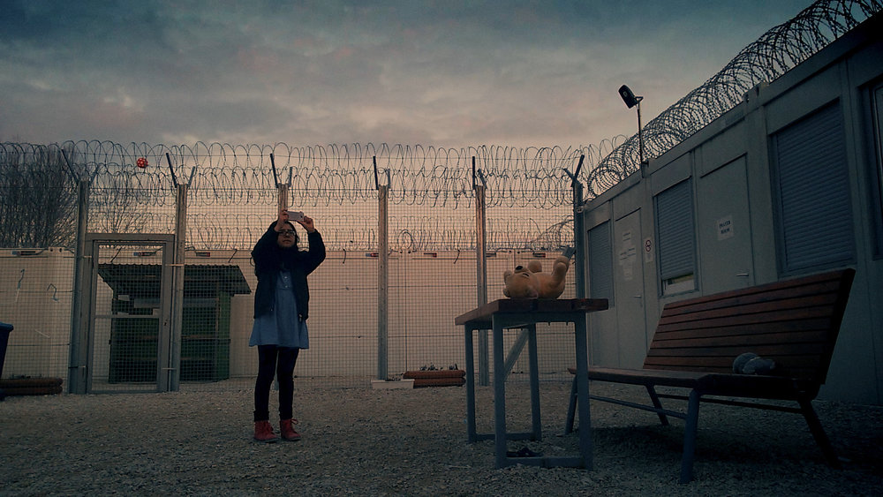
Midnight Traveler (US/UK/ Qatar/ Canada Dir Hassan Fazili)
Marking the Fall of the Berlin Wall 30 years ago, the Barbican Cinema’s film programme Borders and Boundaries is a cinematic gaze on borders the world over.
Never ceasing to be topical, ‘borders’ have shaped people’s lives, formed and fractured communities, solidified and challenged ideologies for centuries.
Screening throughout November, this eight-part season of films, including two ScreenTalks, give a timely opportunity to contemplate borders and boundaries, then and now, physical, man-made ones and the way they have been accounted for, represented, challenged and transgressed in film.
The season opens with a ScreenTalk event featuring the powerful and deeply moving Midnight Traveler (US/UK/Qatar/Canada 2019), which won the World Cinema Documentary Special Jury Award at Sundance Film Festival and received a Special Mention by the Grand Jury at Sheffield Doc/Fest. After receiving a Taliban death sentence, Afghan filmmaker Hassan Fazili is forced to flee with his family through Turkey, Bulgaria and Serbia in the hope of reaching the sanctuary of the European Union. Shot entirely on their mobile phones in real time - Fazili shows first-hand the dramatic, uncertain journey across numerous borders, from menacing smugglers to far right nationalists, that face refugees seeking asylum, as well as portraying the love shared between his family on the run.
In Wall (France/Israel 2004) acclaimed filmmaker Simone Bitton examines the controversial ‘separation wall’ that divides Israel from the West Bank, which began construction in 2002 on a disputed line, cutting through the historical landscape with miles of concrete slabs and wire.
Wall shows the implications for daily life on both sides of the fence. Bitton interviews government officials, the Palestinian labourers who built it, and a fascinating array of people who live on both sides of this vast partition, reflecting on the political and personal implications of this monumental barrier. The director will also be in attendance for a ScreenTalk with Gali Gold (Head of Barbican Cinema).
Other season highlights include Architecture on Film: Berlinmuren (2008 Dir Lars Laumann) + Rabbit à la Berlin (Poland/Germany 2009 Dirs Bartek Konopka), which presents two idiosyncratic films about the Berlin Wall: the former about the love affair between a Swedish woman and the Wall, and the latter about its rise and fall from the perspective of resident rabbits.
The plight of Latin American refugees is highlighted in the Oscar nominated El Norte (USA 1984, Dir Gregory Nava), in which two Guatemalan siblings escape the civil war and attempt to make the dangerous journey to the US, via Mexico.
The Mexican border crossing is also central in El Mar La Mar (USA 2017 Dir Joshua Bonnetta and J P Sniadecki), that tells the oral histories of refugees and migrants who make the desperate decision to cross the Sonoran Desert in the hope of making a new life in the US. The unseen speakers talk of the multiple dangers they face in this powerful work of protest art, which won two awards at the 2017 Berlin Film Festival.
The theme of love and borders is explored in Wieland Speck’s cult film Westler (West Germany 1985) which tells the story between two gay men who embark on a relationship from different sides of the border; their romance is constantly threatened by the wall that divides the city.
Division is also the main theme in Trouble (USA/ UK 2019), in which artist Mariah Garnett traces her roots to Belfast (where her father lived during the Troubles) in this inventive documentary about his early life. It’s a fascinating, experimental take on identity, gender and the borders between us, literal and metaphorical.
Gali Gold, Head of Barbican Cinema comments:
“Marking 30 years since the fall of the Berlin Wall is an opportunity to contemplate the issue of Borders that is so topical in all our lives. While the events of 1989 marked a formative change across Europe - and part of a rapid process of ‘Globalisation’ - what has actually happened since the noughties is the rapid erection of man-made borders the world over. So many extraordinary films engage with the experience, visuals and politics of Borders and Boundaries and this programme highlights a handful to delve into. The thread that crosses these cinematic journeys is the focus on personal lives which those Borders shape and the topographies of the psyche - and being bound by walls and barriers.”
Films screening
Midnight Traveler + ScreenTalk (15*)
Barbican Cinema is delighted to be joined by producer Emelie Mahdavian (via Skype), and activist Syed Haleem Najibi, for a post-screening discussion, hosted by Jess Search, CEO of Doc Society.
Fri 8 Nov 6.15pm, Cinema 1
Afghan filmmaker Hassan Fazili is forced to seek asylum in Europe after receiving a Taliban death sentence in this powerful documentary.
When the Taliban puts a bounty on his head, director Hassan Fazili is forced to flee with his family across Europe, through Turkey, Bulgaria and Serbia, in the hope of reaching the sanctuary of the European Union.
Capturing their dramatic, uncertain journey across numerous borders on their mobile phones, Fazili and his family show first-hand the dangers, from menacing smugglers to far right nationalists, that face refugees seeking asylum, as well as the love shared between a family on the run. This powerful and deeply moving documentary won the World Cinema Documentary Special Jury Award at Sundance Film Festival and received a Special Mention by the Grand Jury at Sheffield Doc/Fest.
US/UK/Qatar/Canada Dir Hassan Fazili 87 min
El Norte (18*)
Sat 9 Nov 3pm, Cinema 3
Two Guatemalan siblings escape the civil war and attempt to make the dangerous journey to the US, via Mexico, in Gregory Nava’s Oscar-nominated epic.
After a bloody massacre, Brother and sister Enrique and Rosa make the difficult decision to leave their home and head north, to start a new life in the US.
Despite the dangers and hardships they face, the pair continue their journey to Tijuana, where they are forced to take terrifying risks.
El Norte was one of the first productions to focus on the challenges facing Latin American refugees hoping to cross the border in to the US. The two protagonists are depicted with great dignity and solidarity, and, tragically, this masterly film, newly restored, has never been more relevant.
USA 1984 Dir Gregory Nava 141 min
El Mar La Mar (15*)
Sun 10 Nov 4pm, Cinema 3
A haunting, immersive journey through the Sonoran Desert on the US-Mexico border.
The oral histories of refugees and migrants who make the desperate decision to cross the Sonoran Desert in the hope of making a new life in the US are told in this experimental film. The unseen speakers tell of the multiple dangers they face on their journey, made overnight away from the merciless heat.
As those crossing the border speak of sacrifice and struggle, the filmmakers present 16mm footage of flora, fauna and items left behind by those who have made the journey and a powerful riposte to the immigration policies of Trump’s America. It’s a unique and powerful work of protest art, which won two awards at the Berlin Film Festival.
USA 2017 Dir Joshua Bonnetta and J P Sniadecki 95 min
Architecture on Film: Berlinmuren + Rabbit à la Berlin #
Wed 13 Nov 7pm, Cinema 1
Two idiosyncratic films present two of the Berlin Wall’s more unusual stories.
In 1979 Swedish woman Eija Riitta consolidated her lengthy love affair with the Berlin Wall by marrying it. In artist Lars Laumann’s film, Berlinmuren ‘objectum-sexual’ identifying Eija narrates her romance and union with the wall; a love story transcending distances, age, politics and conventions.
Rabbit à la Berlin shows a very different side to the wall’s rise and fall, from the perspective of the many thousands of rabbits that comfortably called its Death Zone home.
As barbed wire turns to concrete, and strangely behaving humans erect lengthy structures of unknown purpose, a paradisiacal ‘rabbitland’ temporarily flourishes in the ‘meadows’, before the rabbits are forced to adjust to a very different way of life.
Curated by the Architecture Foundation [www.architecturefoundation.org.uk]
Berlinmuren (2008 Dir Lars Laumann 24 min)
Rabbit à la Berlin (Poland/Germany 2009 Dirs Bartek Konopka, Piotr Rosołowski 50 min)
The Hand of Fate (PG*) + intro
Tue 19 Nov 6.30pm, Cinema 3
Made one year after the end of the Korean war, this entertaining thriller explores the romance between a spy and a poor student.
Margaret, a spy, passes secret messages to the North Korean army, using music score sheets to encrypt the classified information. She shows an interest in a poor, young South Korean student – are her feelings purely romantic, or does she plan to recruit him?
The Hand of Fate blends several genres – film noir, romance, thriller – to create a hugely enjoyable movie which acts as an invaluable time capsule of early-1950s South Korea. It was the first Korean film to feature an on-screen kiss and boasts a strong role for Yoon In-ja as the duplicitous heroine.
South Korea 1954 Dir Han Hyeong-mo 85 min
Westler (15) + intro by cinema curator Alex Davidson
Tue 26 Nov 6.30pm, Cinema 3
This rarely screened West German drama follows the romance between two gay men whose relationship is threatened by the wall that divides their city.
Felix visits East Berlin on a day-trip with an American friend, where he meets Thomas, a handsome guy, with whom he forms an immediate rapport. Felix continues to visit Thomas, making sure he is back in West Berlin by the curfew, but their romance soon arouses the suspicions of the East German police…
Director Wieland Speck filmed the scenes in East Berlin on a hidden camera, lending the footage an unworldly atmosphere and offering rare, authentic footage of pre-unification Berlin. Despite the air of danger, it’s also a charming romance, and an unjustly neglected curio in queer cinema history.
West Germany 1985 Dir Wieland Speck 94 min
Trouble (15*)
Wed 27 Nov 8.30pm, Cinema 3
Artist Mariah Garnett traces her roots to Belfast, where her father lived during the Troubles, in this inventive documentary.
Filmmaker Mariah Garnett reunites with her father in Vienna, before travelling alone to Belfast, where he grew up, to explore his early life. Once in Northern Ireland, she uses archive film and recordings of interviews with her father to reconstruct his younger years.
Garnett plays with gender in her film, as, once in Belfast, she herself portrays her father and casts a trans actor as his Catholic girlfriend – clips from a 1971 doc highlight the contemporary controversy of interfaith relationships.
It’s a fascinating, experimental take on identity, gender and the borders between us, literal and metaphorical.
USA/UK 2019 Dir Mariah Garnett 83 min
Notes to Editors
For further information contact:
Ian Cuthbert, Communications Manager, Cinema
ian.cuthbert@barbican.org.uk/ 07980 925 352
Sarah Harvey, Barbican Cinema Press Consultant
sarah@sarahharveypublicity.co.uk/ 020 7732 7790
Ticket prices:
Box Office: 0845 120 7527
Midnight Traveler + ScreenTalk
& Wall + ScreenTalk:
Standard £13.50, Members £10.80, Concs £12, Young Barbican £5.
All other Borders and Boundaries Screenings:
Standard: £12/ Members: £9.60/ Concs £11, Young Barbican £5.
* Local Classification
About Barbican Cinema
A fully curated programme of international cinema including thematic seasons, new releases, and special events presented in Cinemas 1, 2 and 3.
Our offer includes partnerships with film festivals, art & culture organisations, plus regular family screenings for young audiences and parent & baby screenings.
The Event cinema programme presents the best of the performing arts on screen.
About the Barbican
A world-class arts and learning organisation, the Barbican pushes the boundaries of all major art forms including dance, film, music, theatre and visual arts. Its creative learning programme further underpins everything it does. Over a million people attend events annually, hundreds of artists and performers are featured, and more than 300 staff work onsite. The architecturally renowned centre opened in 1982 and comprises the Barbican Hall, the Barbican Theatre, The Pit, Cinemas 1, 2 and 3, Barbican Art Gallery, a second gallery The Curve, public spaces, a library, the Lakeside Terrace, a glasshouse conservatory, conference facilities and three restaurants. The City of London Corporation is the founder and principal funder of the Barbican Centre.
The Barbican is home to Resident Orchestra, London Symphony Orchestra; Associate Orchestra, BBC Symphony Orchestra; Associate Ensembles the Academy of Ancient Music and Britten Sinfonia, Associate Producer Serious, and Artistic Partner Create. Our Artistic Associates include Boy Blue, Cheek by Jowl,
Deborah Warner, Drum Works and Michael Clark Company. The Los Angeles Philharmonic are the Barbican’s International Orchestral Partner, the Australian Chamber Orchestra are International Associate Ensemble at Milton Court, and Jazz at Lincoln Center Orchestra are International Associate Ensemble.
Find us on Facebook | Twitter | Instagram | YouTube | Spotify

