Barbican Cinema
Nightlife: Ourselves, Our Spaces on Film
15 Oct – 29 Oct
www.barbican.org.uk/whats-on/2019/series/nightlife-ourselves-our-spaces-on-film
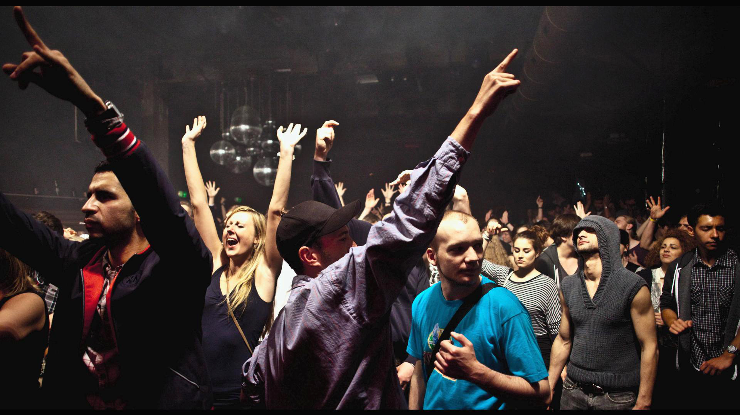
Berlin Bouncer, Germany 2019
From 15-29 October Barbican Cinema presents Nightlife: Ourselves, Our Spaces on Film, a season exploring the allure and glamour of night club culture.
Under cover of darkness, these spaces – clubs and bars – offer a place for people to come together, encounter like minds and express their true selves in safe havens – and of course enjoy themselves.
Gali Gold, Head of Cinema, says:
“Places and spaces to gather, encounter, share experiences and perform who we are, are critical for the formation of our identities, particularly those that are often in the margins. This fundamental truth takes a unique turn after dark, when certain barriers of convention are lifted and a more transgressive reality is celebrated.
Nightlife: Ourselves, Our Spaces on Film celebrates those places and the identities they bring to life through some exciting films, from Mexico City through to Taipei and NY, which by virtue of their Barbican screenings, create another space to gather, experience collectively and take mesmerising nocturnal cinematic journeys.
We’re particularly excited to open the programme with London’s Night Czar, Amy Lamé, in a screening of rare archive film from the BFI National Archive, bringing to life some of London’s vanishing queer spaces.”
This season takes cinema goers on a journey of passion, transgression and joy through a selection of curated films from around the world. Beginning in London - on Tue 15 Oct - with Queer Erasure? London’s LGBTQ+ Nightlife on Film + ScreenTalk, an evening of rarely screened archive film extracts drawn from the BFI National Archive (by BFI Curator Simon McCallum) that celebrate the capital’s most cherished LGBTQ+ venues (including amazing footage of The Gateways Club, The Royal Vauxhall Tavern and the Black Cap) many now long gone due to urban redevelopment.
After the programme, Simon McCallum and London’s Night Czar Amy Lamé, will discuss the films and consider what the future holds for London’s queer spaces.
The season continues with the story of New York’s legendary night club Studio 54 – and its array of eccentric punters – in 54: The Director’s Cut (US 1998) Mark Christopher’s film about sex, drugs and debauchery on the dance floor; this restoration of the 1998 disco drama is more faithful to the filmmaker’s original vision and is a considerably more explicit walk on the wild side.
Berlin’s wild side is revealed in Berlin Bouncer (Germany 2019, Dir David Dietl), which tells the story of the city’s transformation from divided city - to European party metropolis - through three night club bouncers from very different sides of the divide; the trio would go on to become the legendary ‘guardians’ of Berlin’s hippest clubs, including the famous Berghain.
Taipei’s neon-lit nightlife is deftly captured by Hou Hsiao-hsien in the hypnotic Millennium Mambo (Taiwan/ France 2001), which takes the viewer on a journey into the city’s techno-scored club scene at the turn of the 21st century.
The season closes with a screening of the cult classic Los Caifanes (aka The Outsiders) (Mexico 1967); in Juan Ibáñez’s film an affluent couple embark on a whirlwind tour of working-class nightlife in Mexico City, and take in the cabaret clubs, bars and taco joints and enjoy a night of drinking and dancing that leaves an indelible impression on them.
Nightlife: Ourselves, Our Spaces on Film is programmed in association with the Barbican Art Gallery exhibition Into the Night: Cabarets and Clubs in Modern Art.
Films screening:
Queer Erasure? London’s LGBTQ+ Nightlife on Film 15* + ScreenTalk with Amy Lamé and BFI National Archive Curator Simon McCallum - Digital presentation 15*
Tue 15 Oct 6.30pm, Cinema 1
An evening of rarely screened archive film extracts, recently digitised by the BFI National Archive and discussion, celebrating London’s most beloved and iconic LGBTQ+ venues, many long gone.
London’s queer clubs, bars and community centres have offered LGBTQ+ places to meet, have fun and find love and solidarity, but many of these treasured spaces have vanished, as urban redevelopment takes effect.
Running time approximately 100 min
Amy Lamé has a successful track record as a leader and collaborator in the cultural and creative industries and has served as London’s first Night Czar since 2016.
She is co-founder of the Olivier Award winning arts company and club night Duckie.
Originally from New Jersey, Amy has been a proud Londoner for over 25 years. She has served as London’s first Night Czar since 2016.
Discover more films about LGBT Britain on Film from the BFI National Archive for free via BFI Player
54: The Director’s Cut 15
US 1998, Dir Mark Christopher, 106 min Digital presentation
Fri 18 Oct 6.30pm, Cinema 2
Sex, drugs and debauchery on the dance floor – this restoration of the 1998 disco drama has it all.
When it was originally released in 1998, this vibrant story of the legendary Studio 54 nightclub and its array of eccentric punters, was cut by 40 minutes, removing some of the darker elements of the story and, crucially, any scenes showing the bisexuality of its central character, played by Ryan Phillippe.
This director’s cut restores the film to the filmmaker’s original vision, a considerably more explicit walk on the wild side, featuring some of the biggest rising stars of the 1990s. Mike Myers, who plays Steve Rubell, the club’s controversial co-founder, gives a career-best performance.
Berlin Bouncer 15*
Germany 2019 Dir David Dietl 87 min Digital presentation
Sat 19 Oct 4pm, Cinema 2
Berlin’s transformation from divided city to party metropolis are told in this film through the life stories of three legendary bouncers.
In the late 1980s, Frank Künster came from West Germany to Berlin, where Smiley Baldwin, an American GI, was guarding the border to East Berlin and Sven Marquardt, a young punk and photographer, was living on the other side.
When the Wall fell, nightclubs became some of the first truly reunited spaces in the city. Frank, Smiley and Sven were caught up in this scene and soon became the legendary ‘guardians’ of Berlin’s hippest clubs, including the famous Berghain.
This documentary tells their stories, taking them forward to the present where forces of gentrification threaten some of these formative places.
Millennium Mambo 15*
Taiwan/France 2001 Dir Hsiao-Hsien Hou 105 min 35mm presentation
Fri 25 Oct 6.30pm, Cinema 1
Hou Hsiao-hsien’s hypnotic masterpiece plunges us into the techno-scored neon-lit nightlife of Taipei at the turn of the 21st century.
Our guide for this nocturnal tour is Vicky; the film is structured from within her consciousness, remembering her life of ten years earlier, when she was working as a bar hostess. Leading a drifting, neon-lit existence and bored with her possessive DJ boyfriend, she finds herself gravitating towards a gangster named Jack.
With long takes, slo-mo, and close-ups that linger on colours, lights and textures, Vicky’s memories of Taipei’s club scene are distilled into images of amazing radiance and the film as a whole has an appropriately druggy, trance-like feel.
Los Caifanes (aka The Outsiders) 15*
Mexico 1967 Dir Juan Ibáñez 95 min Digital presentation
Tue 29 Oct 7pm, Cinema 2
A chance meeting leads to an all-night tour through Mexico City’s nightlife in this cult classic; one of Guillermo del Toro’s favourite films.
Leaving a swanky party, affluent couple Jaime and Paloma take refuge from the rain in what they think is an abandoned car.
Little do they know they’ve stumbled upon a set of wheels owned by Captain Gato and his gang, Los Caifanes, who invite the pair out to party with them.
And so begins a tour of the working-class nightlife of the Mexican capital, from cabarets to bars to outdoors taco joints – a night of drinking and dancing that leaves an indelible impression on the wealthy duo.
Film courtesy of Cinematográfica Filmex, DCP courtesy of Cineteca Nacional de México
Notes to Editors
For further information contact:
Ian Cuthbert, Communications Manager, Cinema
ian.cuthbert@barbican.org.uk/ 07980 925 352
Sarah Harvey, Cinema Press Consultant
sarah@sarahharveypublicity.co.uk/ 020 7732 7790
Ticket prices:
Box Office: 0845 120 7527
Standard: £12/ Members: £9.60/ Concessions: £11
Young Barbican: £5 * Local Classification
About Barbican Cinema
A fully curated programme of international cinema including thematic seasons, new releases, and special events presented in Cinemas 1, 2 and 3.
Our offer includes partnerships with film festivals, art & culture organisations, plus regular family screenings for young audiences and parent & baby screenings.
The Event cinema programme presents the best of the performing arts on screen.
About the Barbican
A world-class arts and learning organisation, the Barbican pushes the boundaries of all major art forms including dance, film, music, theatre and visual arts. Its creative learning programme further underpins everything it does. Over a million people attend events annually, hundreds of artists and performers are featured, and more than 300 staff work onsite. The architecturally renowned centre opened in 1982 and comprises the Barbican Hall, the Barbican Theatre, The Pit, Cinemas 1, 2 and 3, Barbican Art Gallery, a second gallery The Curve, public spaces, a library, the Lakeside Terrace, a glasshouse conservatory, conference facilities and three restaurants. The City of London Corporation is the founder and principal funder of the Barbican Centre.
The Barbican is home to Resident Orchestra, London Symphony Orchestra; Associate Orchestra, BBC Symphony Orchestra; Associate Ensembles the Academy of Ancient Music and Britten Sinfonia, Associate Producer Serious,
and Artistic Partner Create. Our Artistic Associates include Boy Blue, Cheek by Jowl, Deborah Warner, Drum Works and Michael Clark Company.
The Los Angeles Philharmonic are the Barbican’s International Orchestral Partner, the Australian Chamber Orchestra are International Associate Ensemble at Milton Court, and Jazz at Lincoln Center Orchestra are International Associate Ensemble.
Find us on Facebook | Twitter | Instagram | YouTube | Spotify

