Barbican Cinema
Hidden Figures:
Celebrating the films of Euzhan Palcy & Ha Gil-jong
Oct – Nov 2019
Barbican Cinema announces two Hidden Figures programmes for the autumn, showcasing great directors who deserve far greater recognition in the UK: Martinique filmmaker Euzhan Palcy in October, and Korean director Ha Gil-jong in November.
Alex Davidson, Barbican Cinema Curator says:
“While the work of Euzhan Palcy and Ha Gil-jong is beloved in their homelands of Martinique and South Korea respectively, UK audiences have had little chance to see their films, on the big screen or otherwise. Palcy became the first black woman to win a César (the French equivalent of the Oscars) for Sugar Cane Alley and Ha’s
The March of Fools was voted the best Korean of all time by native critics, and the time is right for their remarkable films to be seen here. We’re delighted to partner with HOME in Manchester and the London Korean Film Festival to bring their works to the Barbican.”
Euzhan Palcy
6 Oct – 26 Oct
www.barbican.org.uk/whats-on/2019/series/hidden-figures-euzhan-palcy
A Dry White Season, USA 1989, Dir Euzhan Palcy
Despite winning the Silver Lion at the Venice Film Festival, directing Marlon Brando to an Oscar nomination, and having created a rich and diverse range of acclaimed dramas that explore race and liberation across the world, Euzhan Palcy’s work remains neglected in the UK, and her films are rarely shown.
The Barbican’s Euzhan Palcy season, featuring introductions and discussions, includes her feature debut, Sugar Cane Alley (Martinque/ France 1983) which Palcy filmed in her homeland Martinique, and remains one of cinema’s great coming-of-age films, about a mischievous orphan and his indomitable grandmother. Palcy subtly criticises French colonial rule throughout the film.
Palcy’s 1989 drama A Dry White Season (USA), about the fall-out from a massacre in Apartheid-era South Africa, stars Donald Sutherland and Brando, in his best late-career performance. Her documentary series Aimé Césaire: A Voice For History (Martinque/France 1994) offers privileged access to the Martinique poet, author and politician, who co-founded the négritude literature movement.
These screenings are in partnership with HOME in Manchester who will also be showcasing Euzhan Palcy’s films in October as part of their year-long Celebrating Women in Global Cinema season.
Ha Gil-jong
4 Nov – 10 Nov
www.barbican.org.uk/whats-on/2019/series/hidden-figures-ha-gil-jong
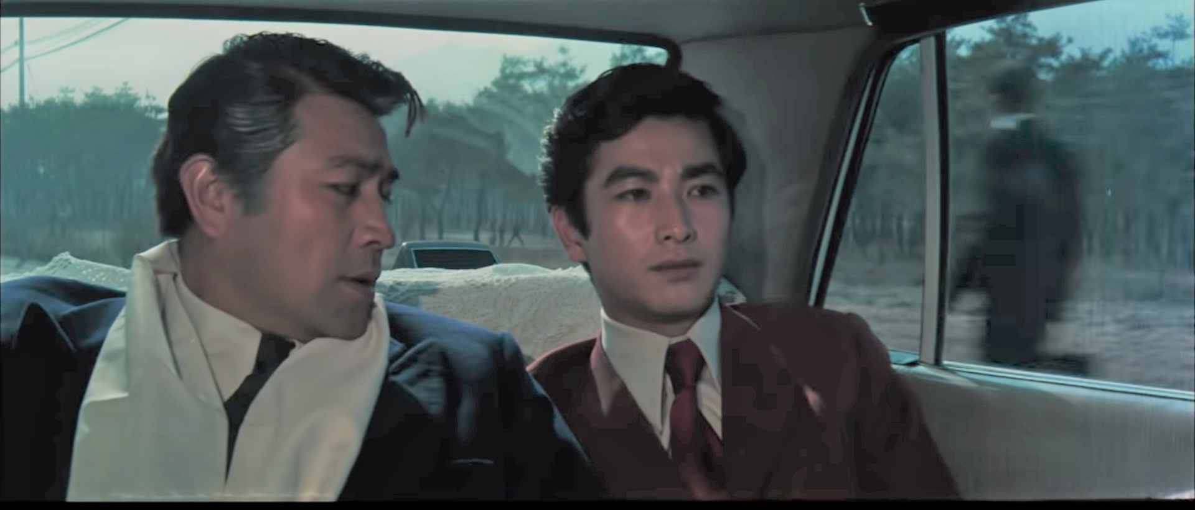
The Pollen of Flowers, South Korea 1972, Dir Ha Gil-jong
The provocative, brutal and captivating films of Ha Gil-jong – a major figure of 1970s Korean cinema, who died tragically young at 37 – are rediscovered in November’s Hidden Figures programme.

In the 1970s, Ha Gil-jong shook up Korean cinema, offering a thrillingly diverse series of features which critiqued the contemporary military dictatorship and put him in constant battle with film censors.

The three films in this programme embrace very different styles and genres – melodrama, comedy and horror – to comment and interrogate a troubled present.

The season opens with his ground-breaking debut The Pollen of Flowers (South Korea 1972), which blends satire with melodrama, as a businessman brings a male lover into his personal life, with cataclysmic results.
The film has echoes with Pasolini’s Teorema and is regarded as the first ever Korean film to depict a same-sex relationship.

Male relationships are also explored in The March of Fools (South Korea 1975) – a college comedy under dictatorship – as two students seek love and happiness in Ha’s best known film, a box office smash in 1975. With its fashions, music and shots of bustling city streets, it is an invaluable time capsule of 1970s Korean youth culture.

The season concludes with The Ascension of Han-ne (South Korea 1975), which mixes period drama and horror to investigate the negative impact of outdated Korean traditions. A woman is rescued from a suicide attempt, but later shunned by local villagers, due to the actions of a misogynist shaman; often disturbing and audacious in its use of tropes from traditional ghost stories, it remains one of Ha’s most intriguing films.

Ha Gil-jong is Co-curated and co-presented by the Barbican and the London Korean Film Festival & supported by the Korean Film Archive.

Hidden Figures - Euzhan Palcy
Sugar Cane Alley (Rue cases nègres) (12A*) + ScreenTalk with June Givanni and Priscilla Igwe
Martinque/France 1983 Dir Euzhan Palcy 103 min
Sun 6 Oct 2019, 18:00, Barbican Cinema 1
Darling Légitimus won the best actress award at Venice for her portrayal of a woman determined to better the life of her grandson in 1930s Martinique.
Euzhan Palcy’s first feature is one of cinema’s great coming-of-age tales. It follows José, an orphan living with his indomitable grandmother, Ma’Tine (Darling Légitimus). She works in the sugar cane fields, exploited by their white boss; adamant that José will avoid the same fate, she makes sacrifices to ensure he receives an education.
Palcy subtly criticises French rule throughout, such as when José faces backlash after writing an essay on colonial oppression.
Following this screening, curator Priscilla Igwe will be in conversation with curator and archivist June Givanni.
A Dry White Season (15) + intro
USA 1989 Dir Euzhan Palcy 106 min
Wed 16 Oct 2019, 18:20, Barbican Cinema 2

Euzhan Palcy became the first black woman to direct a Hollywood studio film for this potent drama set at the height of the anti-Apartheid movement.

Donald Sutherland, Susan Sarandon and Marlon Brando star in Euzhan Palcy’s scathing indictment of South African Apartheid. Sutherland plays Ben, a teacher who has been shielded from the plight of black South Africans, until the violent abuse of his gardener (Winston Ntshona) and the latter’s son brings the crisis to his door.

Brando was nominated for an Oscar for his bravura cameo as a sympathetic lawyer, while Zakes Mokae excels as Ben’s driver, who helps fight for justice.
Aimé Césaire: A Voice for History (12A’) + introduction by Professor Belinda Jack
Martinque/France 1994 Dir Euzhan Palcy 165 min (3 x 55 min episodes)
Sat 26 Oct 2019, 14:00, Barbican Cinema 2
Euzhan Palcy pays tribute to her mentor – author, civil rights activist and négritude co-founder Aimé Césaire – in this revealing documentary.

Euzhan Palcy gained privileged access to the Martinique poet, author and politician Aimé Césaire for this documentary series, made for French TV. Across nearly three hours, Palcy charts Césaire’s remarkable life, from growing up in Martinique to his tenure as mayor of Fort-de-France and his time in Paris, where he co-founded the négritude movement, celebrating black culture and identity.

Intellectuals and writers such as Maryse Condé and Maya Angelou discuss his legacy, while the interviews with Césaire himself offer great insight into a major figure in Francophone literature and politics.
Hidden Figures – Ha Gil-jong
The Pollen of Flowers (18*) + intro
South Korea 1972 Dir Ha Gil-jong 89 min
Mon 4 Nov 2019, 18:30, Barbican Cinema 2
Ha Gil-jong’s unforgettable debut blends satire with melodrama, as a businessman brings a male lover into his personal life, with cataclysmic results. From his first feature, Ha Gil-jong embraced subversion and provocation, as the fractious set-up between a corrupt businessman and his mistress is upended when he brings his male secretary and lover into their home.
The name of the mistress’ mansion – the ‘Blue House’, also the name of the residence of the South Korean head of state – makes the political implications of Ha’s film clear, with sharp jabs at the Park Chung-Hee regime. Regarded as the first Korean film to depict a same sex relationship, it’s an unflinching satire with echoes of Pasolini’s Teorema and the films of Kim Ki-young.
The March of Fools (15*) + intro
Screening in a 35mm presentation
South Korea 1975 Dir Ha Gil-jong 102 min
Wed 6 Nov 2019, 20:30, Barbican Cinema 2
College comedy under dictatorship – two male students seek love and happiness in Ha Gil-jong’s best known film, a box office smash in South Korea.
A much beloved Korean cinema classic from 1975, The March of Fools starts off as a bawdy comedy, as two slacker students get drunk and try to get laid, with varying degrees of success. Slowly the tone shifts into melancholy, as the two men consider their futures, in a repressive society where they feel out of place.
Although censored for its depiction of life under military dictatorship, The March of Fools remains a unique and exhilarating story of youth in crisis, while its fashions, music and shots of the bustling city streets make it an invaluable time capsule of 1970s Korean youth culture.
The Ascension of Han-ne (15*) + intro
Screening in a 35mm presentation
South Korea 1977 Dir Ha Gil-jong 96 min
Sun 10 Nov 2019, 18:00, Barbican Cinema 2
Ha Gil-jong’s personal favourite among his films blends period drama and horror to interrogate the negative impact of South Korean traditions.
In 19th century Korea, a woman is saved from a suicide attempt and brought back to the village of her rescuer. Here, she is regarded with fear and suspicion, with many believing she will bring them bad luck owing to the pronouncements of a corrupt shaman.
Although set far in the past, Ha critiques the present, as he explores how folkloric and often misogynist traditions echo into the present day, in a society framed by archaic patriarchal convention. Often disturbing, and audacious in its use of tropes from traditional ghost stories, it’s one of Ha’s most intriguing films.
Notes to Editors
For further information contact:
Ian Cuthbert, Communications Manager, Cinema
ian.cuthbert@barbican.org.uk/ 07980 925 352
Sarah Harvey, Press Consultant
sarah@sarahharveypublicity.co.uk/ 020 7732 7790
Ticket prices:
Box Office: 0845 120 7527
Euzhan Palcy screenings: £12, Members £9.60, Concs £11, Young Barbican £5
Ha Gil-jong screenings: £10, Memebers £8, Concs £9, Young Barbican £5
* Local Classification
About Barbican Cinema
A fully curated programme of international cinema including thematic seasons, new releases, and special events presented in Cinemas 1, 2 and 3.
Our offer includes partnerships with film festivals, art & culture organisations, plus regular family screenings for young audiences and parent & baby screenings.
The Event cinema programme presents the best of the performing arts on screen.
About the Barbican
A world-class arts and learning organisation, the Barbican pushes the boundaries of all major art forms including dance, film, music, theatre and visual arts. Its creative learning programme further underpins everything it does. Over a million people attend events annually, hundreds of artists and performers are featured, and more than 300 staff work onsite. The architecturally renowned centre opened in 1982 and comprises the Barbican Hall, the Barbican Theatre, The Pit, Cinemas 1, 2 and 3, Barbican Art Gallery, a second gallery The Curve, public spaces, a library, the Lakeside Terrace, a glasshouse conservatory, conference facilities and three restaurants. The City of London Corporation is the founder and principal funder of the Barbican Centre.
The Barbican is home to Resident Orchestra, London Symphony Orchestra; Associate Orchestra, BBC Symphony Orchestra; Associate Ensembles the Academy of Ancient Music and Britten Sinfonia, Associate Producer Serious,
and Artistic Partner Create. Our Artistic Associates include Boy Blue, Cheek by Jowl, Deborah Warner, Drum Works and Michael Clark Company.
The Los Angeles Philharmonic are the Barbican’s International Orchestral Partner, the Australian Chamber Orchestra are International Associate Ensemble at Milton Court, and Jazz at Lincoln Center Orchestra are International Associate Ensemble.
Find us on Facebook | Twitter | Instagram | YouTube | Spotify
About HOME
HOME is Manchester’s centre for international contemporary culture. Since opening in 2015, HOME has welcomed over two million visitors to its five cinemas, two theatres, art gallery, book shop and restaurants. HOME’s five screens showcase the best new independent film releases alongside a unique programme of film seasons, festivals, and special events. HOME's bold and diverse programming has screened 626 films from 57 countries in the past year, and its robust audience numbers consistently make HOME one of the UK's top performing independent cinemas for new releases.
www.homemcr.org | @HOME_mcr |Facebook HOMEmcr
About the London Korean Film Festival
The London Korean Film Festival (LKFF) is the UK’s leading showcase of Korean cinema, and with over 60 titles on offer annually, national press coverage and an ever-increasing audience, it’s one of the largest festivals dedicated to a national cinema in the world. Now in its 14th year, the festival has introduced premiere screenings of major blockbusters to UK cinema screens while also incorporating the most engaging Indie hits, Documentary, Animation, Shorts, Classics and more within its diverse programme.

