Barbican Cinema
Heat of the Moment: Turning Points on Film
Come Together: A Music Film Series
This summer, Barbican Cinema is presenting two summer themed seasons which run throughout August; these are both part of the Cinema Summer Special, offering a film and a beer, wine or soft drink for the combined price of £13.
Heat of the Moment: Turning Points on Film
1–29 Aug, Cinema 1 & 3
www.barbican.org.uk/whats-on/series/heat-of-the-moment-turning-points-on-film
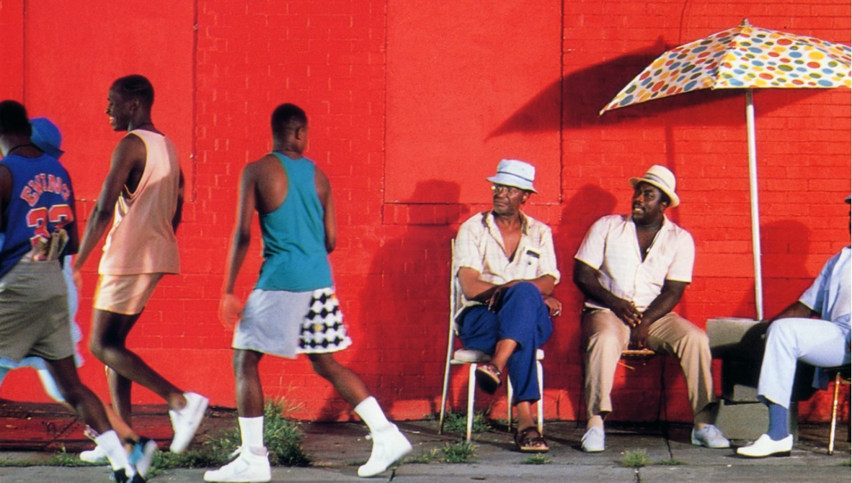
The boiling heat of summer is a catalyst for personal, political and social change in this selection of films, which screen every Thursday in August at the Barbican Cinema.
The programme brings together a diverse range of films – from the sixties to the noughties – and to mark its 30th anniversary, opens with a special screening of Spike Lee’s masterpiece Do the Right Thing (USA 1989). Set on the hottest day of the year, tensions in a Brooklyn neighbourhood culminate in a violent race riot in this ever relevant and prescient drama.
This special event opens with live poetry, followed by a screening of the film and the creation and presentation of a unique mural, painted by street artist Triplezed on the evening, inspired by views on Lee’s film submitted by the audience.
Social change is also pivotal in Stonewall (UK/ USA 1995, Dir Nigel Finch) which screens to mark the 50th anniversary of the famous riots. This tells the story of the rebellion that occurred when the gay and trans clientele of the Stonewall Inn fought back when the bar was raided by police.
Other highlights include I Knew Her Well (Italy 1965, Dir Antonio Pietrangeli), set in glamorous summertime 60s Rome, this follows the fluctuating fortunes of aspiring starlet Adriana, as she moves from the sticks to make it big in the city. Shot in glossy black and white, and set to a soundtrack of lush 60s Italian pop, summer in Italy looks and sounds great, but has an undercurrent as icy as gelato.
Things also turn sour in La Ciénaga (aka The Swamp, Argentina/France/Spain 2001) in a film that, in the words of the New York Times, ‘perspires from the screen.’ In Lucretia Martel’s accomplished debut feature an extended bourgeois family converge on the crumbling family estate one hot, sticky summer, and spend time lounging around a neglected brackish swimming pool, with a disastrous outcome.
Come Together: A Music Film Series
Fri 2 Aug – Fri 30 Aug, Cinema 3
www.barbican.org.uk/whats-on/series/come-together-a-music-film-series
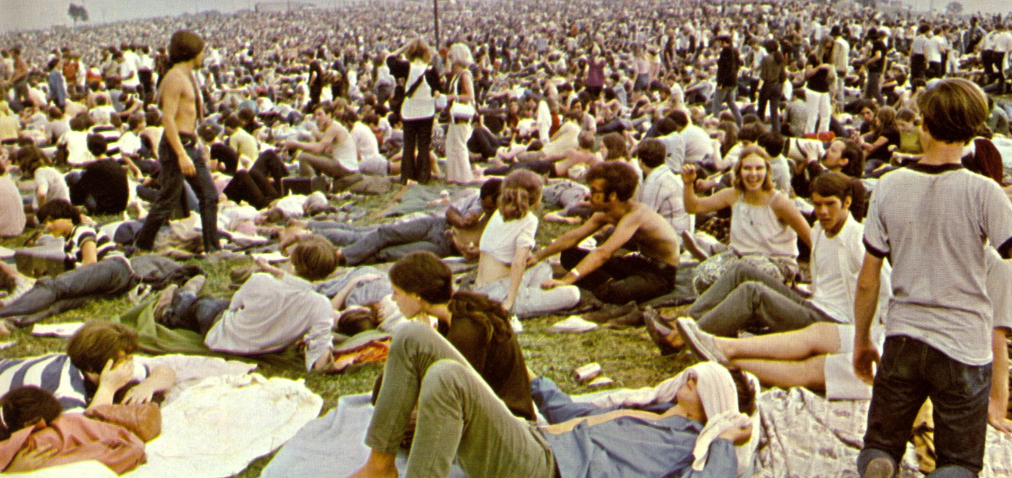
Every Friday in August, Barbican Cinema also presents Come Together - a season of concerts on film - offering the joy of the festival experience from the comfort of a cinema seat.
The season opens with Woodstock (US 1970, Dir Michael Wadleigh), the Academy-Award winning film that chronicles the legendary rock festival. One of the biggest events of all time and a glorious celebration of peace and music; the film includes performances from renowned artists including: Jimi Hendrix, The Who, Jefferson Airplane, Joni Mitchell and Janis Joplin.
Further highlights include Fela Kuti: Midsummer Concert, which features the Nigerian Afrobeat maestro closing Glastonbury 1984 in an electrifying performance; and a rare chance to see Laurie Anderson’s concert film Home of the Brave (USA 1986), ninety minutes of music and performance art accompanied by cutting-edge computer-generated animations.
Come Together closes with Monterey Pop (US 1970) in which prodigious documentarian D.A. Pennebaker deftly captures the raw musical power at this iconic music festival which took place in 1967, and launched the careers of Janis Joplin, Jimi Hendrix and Otis Reading.
Film Listings
Heat of the Moment: Turning Points on Film
Do the Right Thing (15) + live art and poetry
USA 1989 Dir Spike Lee 120 min
Thu 1 Aug 7pm, Cinema 1
A special screening of Spike Lee’s 1989 masterpiece to mark its 30th anniversary, featuring poetry and the creation of a new, unique mural.
Set on the hottest day of the summer, tensions in a Brooklyn neighbourhood culminate in a violent race riot in Spike Lee’s astonishing, tragically relevant drama. From its iconic opening credits to its unforgettable ending, Do the Right Thing changed how black lives were presented on screen.
This special screening will open with some new poetry specially written for this event, and the creation and presentation of a unique mural, painted by street artist Triplezed on the evening, inspired by the reactions of audience members to Lee’s film.
In partnership with We Are Parable
Screens with: Melting (US 1965 Dir Thom Andersen 6 min) a short film, from the director of Los Angeles Plays Itself, showing the disintegration of a strawberry sundae.
Le Bonheur ^{15*}
France 1965 Dir Agnès Varda 80 min
Thu 8 Aug 6.30pm, Cinema 3
The happiness of a family is threatened when the father has an affair in Agnès Varda’s brilliant, visually stunning study of sexual politics.
Criticised by contemporary critics for being anti-feminist, Le Bonheur is a razor-sharp portrait of a one-sided marriage, as the husband begins seeing another woman, with the full knowledge and apparent support of his wife. But his domestic bliss may not be as universal as he seems to believe.
Le Bonheur is Varda’s first colour film, and the screen glows with vibrant, candy-coloured shades, suggesting the artificiality of this supposed domestic idyll, set in a perennial summer haze. Described by the director as an apple with a worm inside, it’s a fearsome dissection of patriarchy and privilege.
Screens with: Melting (US 1965 Dir Thom Andersen 6 min) a short film, from the director of Los Angeles Plays Itself, showing the disintegration of a strawberry sundae.
I Knew Her Well ^{15*}
Italy 1965 Dir Antonio Pietrangeli 99 min Digital presentation
Thu 15 Aug 6.30pm, Cinema 3
In summertime 60s Rome, a wannabe starlet discovers la dolce vita is not so sweet.
Adriana (Stefania Sandrelli) is a hairdresser in a small, provincial seaside resort. A pretty girl, she dreams of making it in showbiz; upping sticks to Rome, she is reborn there as “Adri Astin”.
Adriana picks up the odd bit of work – a fashion shoot, a small film part – zips around in convertibles, hangs out at glamorous open-air nightspots, has a string of liaisons. The clothes are wonderful and the sun’s always shining but as she makes her way on the fringes of showbiz it seems she may at any moment tumble into a sleazier world of glamour modelling or prostitution.
Shot in glossy black and white, and set to a fabulous soundtrack of lush 60s Italian pop, summer in Italy looks and sounds great, but with an undercurrent as icy as gelato.
Screens with: Melting (US 1965 Dir Thom Andersen 6 min) a short film, from the director of Los Angeles Plays Itself, showing the disintegration of a strawberry sundae.
Stonewall ^{15*} + intro by Cinema Curator Alex Davidson
UK, USA 1995 Dir Nigel Finch 99 min
Thu 22 Aug 6.30pm, Cinema 3
A screening, marking the 50th anniversary of the Stonewall Riots, of the BBC drama-documentary about the run-up to the night of queer protest.
Nigel Finch’s fictionalised account of the lead-up to the 1969 Stonewall riots, the rebellion that occurred when the gay and trans clientele of the Stonewall Inn fought back when the bar was raided by the police, remains a powerful drama.
Unlike Roland Emmerich’s notorious 2015 film about the riots, Finch and screenwriter Rikki Beadle-Blair focus on the queer people of colour who resisted, sparking off the Gay Liberation Movement. Finch’s film stars gay actors in gay roles, a rarity at the time it was made, and is a must-see for anyone with an interest in queer history.
Screens with: Melting (US 1965 Dir Thom Andersen 6 min) a short film, from the director of Los Angeles Plays Itself, showing the disintegration of a strawberry sundae.
La Ciénaga (aka The Swamp) ^{12A}
Argentina/France/Spain/Japan 2001 Dir Lucretia Martel 100 min Digital presentation
Thu 29 Aug 6.45pm, Cinema 3
A bourgeois extended family converge on the crumbling family estate over one hot, sticky summer. What could possibly go wrong?
Opening on a memorably awful poolside party, the film has at its centre a terrible brackish swimming pool, full of murky green water and assorted debris. The teenage children come and go, but the parents are a permanent fixture, sitting around it quietly getting soused.
Ice cubes tinkle in a glass. Cicadas chirp. A chair is dragged across the patio. There is thunder. Nothing much ‘happens’ exactly but against a background of oppressive humidity, small events accumulate leaving us with the dread feeling that it can only be so long before someone gets hurt.
A film that, in the words of the New York Times, “perspires from the screen”, this first feature by Argentine director Lucretia Martel (The Headless Woman) is one of the great contemporary debuts.
Screens with: Melting (US 1965 Dir Thom Andersen 6 min) a short film, from the director of Los Angeles Plays Itself, showing the disintegration of a strawberry sundae.
Come Together: A Music Film Series
Woodstock ¹⁸
US 1970 Dir Michael Wadleigh 216 min Digital presentation
Fri 2 Aug 6.30pm, Cinema 3
The Academy-Award winning film chronicle of the legendary 1969 music festival.
Taking place over three days in 1969, Woodstock was one of the biggest rock festivals of all time and a cultural touchstone for the late 1960s.
A glorious celebration of peace and music, the festival featured performances from some of the most legendary recording artists of all time.
Thirty-two acts performed outdoors during the festival; from Jimi Hendrix, Creedence Clearwater Revival and The Who, to Jefferson Airplane, Joni Mitchell and Janis Joplin.
A pivotal moment in popular music history, as well as the definitive nexus for the larger counterculture generation.
Fela Kuti: Midsummer Concert ^{12A*}
Fri 9 Aug 6.45pm, Cinema 3
The Nigerian Afrobeat maestro closes Glastonbury 1984 with an electrifying performance, accompanied by his 20-piece band Egypt 80.
Fela Kuti performs two epic songs on Glastonbury’s Pyramid Stage in this vivid concert film, which wisely lets the music take centre stage, save two brief, revealing interviews with Kuti himself.
In the first half, he performs ‘C.B.B. (Confusion Break Bones)’. After Kuti discusses discovering his African identity in post-colonial Britain, he and his band perform the astonishing ‘Teacher Don’t Teach Me Nonsense’, about rejection of authority and abuse of democracy, across nearly 40 minutes. Later in 1984, Kuti was arrested in Nigeria, leading to a jail term widely considered to be politically motivated.
C***sucker Blues (aka CS Blues) ^{18*}
Fri 16 Aug 6.45pm, Cinema 3
US 1972 Dir Robert Frank, Danny Seymour 93 min Digital presentation
Long unreleased, this documentary is a revealing record of the Stones’ pivotal 1972 US tour.
Our screening of this legendary documentary is arranged courtesy of Robert Frank, whose involvement with the Rolling Stones began when he shot the cover for their Exile on Main Street album in 1971.
The next year, Frank documented the band’s American tour; their first since the tragic Altamont concert.
As well as in concert, Frank shot the band between shows – back stage, in hotel rooms and in transit – capturing the seedier moments of life on tour, footage that lays bare some of the uglier manifestations of the male-dominated rock and roll culture of the early 1970s.
Described by filmmaker Jim Jarmusch as “definitely one of the best movies about rock and roll I’ve ever seen”, C***sucker Blues (aka CS Blues) features some great music and some great performances, including a dazzling joint appearance with Stevie Wonder on ‘Uptight’ and ‘Satisfaction’.
© Robert Frank, 1972, distributed by The Museum of Fine Arts, Houston.
Home of the Brave (U) + intro by Cinema Curator Alex Davidson
USA 1986 Dir Laurie Anderson 90 min
Fri 23 Aug 6.30pm, Cinema 3
A rare chance to see Laurie Anderson’s astonishing concert film, shot in New Jersey in 1986, on the big screen.
Home of the Brave is one of the most visually inventive music concerts to be captured on film. 90 minutes of thrilling music and spoken word performance art are accompanied by cutting-edge computer-generated animations and electronically modified instruments.
Robert Ebert called it a cross between “a cosmic Garrison Keillor and Talking Heads”, although that description only scratches the surface of Anderson’s wonderfully weird numbers. Highlights include the haunting ‘Excellent Birds’, the entire, bonkers rendition of ‘Smoke Rings’ and a surprise cameo appearance from William S. Burroughs. There’s nothing else like it. F Rating
Monterey Pop ¹⁵
US 1970 Dir DA Pennebaker 79 min Digital presentation
Fri 30 Aug 6.40pm, Cinema 3
Prodigious documentarian D.A. Pennebaker captures the raw musical power on display at this iconic festival.
Very much a pre-cursor to Woodstock two years later, the ’67 Monterey Pop festival brought together some of the most iconic performers of the Summer of Love. The festival would launch the careers of Janis Joplin, Jimi Hendrix, and Otis Redding, but they were just a few among a wildly diverse cast that included the Mamas and the Papas, the Who, Simon and Garfunkel, the Byrds and many more, capturing a decade's spirit and ushering in a new era of rock and roll.
ENDS
Notes to Editors
For further information contact:
Ian Cuthbert, Communications Manager, Cinema
ian.cuthbert@barbican.org.uk/ 07980 925 352
Sarah Harvey, Cinema Press Consultant
sarah@sarahharveypublicity.co.uk/ 020 7732 7790
Ticket prices:
Box Office: 0845 120 7527
Standard: £12/ Members: £9.60/ Concessions: £11, Young Barbican: £5
* Local Classification
** Cinema Summer Special – throughout Jul & Aug **
Throughout July and August, film goers can book a film and enjoy a beer, wine or soft drink for the combined price of £13*
Valid for all screenings, including Thursday Heat of the Moment series, After the Wave, and Friday Come Together series, except: ScreenTalks, Festivals and Event Cinema. * plus booking fee
About Barbican Cinema
A fully curated programme of international cinema including thematic seasons, new releases, and special events presented in Cinemas 1, 2 and 3.
Our offer includes partnerships with film festivals, art & culture organisations, plus regular family screenings for young audiences and parent & baby screenings.
The Event cinema programme presents the best of the performing arts on screen.
About the Barbican
A world-class arts and learning organisation, the Barbican pushes the boundaries of all major art forms including dance, film, music, theatre and visual arts.
Its creative learning programme further underpins everything it does. Over a million people attend events annually, hundreds of artists and performers are featured, and more than 300 staff work onsite.
The architecturally renowned centre opened in 1982 and comprises the Barbican Hall, the Barbican Theatre, The Pit, Cinemas 1, 2 and 3, Barbican Art Gallery, a second gallery The Curve, public spaces, a library, the Lakeside Terrace, a glasshouse conservatory, conference facilities and three restaurants. The City of London Corporation is the founder and principal funder of the Barbican Centre.
The Barbican is home to Resident Orchestra, London Symphony Orchestra; Associate Orchestra, BBC Symphony Orchestra; Associate Ensembles the Academy of Ancient Music and Britten Sinfonia, Associate Producer Serious, and Artistic Partner Create.
Our Artistic Associates include Boy Blue, Cheek by Jowl, Deborah Warner, Drum Works and Michael Clark Company. The Los Angeles Philharmonic are the Barbican’s International Orchestral Partner, the Australian Chamber Orchestra are International Associate Ensemble at Milton Court, and Jazz at Lincoln Center Orchestra are International Associate Ensemble.
Find us on Facebook | Twitter | Instagram | YouTube | Spotify

