Barbican Cinema
Forbidden Colours
9 Jul & 22 Oct ’19
www.barbican.org.uk/forbiddencolours
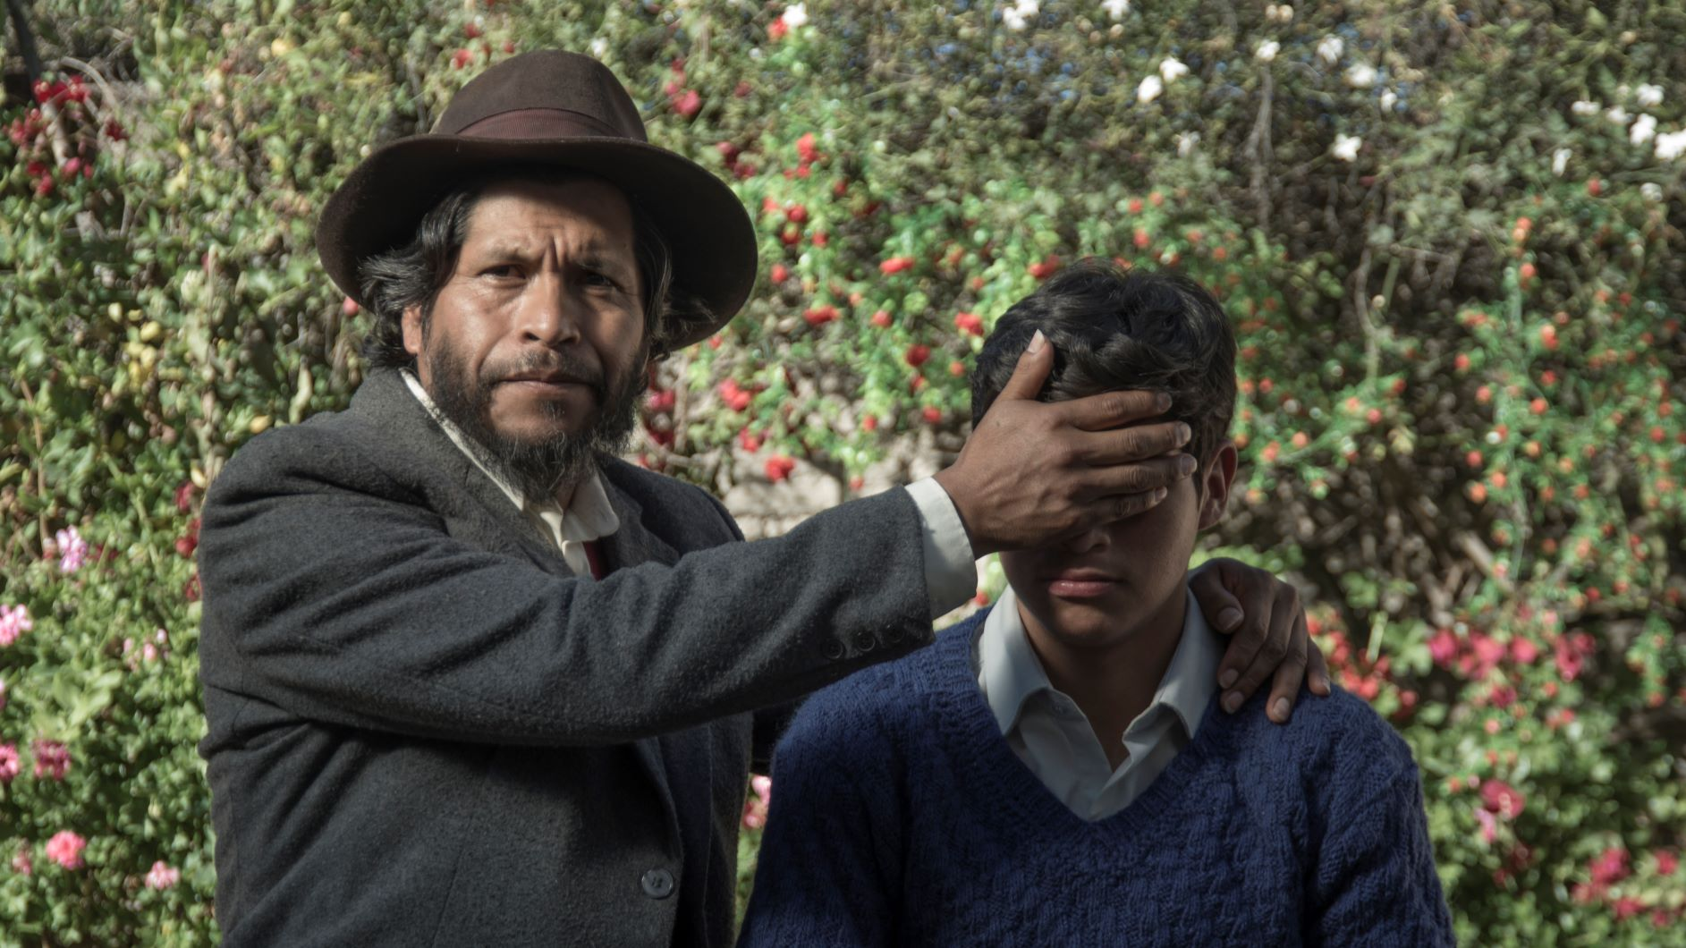
Barbican Cinema is pleased to present Forbidden Colours, a new strand which celebrates rarely seen queer-focused films from places where LGBTQ+ people still suffer societal oppression and struggle for equality.
Opening on 9 July – with the Peruvian film Retablo – this series offers an opportunity for these stories and points of view to be seen on the big screen. Despite huge progress made for LGBTQ+ equality, homosexuality remains illegal in more than 70 countries - as identified by Stonewall - with Brunei briefly joining the ranks of nations where gay sex is punishable by death.
Even in places where legislation has improved, social attitudes are far slower to change and in many societies Queer people still suffer rife oppression, discrimination and deep lack of genuine acceptance.
Yet, despite the oppression queer people continue to face, some great films portraying sympathetic, well rounded LGBTQ+ characters, queer experiences and sensibilities, have emerged from regions where homophobia and persecution of queer people has been normalised. Forbidden Colours will showcase these films, celebrating queer visibility in contemporary international cinema.
Alex Davidson (Barbican Cinema Curator) comments:
“The last few years have been a golden era for queer cinema, but films from places where LGBTQ+ continue to face deeply intrenched prejudice, human rights restrictions, criminalisation and even the death penalty are seldom seen in cinemas in the UK.
Forbidden Colours will present brave and brilliant films about queer people from these communities, often made under challenging circumstances, beginning with the London premieres of two films from Peru and Romania. We are excited to offer audiences the opportunity to see these films on the big screen, complemented with introductions and ScreenTalks with special guests.”
Films screening
Retablo (18*) + Introduction
Peru/Germany/Norway 2017 Dir Alvaro Delgado Aparicio, 95 min
9 Jul 2019, 18:30, Barbican Cinema 2
Alvaro Delgado Aparicio’s beautiful, powerful drama Retablo features excellent performances, especially from Junior Bejar as the conflicted teen living in a Peruvian Andes village, struggling with complex emotions in an oppressive environment where male vulnerability is held in contempt.
In this highly acclaimed drama, Segundo is a young apprentice learning how to make retablos – artisan story-boxes depicting personal scenes – under the tutelage of his adored father. One day, Segundo finds out that his father has been unfaithful to his wife with other men.
In a community defined by traditional values, Segundo decides to keep this revelation a secret, even as it threatens to tear his world apart.
This screening is introduced by David Edgar, Film Officer at the Royal Anthropological Institute.
Several Conversations about a Very Tall Girl (15*) + ScreenTalk
Romania 2018 Dir Bogdan Theodor Olteanl, 70 min
22 Oct 2019, 18:30 ,Cinema 2
Two young women – one out and proud, the other less confident in her sexuality – begin a tentative affair in this sensitive Romanian drama.
In Bogdan Theodor Olteanu’s intimate drama, a confident lesbian filmmaker (Florentina Nastase) and a shy woman (Silvana Mihai) realise they have an ex-girlfriend in common and, after communicating online, start to date each other.
Although LGBTQ+ rights in Romania have improved in recent years, it remains a conservative society; Nastase’s character recalls a violent hate crime, the other woman is plagued by shame and internalised homophobia. Both actors are excellent, and Olteanu’s debut feature is a quietly powerful depiction of the challenges of being yourself in a hostile climate.
Notes to Editors
For further information contact:
Ian Cuthbert, Communications Manager, Cinema
ian.cuthbert@barbican.org.uk/ 07980 925 352
Sarah Harvey, Cinema Press Consultant
sarah@sarahharveypublicity.co.uk/ 020 7732 7790
Ticket prices:
Box Office: 0845 120 7527
Standard: £13.50 & £12/ Members: £9.60 &10.80/ Concessions: £12.50 &£11
Young Barbican: £5 * Local Classification
About Barbican Cinema
A fully curated programme of international cinema including thematic seasons, new releases, and special events presented in Cinemas 1, 2 and 3.
Our offer includes partnerships with film festivals, art & culture organisations, plus regular family screenings for young audiences and parent & baby screenings.
The Event cinema programme presents the best of the performing arts on screen.
About the Barbican
A world-class arts and learning organisation, the Barbican pushes the boundaries of all major art forms including dance, film, music, theatre and visual arts. Its creative learning programme further underpins everything it does. Over a million people attend events annually, hundreds of artists and performers are featured, and more than 300 staff work onsite. The architecturally renowned centre opened in 1982 and comprises the Barbican Hall, the Barbican Theatre, The Pit, Cinemas 1, 2 and 3, Barbican Art Gallery, a second gallery The Curve, public spaces, a library, the Lakeside Terrace, a glasshouse conservatory, conference facilities and three restaurants. The City of London Corporation is the founder and principal funder of the Barbican Centre.
The Barbican is home to Resident Orchestra, London Symphony Orchestra; Associate Orchestra, BBC Symphony Orchestra; Associate Ensembles the Academy of Ancient Music and Britten Sinfonia, Associate Producer Serious, and Artistic Partner Create. Our Artistic Associates include Boy Blue, Cheek by Jowl, Deborah Warner, Drum Works and Michael Clark Company. The Los Angeles Philharmonic are the Barbican’s International Orchestral Partner, the Australian Chamber Orchestra are International Associate Ensemble at Milton Court, and Jazz at Lincoln Center Orchestra are International Associate Ensemble.
Find us on Facebook | Twitter | Instagram | YouTube | Spotify

