Chronic Youth Film Festival 2019
23 – 24 Mar 2019
www.barbican.org.uk/whats-on/2019/series/chronic-youth-film-festival-2019
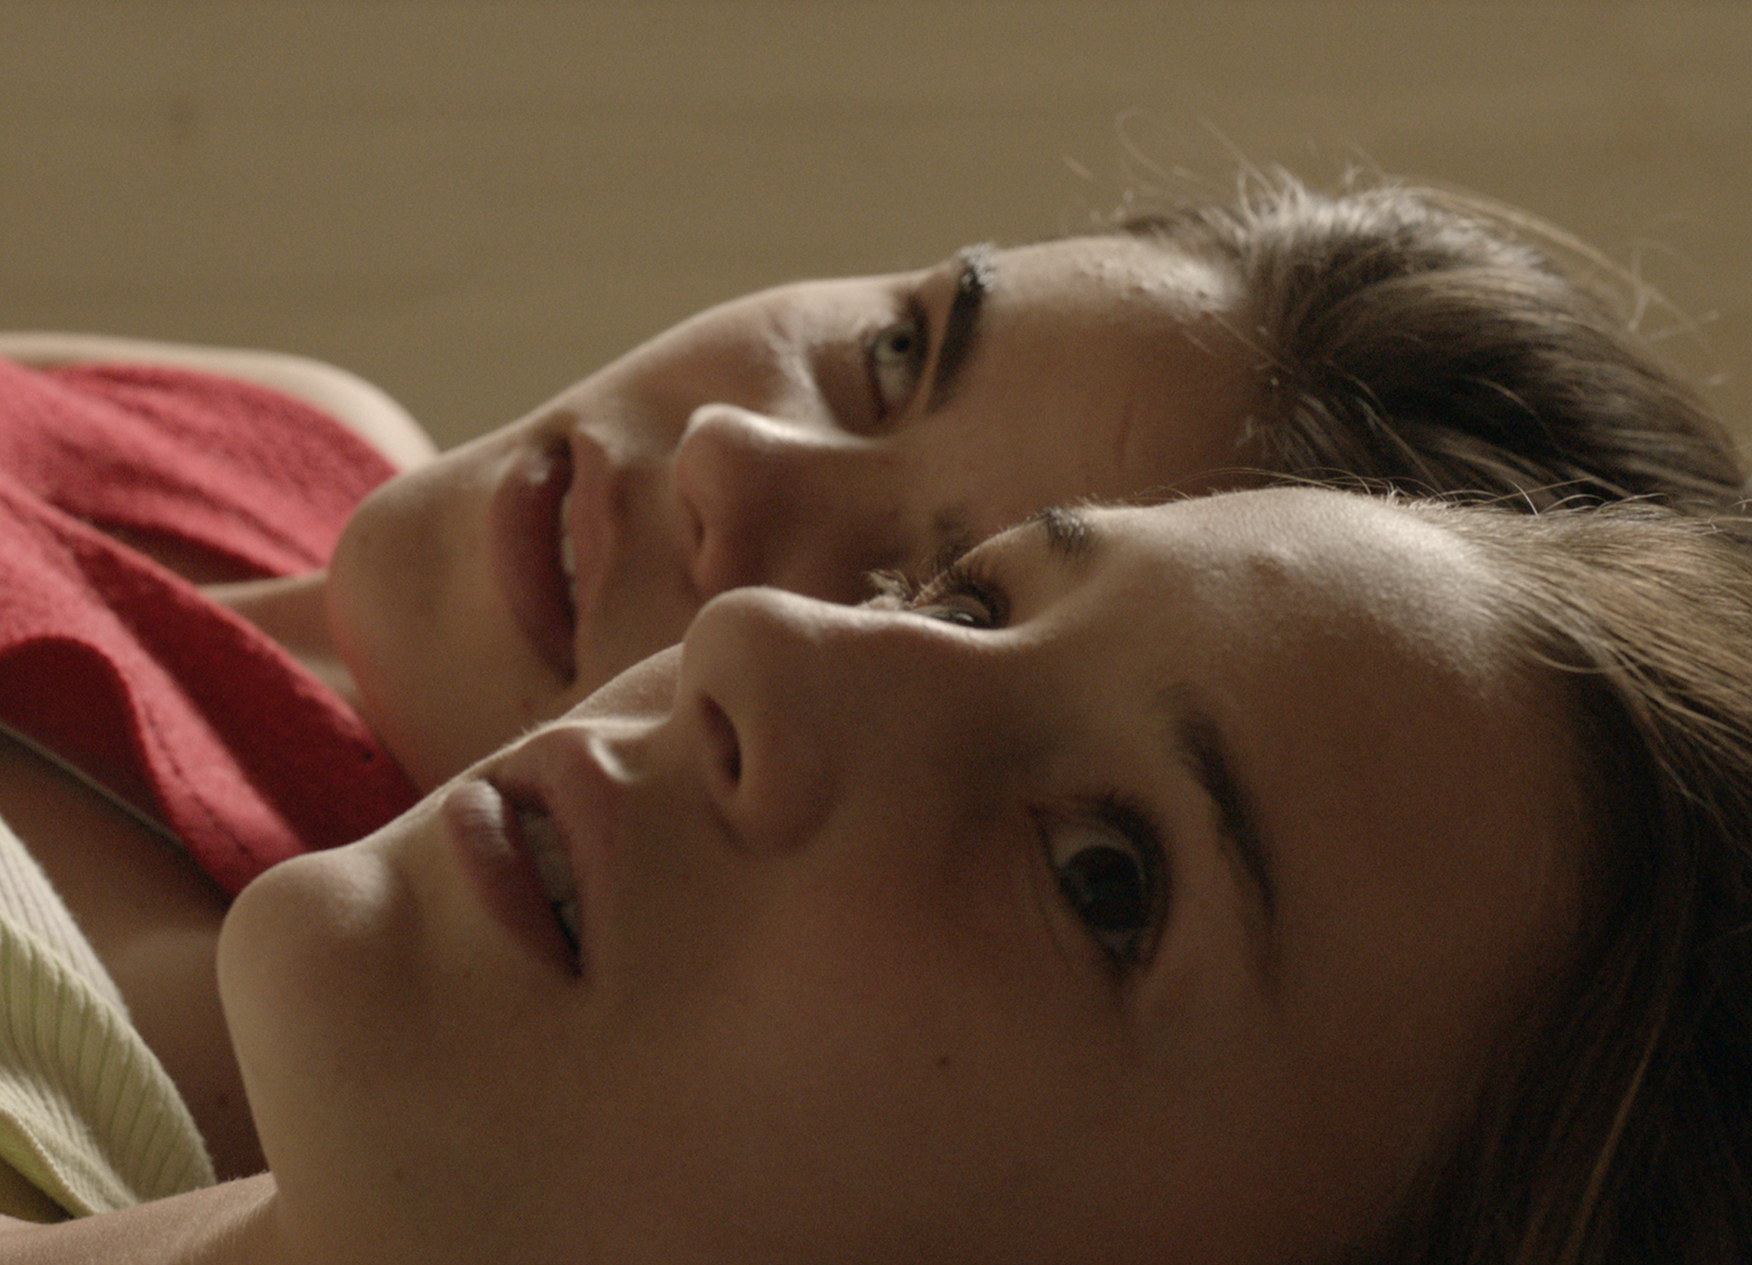
This year’s Chronic Youth Film Festival, the result of a seven-month collaborative exploration by Barbican Young Programmers aged 15 to 25, showcases a series of innovative films that deal with escape and rebellion across diverse countries, cultural environments and opposing landscapes.
Luis Correia and Ufuoma Essi, Barbican Young Programmers said:
“Our 2019 Chronic Youth festival is a collective result of the individual voices and tastes of a diverse group of programmers, filmmakers, and storytellers from across the UK and Europe. The programme’s most distinctive feature is that we have brought films from around the globe and films with a strong emphasis on female-led narratives. We are proud to present a festival that is socially engaged, innovative, and uplifting.”
The programme includes UK premiers, Q&A’s, an open submission shorts programme, and a showcase of British archive films which reflect upon and challenge the shifting role of youth culture within society at large, and provide a platform for emerging film-makers programmers to reach new audiences,
The films cover the myriad of issues young people face today, from dysfunctional families, body image and sexuality, to moving cities, chasing ambitious careers and the harsh realities of millennial post-graduate life.
Highlights include Isaac Julien’s ground-breaking Young Soul Rebels, a sharp snapshot of 1970s London youth culture, and the energetic and 90s-nostalgic Crystal Swan, about a young Belarusian woman aspiring to make it as a techno DJ. Other cinematic jewels include UK premieres of the Brazilian film Two Irenes – an enchanting ode to early adolescence – and the South African docu-drama We Are Thankful, a captivating story following a young man’s quest to land a life-changing role in a feature film.
Events and Films screening
Into the Archive (15*) + panel discussion
23 Mar 2019, 14:00, Barbican Cinema 2
A special opportunity to see four rare, archival films that tackle diversity through the decades in London.
Spanning the seventies, eighties and nineties, these films encapsulate and preserve the history and diverse culture in London, covering themes still relevant to the contemporary youth experience. The Barbican Young Programmers are delighted to host a panel event with directors Helen Petts (MsTaken Identity), Alnoor Dewshi (Latifah and Himli's Nomadic Uncle) and Menelik Shabazz (Step Forward Youth)
The panel will expand on the importance of recognising and celebrating the power of archival film, and how different eras have and can utilise film as a creative tool to project the voices of youth culture.
Step Forward Youth - Menelik Shabazz - 29 min – 1977
Menelik Shabazz’s 1977 political yet playful documentary successfully weaves in the voices of local Brixton youths. This film magnifies their social observations through mediating upon their dreams, aspirations and clothing choices.
Latifah and Himli's Nomadic Uncle - Alnoor Dewshi - 15 min – 1992
A beautifully poetic and sometimes surreal exploration of the duality between nomadic heritage and the first-generation experience of metropolitan England.
MsTaken Identity - Helen Petts & Karen Alexander - 26 min - Video – 1985
Through close collaboration with community-led feminist youth groups, Helen Petts collages a series of sketches exploring feminine discourse of the 1980s. MsTaken Identity simultaneously critiques and entertains conversations that women are still having today.
Tealeaf – Ruth Novaczek - 8 min - 1988
The first of many works made by experimental filmmaker Ruth Novaczek. By projecting a range of Super 8 shots on top of one another, Novaczek creates layered and complex.
Crystal Swan (15*)
Belarus 2018, dir Darya Zhuk. 95 min
23 Mar 2019, 14:15, Barbican Cinema 3
Crystal Swan is the energetic debut feature by Darya Zhuk’s (and the first feature- length film by a Belarusian woman).
In post-communist Belarus, recent graduate Velya (Alina Nasibullina) attempts to forego Minsk in favour of chasing the American Dream and aspirations of becoming a techno DJ in Chicago. When due to complications on her Visa application things take a turn for the worst, she is forced to resort to desperate measures.
Appearing almost light-hearted due to its colourful art direction, Crystal Swan soon reveals a harsher reality that packs an emotional punch. The tongue-in-cheek rebellion of the electronic scene of the 1990s, is juxtaposed against the struggles of a broken country.
Night Comes On (15*)
USA 2018, Dir Jordana Spiro 84 min, Cert 15
23 Mar 2019, 16:15, Barbican Cinema 2
Jordana Spiro’s tender and loving first feature Night Comes On is a touching story of sisterhood and the impact of childhood trauma featuring magnetic lead performances from Dominique Fishback (The Hate U Give) and debut by Tatum Marilyn Hall. Co-written by Spiro and Angelica Rwanda for whom the film is semi-autobiographical, Night Comes On is a bittersweet revenge tale that rebirths into new possibilities.
At eighteen, Angel has just been released from a young offenders centre. Mourning the loss of her childhood, she embarks on a mission to hunt down her father and reconcile her family traumas. Accompanied and bolstered by the infectious innocence of her effervescent younger sister Abby, Angel begins to find solace.
Young Soul Rebels (18)
UK 1991, dir Isaac Julien, 105 min
23 Mar 2019, 18:00, Barbican Cinema 2
A masterpiece of black British cinema, this cult classic presents a unique perspective of black British masculinity and a sharp and syncopated snapshot of youth culture in 1970s London.
Two young best friends Chris and Caz run an underground soul radio station in the heart of the violent, tumultuous 1970s East London. Their altercations with the law; and experience of living amongst punks, skinheads and soul boys is examined with a colourful lens. Capturing the vibrancy and rebellion of music, the film contains a rare depiction of queer inner-city youth in the 1970s.
Into The Archives
23 Mar 2019, 20:00, Cinemas 2 & 3 foyers
Barbican Young Visual Artist Shamica Ruddock, Barbican Young Poets and the Barbican Young Programmers have collaborated to create a multimedia performance piece, featuring archive films, music by Barbican Young Programmer Meenu, and live poetry by poets.
Youth Invisible Shorts (15*)
24 Mar 2019, 12:00, Free, Cinemas 2 & 3 foyers
A series of short films that focus on unseen youth, with common ground in their experimental take on the medium through animation.The Barbican Young Programmers have invited independent short-filmmakers to share their work,
responding to ideas raised by this year’s selection of feature films: escape, rebellion, and experiences of growing up that aren't bound within the borders we live in.
Each screening will be followed by a discussion with the directors and cast/crew available, alongside Barbican Young Programmers, discussing everything from cinematic inspiration to ideas for the future.
This event is free and not ticketed but there is limited space, therefore places are available on a first come, first served basis.
Two Irenes (UK Premiere) (15*)
Brazil 2018, dir Fabio Meira, 89min,
24 Mar 2019, 14:00, Barbican Cinema 3
The UK premiere of Fabio Meira’s refreshing coming-of-age drama, centred on the inception of an odd friendship between two girls and complex family dynamics.
In the shimmering heat of Brazil, we follow teenager Irene as she befriends another girl named Irene who is, in her eyes, the perfect version of herself.
Discovery of a secret her father has been hiding leads her down a path of emotional unravelling, gently wading through adolescent anxieties around sexuality, identity and the meaning of family.
An enchanting and heart-warming ode to early adolescence masterfully enacted by the young protagonists’ lead performances.
Little Forest (15*)
Korea 2018, dir Yim Soon-rye, 104 min,
24 Mar 2019, 16:00, Barbican Cinema 3
Based on the slice-of-life manga Ritoru Foresuto by Daisuke Igarashi, director Yim Soon-rye uses a colourful and vivid lens to depict the universal toil of finding your way in life in Little Forest.
Recently graduated from university, Hye-won is disillusioned by her life in Seoul – she works a dead-end job and eats terrible food. After returning to her hometown, in countryside South Korea, she plunges into a journey of self-discovery by rekindling old friendships and cooking up a storm.
Yim Soon-rye’s tasty slice of feel-good realism celebrates the restorative ability of food to evoke feelings of tenderness and home, and the power of everyday perseverance within oneself.
We Are Thankful (UK Premiere) (15*) + ScreenTalk with Joshua Magor
South Africa 2018, dir Joshua Magor, 97 min
Sun 24 Mar 2019, 18:15, Barbican Cinema 3
Set in a small-town South Africa, first-time director Joshua Magor’s one-of-a-kind docu-drama tells the story of how the film's lead actor and director came to meet.
Blurring the lines between documentary and fiction, we accompany Siyabonga (Siyabonga Majola) on his odyssey-like quest to go beyond the confines of his rural, close-knit South African community.
Chasing a potentially life-changing opportunity with a film production company in a neighbouring city, Siyabonga's sense of urgency is contrasted by his relaxed surroundings through slow, bucolic scenes. With generous doses of humour, the film depicts Siyabonga becoming his own agent in life, leading to surprising and uplifting results.
We are delighted that director, Joshua Magor will join us after the film for a Q&A with the Young Programmers.
Notes to Editors
For further information contact:
Ian Cuthbert, Communications Manager, Cinema
ian.cuthbert@barbican.org.uk/ 07980 925 352
Sarah Harvey, Press Consultant
sarah@sarahharveypublicity.co.uk/ 020 7732 7790
Ticket prices:
Box Office: 0845 120 7527
Standard: £10.50, Barbican Members: £8.40, Concs: £9.50, Young Barbican: £5.00
About Barbican Cinema
A fully curated programme of international cinema including thematic seasons, new releases, and special events presented in Cinemas 1, 2 and 3.
Our offer includes partnerships with film festivals, art & culture organisations, plus regular family screenings for young audiences and parent & baby screenings. The Event cinema programme presents the best of the performing arts on screen.
About the Barbican
A world-class arts and learning organisation, the Barbican pushes the boundaries of all major art forms including dance, film, music, theatre and visual arts.

Its creative learning programme further underpins everything it does. Over 1.1 million people attend events annually, hundreds of artists and performers are featured, and more than 300 staff work onsite.
The architecturally renowned centre opened in 1982 and comprises the Barbican Hall, the Barbican Theatre, The Pit, Cinemas 1, 2 and 3, Barbican Art Gallery, a second gallery the Curve, foyers and public spaces, a library, Lakeside Terrace, a glasshouse conservatory, conference facilities and three restaurants. The City of London Corporation is the founder and principal funder of the Barbican Centre.
The Barbican is home to Resident Orchestra, London Symphony Orchestra; Associate Orchestra, BBC Symphony Orchestra; Associate Ensembles the Academy of Ancient Music and Britten Sinfonia,
Associate Producer Serious, and Artistic Partner Create. Our Artistic Associates include Boy Blue, Cheek by Jowl, Deborah Warner, Drum Works and Michael Clark Company.
The Los Angeles Philharmonic are the Barbican’s International Orchestral Partner, the Australian Chamber Orchestra are International Associate Ensemble at Milton Court and Jazz at Lincoln Center Orchestra are International Associate Ensemble.
Find us on Facebook | Twitter | Instagram | YouTube | Spotify

