Thu 21 March 2024

The Devil Finds Work: James Baldwin Through Film
Thu 2 May - Wed 22 May
Barbican Cinema is pleased to mark the centenary of the birth of James Baldwin – one of the most influential writers and activists of the 20th century – with The Devil Finds Work: James Baldwin Through Film.
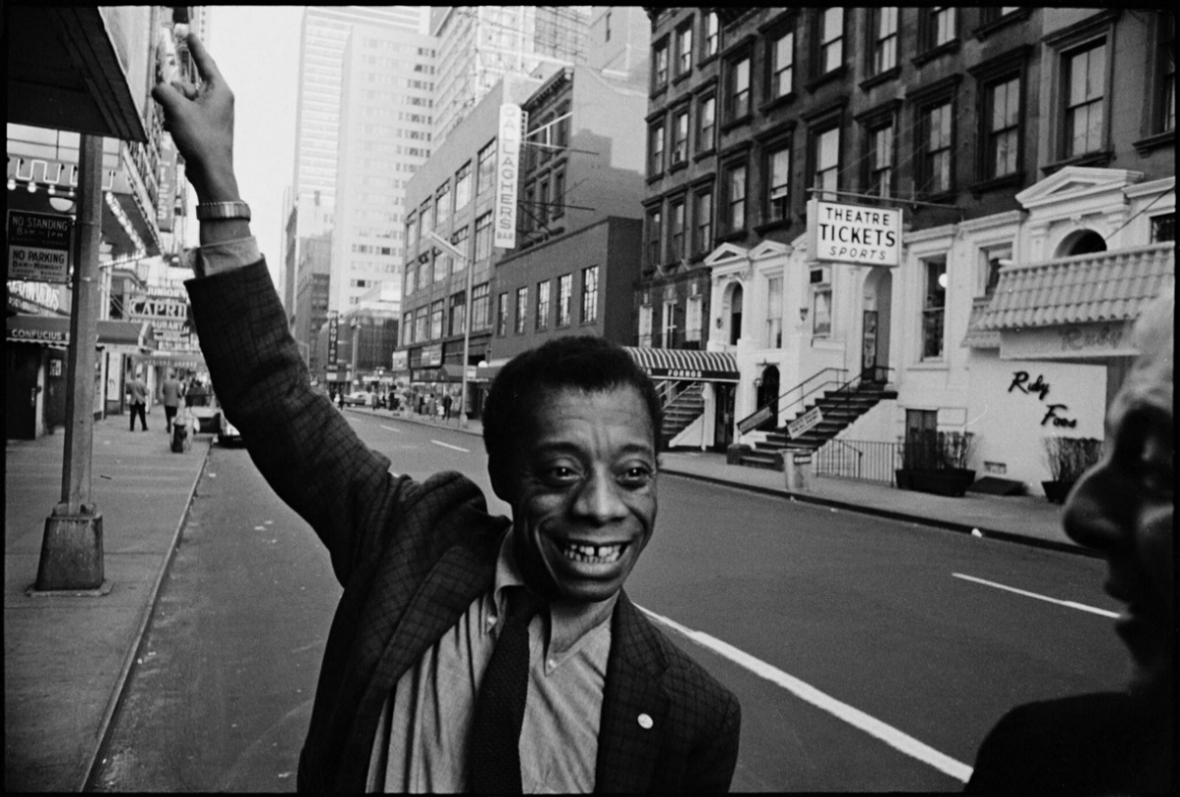
Curated by Dr Clive Chijioke Nwonka, this season explores Black representation in modern cinema through the ideas in James Baldwin’s 1976 seminal book The Devil Finds Work, with a selection of inspiring contemporary films.
Baldwin’s book is a personal exploration of American filmmaking and racial politics. Despite being published nearly 50 years ago it remains a valuable account of Black representation and the influence of Hollywood.
The season looks at James Baldwin’s approaches to cinema and film criticism placing the films in dialogue with literature, popular culture, politics and society. There will be a
ScreenTalk after each film to discuss its relevant themes and Baldwin’s influence.
The Devil Finds Work: James Baldwin Through Film opens with the Oscar nominated If Beale Street Could Talk (with recorded intro by director Barry Jenkins) the 2018 adaptation of James Baldwin’s 1974 novel.

This Harlem set story of a young relationship, developing against a backdrop of racial politics of 1970s America, offers an entry point to Baldwin’s themes of Black injustice, the Black family and love. There will also be ScreenTalk with scholar, poet and critic Dr Janine Bradbury about his influence on Jenkins’ filmmaking and how the director went about its screen adaptation.
This follows with Steve McQueen’s debut feature Hunger, which looks at themes of personal and national freedoms and bodily suffering, which Baldwin investigates as a means of approaching cinema more broadly.
The film is an under-appreciated examination of the 1981 Hunger Strike by IRA prisoner Bobby Sands and his experiences of political oppression; and this screening, inspired by Baldwin’s analysis of the 1958 prison drama The Defiant Ones, asks how the audience responds when they are confronted with images of human suffering. Following the film there will be a ScreenTalk with the playwright and screenwriter Enda Walsh and the scholar, poet and critic Dr Janine Bradbury.
The Devil Finds Work shorts programme looks at further themes around the condition of Black existence. There are several short films by contemporary artist filmmakers – including Ayo Akingbade and Rhea Storr – that cover urban life, Black/diasporic identity, spacial injustice and displacement. A ScreenTalk including Rhea Storr will trace the influence of Baldwin’s voice in the work of contemporary filmmaking and narrative practice.
The season closes with a 35mm screening of Claire Denis' 35 Shots of Rum, a father/daughter drama about multiracial relationships, followed by a ScreenTalk with Dr Hélène Neveu Kringelbach relating the work to Baldwin's ideas on interracial representation on screen.
Building on Baldwin’s thinking, Claire Denis’ accomplished drama looks at the subtle and everyday experiences of a multiracial community and asks the audience to consider the role of interraciality in regard to social change, belonging and cultural identify.
Central to Baldwin’s The Devil May Find Work is the question of interracial relationships as a cinematic spectacle. Baldwin asserts that by looking at interracial relationships on screen, the viewer gains an understanding of the racial climate of American society through the way it responds to different forms of Black masculinity.
Dr Clive Chijioke Nwonka says:
“James Baldwin’s The Devil Finds Work remains an important but underappreciated publication. Having both researched and taught Baldwin in film and literature, it has been a long ambition of mine to curate a public cinema programme that, rather than re-screening the many valuable but well-circulated films on Baldwin, his life and his works, instead asks a number of questions: how can we apply Baldwin’s ideas on film to contemporary works? What themes emerge from contemporary cinema that speak to Baldwin’s perspectives on how cinema both constructs and is constructed by society, politics and culture? How do filmmakers draw influence from Baldwin’s ideas on film, Black identity, culture and racial politics in their own visual approaches?
This programme brings together a diverse range of films, filmmakers and perspectives to consider the looking practices, representations and ideas embedded in and emerging from cinema that all find some reference in Baldwin’s thinking on cinema, society and identity.”
Gali Gold, Head of Barbican Cinema says:
“The connection between film, society and politics has always been a prism through which I see the work of cinema and its power. Baldwin masters drawing these connections as they work their way between his personal disposition as a viewer and a Black man growing up in
the US and the racial politics in American society.

This programme demonstrates how these valuable critical insights can be useful today in the way we look at how films are made, watched and discussed. It keeps the legacy of Baldwin as a brilliant thinker and influential activist alive and meaningful.”
This is part of the ‘James Baldwin and Britain’ project (2024-2027), led by Douglas Field, Kennetta Hammond Perry and Rob Waters, with thanks for the generous support by the Arts and Humanities Research Council.

The film programme is curated by Dr Clive Chijioke Nwonka.

Screenings:
If Beale Street Could Talk (15*) + recorded intro by Barry Jenkins + ScreenTalk and scholar, poet and critic Dr Janine Bradbury.
US 2018, Dir Barry Jenkins, 117 min
Thu 2 May, 6pm, Cinema 2
This screening will be shown with closed captions.
Hunger (15*) + ScreenTalk with playwright/ screenwriter Enda Walsh and scholar, poet and critic Dr Janine Bradbury, hosted by Clive Nwonka
UK/Ireland 2008, Dir Steve McQueen, 96 min
Wed 8 May, 6.20pm, Cinema 2
The Devil Finds Work shorts programme (15*) + ScreenTalk with artist filmmaker Rhea Storr, hosted by Ellen E Jones
A protest, A Celebration, A Mixed Message, UK 2018, Dir Rhea Storr, 11 min
Junkanoo Talk, UK 2017, Dir Rhea Storr, 12 min
+ Fire in my Belly, UK 2021, Dir Ayo Akingbade, 11 min
Dear Babylon, UK 2019, Dir Ayo Akingbade, 21 min
So They Say, UK 2019, Dir Ayo Akingbade, 11 min
Sun 12 May, 3.20pm, Cinema 2

35 Shots of Rum (12A) + ScreenTalk with Dr Hélène Neveu Kringelbach, Associate Professor of African Anthropology at University College London
France/Germany 2009, Dir Claire Denis, 100 min
Wed 22 May, 6.15pm, Cinema 1
ENDS
Notes to Editors
For further information contact:
Ian Cuthbert, Communications Manager, Cinema
ian.cuthbert@barbican.org.uk / 07980 925 352
Sarah Harvey, Barbican Cinema Press Consultant
sarah@sarahharveypublicity.co.uk / 07958 597 426
Sumayyah Sheikh, Communications Assistant, Theatre & Dance and Cinema:
sumayyah.sheikh@barbican.org.uk
Box office: www.barbican.org.uk
Standard ticket price: £13/ Members: £10.40/ Concessions: £11
Under 18s: £6, Young Barbican: £5
Barbican press room
All Barbican Centre press releases, news announcements and the Communications team’s contact details are listed on our website at www.barbican.org.uk/our-story/press-room
About the Barbican
The Barbican is a catalyst for creativity, sparking possibilities for artists, audiences, and communities.
We showcase the most exciting art from around the world, pushing traditional artistic boundaries to entertain and inspire millions of people, create connections, provoke debate, and reflect the world we live in.

We are an international arts and events centre rooted firmly in our own neighbourhood, collaborating with local communities and putting the City of London on the map as a destination for everybody. Central to our purpose is supporting emerging talent and shaping opportunities that will accelerate the next generation of creatives.

As a not-for-profit, we rely on the generosity of individuals and organisations, including our principal funder the City of London Corporation. Every ticket purchased, donation made, and pound earned supports our arts and learning programme and enables the widest possible range of people to experience the joy of the arts.

Opened in 1982, the Barbican is a unique and audacious building, recognised globally as an architectural icon.
As well as our theatres, galleries, concert halls and cinemas, we have a large conservatory with over 1,500 species of plants and trees, a library, conference facilities, public and community spaces, restaurants, bars, and a picturesque lakeside oasis.

We’re proud to be the home of the London Symphony Orchestra, and a London base of the Royal Shakespeare Company. We regularly co-commission, produce and showcase the work of our other associates and partners including the Academy of Ancient Music, the BBC Symphony Orchestra, Boy Blue, Britten Sinfonia, Cheek by Jowl, Darbar Festival, Doc'n Roll Film Festival, Drum Works, EFG London Jazz Festival, Human Rights Watch Film Festival, London Palestine Film Festival, Serious, and Trafalgar Entertainment.

For more information, visit our website or connect with us on Instagram | Twitter | Facebook | YouTube | Spotify | LinkedIn

About Barbican Cinema
We connect audiences with a curated programme of international cinema; from celebrated filmmakers to ground-breaking and under-heard voices from past and present.
Our programmes are presented in Cinemas 1 in the main centre and Cinemas 2&3 on Beech Street. Our programme ranges from thematic seasons that respond to today’s world, to new releases, ScreenTalks, cross-artform collaborations, family events, access screenings and event cinema that presents the performing arts on screen.
We showcase the work of emerging filmmakers, as well as less familiar work of exceptional filmmakers from the UK and around the world.
We champion the work of Barbican Young Programmers and give stage to emerging musicians in our ongoing film & live music series which includes our flagship collaboration with the Guildhall School of Music & Drama.
As part of a cross-arts centre, our cinemas are a cultural space for people to share the viewing experience. We strive to be inclusive in everything we do; providing platforms for the widest possible range of filmmakers and ensuring we are an open, welcoming and accessible venue for all our audiences.

